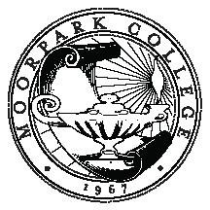

MOORPARK COLLEGE

Committee on Accreditation and Planning – Education

Responsible to plan, monitor and evaluate the college-wide educational master planning process: Annual Program Planning ~ Educational Master Plan ~Accreditation Self-Study Process Implementation

GOALS
2014-2015
# | GOALS | ACCOMPLISHMENTS
1 | Validate gap analysis
2 | Accreditation: Continue to collect data for the Self-Study
3 | Become informed about Student Success Scorecard & Institutional Goals/Benchmarks
4 | Evaluate our program planning process
5

Approved 5/16/2013

