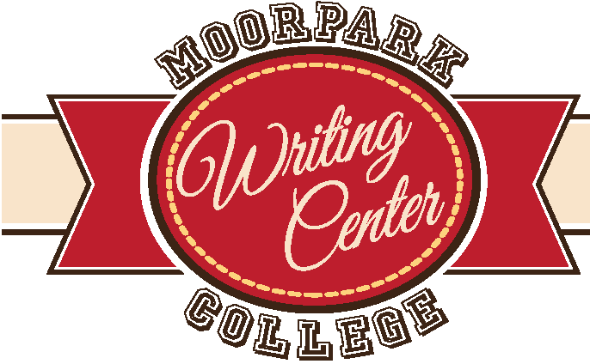
How to Write an Essay
moorparkcollege. edu/writingcenter

While there are many ways to write an essay, it is important to have a process or strategy. It is also important that your essay has a structure; usually an essay has a main idea early in the paper, which is supported by a number of paragraphs, and ends with a conclusion. Each body paragraph is a subtopic of the main argument, and each subtopic is supported by evidence and analysis.

- Brainstorm to help you come up with your main idea (brainstorming includes freewriting, listing, clustering, mapping, drawing, talking, etc.). If the paper requires research, complete the research. Once you have your main idea, divide it into logical parts; these parts will become the body paragraphs. Then, consider which of the following patterns is the best way to arrange these paragraphs in your essay:

- Time: Chronological order or Sequential order
- Location
- General to Specific
- Specific to general
- Least important to most important
- Problem to solution

- Complete an outline (see the outlining handout)

- Draft each paragraph. For each paragraph, try to focus on one key point. Realize that each step might be a few sentences and that steps 3 and 4 often repeat in a paragraph

- Topic sentence that shows the direction and claim of that paragraph
- Explanation of what the topic sentence means or how it could be pictured
- Evidence/ Example that proves the topic sentence or helps the reader better understand or picture the issue.
- Analysis in which the evidence or example is broken down in order to show what it means, how it explains or relates to the issue, and/or how it supports the claim made in the topic sentence. Steps 3 and 4 might repeat with the each additional piece of evidence for that paragraph.
- Synthesis that connects the evidence shown in the paragraph with the topic sentence and, ultimately, with the thesis of the paper.

- Write the conclusion. For a short essay, do not summarize your points in the conclusion. Instead, remind the reader of your main points, and leave them with something strong and memorable, such as a call to action or a powerful last statement .

- Revise your draft many times, checking for organization, logical support, sentence structure, proper citation of sources if needed, etc. Make an appointment with a writing center tutor and/or have others give you feedback. Your final proofreading should look for errors in punctuation, grammar, word choice, formatting, etc. Read your paper aloud to catch any final issues.

Practice

- Write down your main idea

- What are 3-5 subpoints of your main idea?

- What evidence do you have or need to support those subpoints?

- What do you want your reader to feel or know by the end of your paper?

