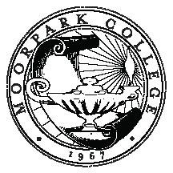

SUMMARY OF DISCUSSION ON
MAKE-UP OF PROFESSIONAL DEVELOPMENT COMMITTEE

Membership of Committee
- Membership was originally 2 per division, and then it was changed to 1 per department.
- Vacant positions have no effect on obtaining a quorum.
Pros | Cons
Currently there are 19 dept. positions available, 11 of which are filled and 8 vacant for this semester. Many department positions have been unfilled for several years now. | When divisions get shuffled, the membership would be disproportionate to the number of academic programs in each division.
Attendance by those depts. which do have reps tends to be low. | This would not be inclusive.
Others involved with professional development on campus would be invited to attend as non-voting members if they were interested in doing so. Would increase coordination of PD on campus. | The same thing could be accomplished by improved communication with faculty members in each department.
A larger committee becomes ineffective due to a lack of time to let all members comment and discuss business. | [There was also a request for adding a SEIU representative member to address union issues and further the goal of being inclusive]

Committee Chair Increase to 3
- This would allow for an addition of a classified staff chair.
Pros | Cons
This would reflect the goal of complete integration of the campus community for professional development. | Lack of clarity and decisive actions.
There would be less work, as it will be split between 3, rather than 2. | There could be communication issues with an additional chair.
Improves classified leadership at the campus level.
Seeing classified staff as part of the team matches the Moorpark College philosophy.

