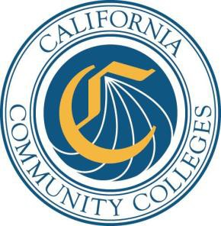

**Credit**

**Student Success and Support Program Plan**

**2015-16**

District: **Ventura County Community College District**

College: **Moorpark College**

**Report Due by**

**Friday, October 30, 2015**

**Email PDF of completed plan to:**

[**cccsssp@cccco.edu**](mailto:cccsssp@cccco.edu) **and**

**Mail signature page with original signatures to:**

Patty Falero, Student Services and Special Programs Division

California Community Colleges Chancellor’s Office

1102 Q Street, Suite 4554

Sacramento, CA 95811-6549

**Instructions for Completion of the College**

**Student Success and Support Program Plan**

**INTRODUCTION**

The purpose of the credit Student Success and Support Program (SSSP) Plan is to outline and document how the college will provide SSSP services to credit students1. The goal of this program is to increase student access and success by providing students with core SSSP services to assist them in achieving their educational and career goals.

More specifically, colleges are to:

● Provide **at least** an abbreviated student education plan (SEP) to all entering students with a priority focus on students who enroll to earn degrees, career technical certificates, transfer preparation, or career advancement.

● Provide orientation, assessment for placement, and counseling, advising, and other education planning services to all first-time students2.

● Provide students with any assistance needed to define their course of study and develop a comprehensive SEP by the end of the third term but no later than completion of 15 units.

● Provide follow-up services to at-risk (students enrolled in basic skills courses, students who have not identified an education goal or course of study, or students on academic or progress probation).

**INSTRUCTIONS AND GUIDELINES**

***Please carefully review these instructions and resources, including the SSSP Handbook, relevant sections of the Education Code and title 5 regulations before completing the program plan.***

The program plan is set up as a Word document. As you enter your responses below each question, the document will expand to accommodate the information provided. *Colleges are to use the template as provided.* When complete, also save the document as a PDF file and email it as an attachment to [cccsssp@cccco.edu](mailto:cccsssp@cccco.edu) with the name of the college and “SSSP Credit Program Plan” in the subject line. Mail the signature page with the original signatures, along with the separate Budget Plan signature page, by the due date (Oct. 30th).

The program plan is to be submitted on an annual basis3. When writing the program plan, assume that the reader knows nothing about your program and will have only your document to understand the delivery of program services and resources needed for implementation. Be sure to include input from faculty, staff, administrators and students in the development of this plan (per title 5, §55510[b]).

1 Colleges operating SSSP programs for noncredit students must prepare a separate noncredit plan.

2 A first-time student is defined as a student who enrolls at the college for the first time, excluding students who transferred

from another institution of higher education, and concurrently enrolled high school students.

3 The program plan is now required on an annual basis due to new SSSP requirements focusing funding on core services,

changes related to priority enrollment, mandatory core services, and the significant increases in funding in 2013-14, 2014-

15 and 2015-16. As implementation and funding stabilizes, this requirement may be revisited.

All state-funded SSSP services, procedures, and staff activities must be described in the program plan. Section 78211.5(b) of the Education Code permits districts and colleges to expend these categorical funds only on SSSP activities approved by the Chancellor. Please be sure all expenditures are consistent with the [SSSP Funding Guidelines](http://extranet.cccco.edu/Portals/1/SSSP/Matriculation/SSSP%20Handbook%202014/Chapter%204%20-%20SSSP%20Funding%20Guidelines.pdf) or your plan may not be approved. The information provided and the funding source should be clearly indicated in the plan narrative and correspond with expenditures listed in the Budget Plan. In districts with more than one college, the college program plan must also address any portion of the college’s allocation expended by the district. The program and budget plans will also be compared with the colleges’ credit SSSP Year-End Expenditure Report to

monitor for consistency. Note that SSSP funds may not be used to supplant general or state categorical (restricted) funds currently expended on SSSP activities. Any services provided should supplement--not supplant--any services provided to students currently participating in college categorical programs and any other federal, state, and local programs.

The SSSP Plan is divided into six sections. The Budget Plan is a separate document.

I. Program Plan Signature Page

II. Planning & Core Services

A. Planning

B. Orientation

C. Assessment for Placement

D. Counseling, Advising, and Other Education Planning Services

E. Follow-up for At-Risk Students

F. Other SSSP/Match Expenditures

III. Policies

A. Exemption Policy

B. Appeal Policies

C. Prerequisite and Corequisite Procedures

IV. Professional Development

V. Attachments

Links to program resources are provided below to assist with the development of your SSSP Plan.

**RESOURCES**

➢ [Seymour-Campbell Student Success Act of 2012](http://www.leginfo.ca.gov/pub/11-12/bill/sen/sb_1451-1500/sb_1456_bill_20120927_chaptered.pdf)

➢ [California Code of Regulations](https://govt.westlaw.com/calregs/index?__lrguid=i278f056bb5c04e7d94f9d40fbfb9390f&amp;transitionType=Default&amp;contextData=(sc.Default))

➢  [Ch an cello r’s Of f ice Stu d en t Eq u it y web p age](http://extranet.cccco.edu/Divisions/StudentServices/StudentEquity.aspx)

➢ [Accrediting Commission for Community and Junior Colleges](http://www.accjc.org/)

➢ [Chancellor's Office Basic Skills website](http://extranet.cccco.edu/Divisions/AcademicAffairs/BasicSkillsEnglishasaSecondLanguage.aspx)

**SECTION I. STUDENT SUCCESS AND SUPPORT PROGRAM PLAN SIGNATURE PAGE**

College Name: Moorpark College

District Name: Ventura County Community College District

We certify that funds requested herein will be expended in accordance with the provisions of Chapter

2 (commencing with Section 55500) of Division 6 of title 5 of the *California Code of Regulations* and

*California Education Code* sections 78210-78219*.*

Signature of College SSSP Coordinator: Name: Dean Patricia Ewins Date:

Signature of the SSSP Supervising Administrator

or Chief Student Services Officer:

Name: Dr. Lori Bennett Date:

Signature of the Chief Instructional Officer:

Name: Dr. Lori Bennett Date:

Signature of College Academic Senate President:

Name: Professor Mary Rees Date:

Signature of College President:

Name: President Luis Sanchez Date:

Contact information for person preparing the plan:

Name: Patricia Ewins Title: Dean of Student Learning

Email: [pewins@vcccd.edu](mailto:pewins@vcccd.edu)

Phone: (805) 378-1408

**SECTION II. PLANNING & CORE SERVICES**

**Directions:** Please provide a brief but thorough answer to each of the following questions relating to how your college is meeting the requirements to provide core services under title 5, section 55531. Do not include extraneous information outside the scope of SSSP. Projected expenditures should correspond to items listed in the Budget Plan. Answers should be entered in the document below each question.

**A. Planning**

1. a. Describe the planning process for updating the 2015-16 SSSP Plan.

PLANNING PROCESS

● Planning began in SP 15 by the Student Success and Equity Committee (SS&E), a college standing committee with members from both instruction and student services, who reviewed and updated SSSP activities completed for the year and brainstormed planned projects for the upcoming 15-16 year.

● FA 15 Flex Day presentation on SSSP, which reviewed core services, Student Success Scorecard Data, funding guidelines, and ways in which campus constituents can contribute to student success through SSSP activities.

● Executive Vice-President (EVP) in consultation with Academic Senate proposed master timeline for SSSP, Equity, and Basic Skills Plans for the fall semester.

● FA 15, SS&E reviewed commendations and recommendations from State Chancellor’s

Office and revision timeline from EVP.

● Ensure coordination with other plans through budget and activities review and discussion; SS&E Committee allows for the continuous discussion and integration of both Student Success and Equity. Two major ideas that will require a collaborative effort between Equity and Student Success are 1) a First-Year Experience program and 2)

faculty mentors/coaches. In addition, the Basic Skills Plan identifies Action Items including Counselors and support services which would impact “at risk” students—we intend on working closely with them to maximize services and resources.

● Review and feedback from all campus constituents was a priority for the revision of the plan. Presentations were scheduled for the Academic Senate, Associated Student Government, Student Services Council, SS&E Committee, Dean’s Council, Classified Senate, VP Council, and the Moorpark College Consultation Council. After broad campus review, the SSSP plan will be presented to the District Consultation Committee and the VCCD Board of Trustees, in time for the October 30 submission deadline.

● Implementation of SSSP survey administered to faculty and staff who attend SSSP funded trainings, conferences, and events. The survey identifies the specific activities and/or

ways individuals would be able to use the acquired knowledge/experience to impact core services.

b. What factors were considered in making adjustments and/or changes for 2015-16?

ASSESSMENT AND ADJUSTMENTS

● While overall feedback of our previous plan from the State was positive, diligent effort was made to ensure that we addressed specific areas identified by the State Review Team that needed further clarification.

● Integrated planning was essential; as a college we are dedicated to thoughtful and intentional activities which not only support the campus’ vision and strategic goals but promotes student success and completion.

● We wanted to make sure that we incorporated broad feedback and input through the many assessment tools we used across the college to improve satisfaction, participation, and effective utilization of services.

● It was important to identify in the narrative of the plan actual positions and expenditures listed in the budget. We did this by noting positions funded by SSSP in the description of services as well as making sure they were listed in the budget. These positions were also notated so that they can be readily matched to the budget at the end of each core service.

● Assessment of the previous plan highlighted the need to hire additional SSSP staff to include a Director of SSSP, additional Counselors, Counselor Assistants, Multi-Media Specialist, Orientation Navigators and an IT Specialist dedicated to supporting SSSP technology systems (GradesFirst and DegreeWorks).

c. In multi-college districts, describe how services are coordinated among the colleges. INTER COLLEGE COORDINATION

● A district-wide committee, with members from all three campuses (Moorpark College, Oxnard College and Ventura College) works efficiently and collaboratively to develop MIS data tracking systems and ensure consistency in reporting across the colleges.

● Members share best-practices on implementation of student success activities, and allow us to learn from each other and focus IT support effort on developing the computer programming and other technology-based support to ensure all the colleges were able to meet the SSSP guidelines for implementation and documentation of online orientations, education plans, etc.

● This committee continues to monitor the implementation of the student success and support programs across the District, and to trouble shoot problems that may arise as well as to continue refining our collaboration. An example of coordination came from discussion at this committee requesting an IT Specialist to support SSSP technological systems used District-wide (GradesFirst and DegreeWorks). In addition, this position would work toward making the Student Success Checklist available to students so that they can see which core services they’ve completed. Currently, only college staff and counselors can view this information.

● In addition, the District Technical Review Workgroup for Student Services, which includes members from all three campuses, also worked together to update the district policies and procedures to implement the new registration priorities.

d. Briefly describe how the plan and services are coordinated with the student equity plan and other district/campus plans (*e.g.*, categorical programs) and efforts including accreditation, self- study, educational master plans, strategic plans, Institutional Effectiveness, the Basic Skills Initiative, Adult Education (Assembly Bill 86), and departmental program review.

COORDINATION OF PLANNING EFFORTS

● The district and college-level educational master plans drive our college strategic planning, which directs our program planning and other college-wide plans. The strategic goals are: access, retention and success, responsiveness to the marketplace in career training and effective use of organizational resources. These goals align with and support the goals of the student success and equity initiatives.

● To prepare for our upcoming accreditation self-study, we have conducted a campus-wide gap analysis and are focusing on integrated planning, assessment, and evaluation. Understanding how our equity data captures effects of student access, retention, and success is a critical part of our work. Analyzing assessment results and using this information to improve our programs and services, is central to our program planning process.

● Moorpark College’s Student Success and Equity Committee (SS&E) is tasked to develop and monitor the student success and equity plans, thus ensuring the coordination of these plans and programs. In addition to program-level review of equity data, SS&E will review campus-level equity data and use this information to develop future Success and Equity Plans. The equity data also informs our Basic Skills planning, and the Basic Skills

planning goals were incorporated into the Student Success and the Equity Plans to ensure

a well-rounded college-wide program.

● Budget and revision planning for the SSSP, Equity, and Basic Skills occur collaboratively to allow for the integration of these plans. Many members of the revision teams serve on two or more of these important initiatives, thereby ensuring cross-sharing of feedback and participation.

● Moorpark College’s Basic Skills Initiative embeds counseling and academic support within identified sections of Math, English, Integrated ESL and ESL. The Basic Skills and the Student Success Committees share many of the same members. In fact, the Co-Chair of the Student Success and Equity Committee is a Writing Center Coordinator and founding member of the Basic Skills Committee. Thus, SSSP supports a dedicated Basic Skills Counselor, allowing more of the Basic Skills funds to be allocated to Supplemental Instruction and Tutoring. In addition, SSSP has supported assessment efforts to further develop a data collection process for our online English self-placement, and is

researching additional assessment tools to support student success in Math and English.

● In coordination with the Student Success and Equity Committees, the First-Year Experience (FYE) Activity student support program will connect students with Faculty Success-Coaches, Orientation Navigators, and Peer Mentors. Incoming, first-time college students will be connected with a staff member (Orientation Facilitator) immediately upon their application to the college. A welcome letter will be sent, introducing the student to their facilitator, followed-up by a personal phone call from that facilitator. The facilitator will invite the student to attend the College Welcome event, where they can meet face-to-face for the first time, connecting the new student to other new students, classroom faculty, and faculty counselors. As students develop their educational plans with their counselor, they will then be connected with a Faculty Success-Coach based on the student’s chosen major and/or educational pathway. The Orientation Facilitator, with a team of peer mentors, will remain in contact with the new college students, providing encouragement, and guiding the students to different support services as appropriate, serving as a liaison between the new college student and the student support service programs.

2. Describe the college’s student profile.

STUDENT PROFILE

● The Student Profile information listed below is taken from our [Institutional Effectiveness](http://www.moorparkcollege.edu/departments/administrative/institutional-effectiveness-office/institutional-effectiveness-reports)

[Report for Fall 2015.](http://www.moorparkcollege.edu/departments/administrative/institutional-effectiveness-office/institutional-effectiveness-reports)

● Student Access is a critical focus for Moorpark College, and the Ventura County Community College District. Although it is clear that student headcounts have been on the decline since 2009, the College has seen an increase in student completions and success, evidence of improved scheduling strategies decreasing barriers for students seeking associate degrees, transfer requirements and certificates in career technical education programs.

Moorpark College Unduplicated Headcounts

17,000

c*.,*o*-*

.; " c"o'

*<D* -.. "*.,*'*-*

..

"*.,*'*-*

16,000

g N -

....

.... .... *<D*

"! 0

-

v "' ....

,...

,.- ,..

"v' *;h <D*

.c, 15,000

0 v' ..... .... v o,

4>

14,000

13,000

12,000

",....-

,.........

....

*r-* -

,..

.... ;'!;

,........

t

Fall Fall Fall Fall IFall Fall Fall Fall Fall Fall

2005 2006 2007 2008 2009 2010 2011 2012 2013 2014

Declared Educational Goals

.<g=

a.

"

0

(:.L:.

100"

75"

50"

- ; -

'=

-:11 ....

-.-

[--:J

-=--

-o

"

0 25"

*\** / l- - l- l- 7

0%

Fall2010 Fall2011 Fall2012 Fall 2013 Fall 2014

OOther 4,152 3,385 2,624 2,566 2,241

0 Earn Career Certificate 154 154 146 143 280

Earn Associate Degree Only 923 923 875 855 840

0 Earn Degree (w/or w/Transfer ) 8,920 9,231 9,474 9,265 9,244 [)Transfer (w/or w/out Degree) 10,150 10,770 10,349 10,548 10,505

-

- '-

Enrollment Status

First-Time College students make up 20 percent of the Moorpark College population in Fall 2014 (having reached 25 percent in Fall 2012).This is important to remember when revi ewing success data in the following chapter.The California Community College Student Success Scorecard reports on student cohorts that comprise of First-Time College Students whose progress was monitored for 6 years. Although those data are important, it is equally important to understand that those data reflect 25 percent of our student population in any given semester.

-

c :;;,

.-.2.

:;

.<.>.

E SO%

100%

75% --

Cll --a; -..r:

--

'=''

'0

""'

*25%*

/

1- 1--- 1- 1- t-7

.0, 0%

Fall 2010 112011112012 Fall 2013 ,_£all 2014

r..Spedal Admit 308 308 146 285 280

OContinuing Student 8,612 8,616 - 8,163 7,982 7,983

Returning Student 1,999 2,000 1,749 1,425 1,821

0First Time Transfer-Student 1,230 1,231 875 855 1,120

0First Time College Student 3,230 3,231 3,644 3,706 2,801

Proportion of Enrollments by Age

The age of Moorpark College students has been slowly getting younger.In Fall 2014, nearly 80 percent of Moorpark College students were under the age ol25,as compared to Fall 2010 when 74 percent of

the students were under the age of 25.

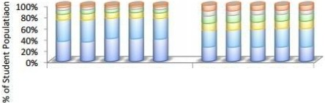

Fall fall Fall Fall Fall

2010 2011 2012 2013 2014

Fall Fall Fall Fall fall

2010 2011 2012 2013 2014

Moorpark College California CCs

D 19 or Under 0 20 • 24 yrs *25* • 29 yrs 30 • 39 yrs .J40 • 49 yrs 0 50 or Over

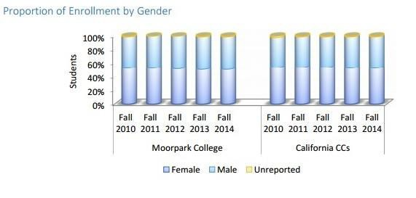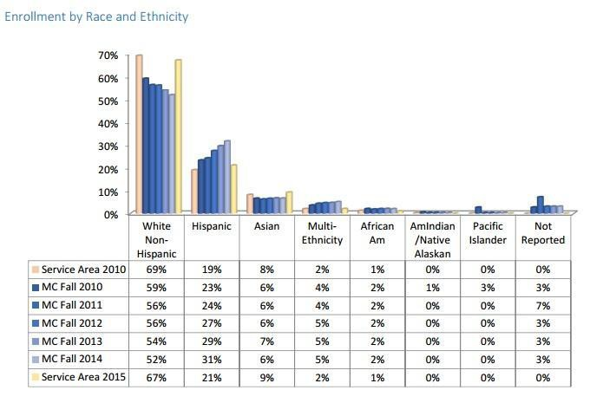

3. Describe any partnerships among colleges or with high school districts, workforce agencies, or other community partners that assist with providing core services to new students.

PARTNERSHIPS

● High Schools near Moorpark College have close interaction with our counseling and outreach staff and assist in preregistration activities to prepare students for transition to college.

● All local High School counselors are invited to a breakfast meeting at the college each year.

This kick-off event orients the HS counselors and gives them the information needed to take back to their students to begin the orientation process. During spring 2015, 70 HS Counselors from 22 local high schools were in attendance.

● Throughout the spring, Counselors and Outreach personnel visit local high schools to speak at student assemblies. We visited 20 local high schools to provide informative presentations to 1180 students about the opportunities at Moorpark College.

● During their senior year, interested students from local high schools are invited on a “field trip” to Preview Days, at Moorpark College to visit facilities, meet professors, and talk with counselors. 11 Preview Days were held in Spring 2015 with 660 students in attendance.

● Local high schools are familiar with our self-assessment/self-placement process and prepare students to understand the process and the importance and long-term benefits of making honest and informed self-assessments/self-placements as one of their first adult responsibilities in college. Local high school seniors who attend our Spring Preview Days are required, with the support of the high school counselors, to bring their high school transcript with them to the Preview Days. These transcripts are reviewed for proper prerequisite clearance/placement for Moorpark courses which require a high school prerequisite and cleared into Banner. We will conduct similar activities during 2015-2016.

• In collaboration with local high schools, we will be offering Counseling M03: Orientation to College which will be conducted both at the HS and the college. This will improve access to students completing core services at the high school but also enable them to develop an education plan on site and familiarize themselves with campus services.

• Additional activities include increasing outreach to Veterans by working with Ventura County Military Collaborative as well as connecting with Many Mansions, a housing development community serving economically disadvantaged residents of Ventura County.

• Moorpark College is a participant in Project ALAS (Aligning Learning and Success) a partnership with CSU Channel Islands, Ventura County P-20 Council, and the Ventura County Community College District which seeks to facilitate successful student transitions in the regional transfer pipeline.

• The Connections Project will allow counselors and discipline faculty to expand college, career, and education planning to local middle-schools and high schools.

**B. Orientation**

1. Were adjustments made to your orientation process based on outcomes from your 2014-15 program plan?

ASSESSMENT AND ADJUSTMENTS

● “3 in 1” process (self-assessment, online orientation, and abbreviated ed plan) which was commended by the State Chancellor’s Office will continue as well as updates to the

online orientation.

● Plan to increase the number of students completing orientation through outreach, marketing, and utilization of Orientation Navigators.

● Explore additional ways to assist students in better understanding the development of their abbreviated education plans and their course selection process as part of the online orientation.

● Review student feedback from satisfaction surveys and incorporate their suggestions for improvement in the orientation process.

2. a. How many students were provided orientation services in 2014-15? ORIENTATION SERVICES PROVIDED IN 2014-2015

● In 2014-2015, we had 3317 first-time college students and 1710 first-time transfer students enroll. These “new-to-Moorpark” students were required to complete the orientation process to receive registration priority. Of these students, **3123 completed** the online orientation.

b. What percentage of the target population does this represent? PERCENTAGE OF TARGET POPULATION

• All new college students, students returning after an absence, or new to Moorpark

College are expected to complete the orientation. We believe that the online orientation provides a great foundation for students to transition to our campus and even if they’ve attended another college, to see the signature programs and services available at Moorpark is beneficial.

• Our first time college student population holds fairly steady at the rate of about 3000-

3500 new to college students each year and these new students typically account for about 25% of our college population.

● As there were 5027 total new students for 14-15 and 3123 completed orientation, the percentage of the **target population is 62%.**

c. What steps are you taking to reduce any unmet need or to ensure student participation? INCREASE STUDENT PARTICIPATION

● Improve marketing and increased awareness of completing “new student steps” (especially w/ partnerships: HS outreach, etc.) The hiring of the Director of SSSP and Orientation Navigators will greatly assist in improving student participation through their focused efforts in working directly with students. In addition, student ambassadors will continue to assist students in navigating through the orientation process.

● Continue follow-up in their first semester for those students missing orientation to maintain priority registration for the next term.

● In order to make the orientation more relevant to returning adult students we plan to create targeted orientations that are relevant and contain required information as well as information targeted at the specific audience.

● Include discipline faculty in orientation process through cohorts by major/career pathways.

3. a. Are orientation services offered online? ONLINE ORIENTATION SERVICES

● First implemented in 2014-2015, Moorpark College’s Online Orientation was developed to be a simple, no on-going cost, hands-off, “3 in 1” process that incorporates Student Self-Placement, Orientation, and Abbreviated Ed Plan into one set of self-guided operations, completed independently, and automatically entered into MIS data collection.

● Once students have completed the online orientation, they have the option of attending a New Student Workshop conducted by Counselors and assisted by Counselor Assistants. These workshops expand on information presented in the orientation, specifically recommended first semester course selection and the development of their abbreviated ed plan. Data shows that the number of students attending these workshops is up 40% since last year. This indicates that more students are requiring additional orientation services beyond our online orientation and because of this, we have plans to include making the New Student Workshop available online. An Office Assistant also provides clerical support for orientations and workshops.

**New Student Workshops Summer 2015**

|  |  |  |  |
| --- | --- | --- | --- |
|  | **Month/Year** | **Students Attended** |  |
| **May 2015**  7 workshops | 43 |
| **June 2015**  16 workshops | 146 |
| **July 2015**  31 workshops | 261 |
| **August 2015**  7 workshops | 48 |
| **Total**  61 workshops offered | 498 |
| b. Identify any technology used to provide orientation, including any commercial or in-house products in use or under development, and annual subscription or staff support requirements.  TECHNOLOGY  ● Our Online Orientation was developed in-house which enables us to update information as needed.  ● We plan on creating online orientations geared toward different student populations (re- entry, Veterans, and international students ). As we do not subscribe or utilize any commercial product, updates to our online orientation are done through campus-wide collaboration. The Technical Data Specialist will assist with this project in addition to Professional Experts.  ● With the hiring of a Multimedia Specialist for our SSSP projects, we will design mobile phone apps and other technological tools to further reach students for orientation. In addition, the Research Assistant provides necessary data support as we implement student surveys to assess satisfaction and access.  4. Identify the topics covered in orientation. Include those topics mandated by title 5 section 55521 and any additional information, policies and/or procedures that the college or district determines necessary to include in a comprehensive orientation.  TOPICS COVERED IN ORIENTATION  ● The purpose of orientation, as defined in title 5, section 55502, is to acquaint “students and potential students with, at a minimum, college programs, student support services, facilities and grounds, academic expectations, institutional procedures, and other appropriate information pursuant to title 5, section 55521.”  ● Orientation Checklist (Required Policy or Procedure) per title 5 section 55521 | | | |

o (1) Academic expectations and progress and probation standards pursuant to section 55031;

o (2) Maintaining registration priority pursuant to section 58108;

o (3) Prerequisite or co-requisite challenge process pursuant to section 55003;

o (4) Maintaining Board of Governors Fee Waiver eligibility pursuant to section

58621

o (5) Description of available programs, support services, financial aid assistance, and campus facilities, and how they can be accessed;

o (6) Academic calendar and important timelines.

o (7) Registration and college fees.

o (8) Available education planning services

● The Online Orientation was developed to include all of the required information on the above checklist. A question is required to be answered correctly at the end of each section of the online orientation before students can move on to the next section to acknowledge understanding of the content. These questions are specific to the 8 checklist items. By requiring all new students to complete the same online orientation we can

verify that all students have received the required information noted above.

*Continued Orientation Services Along the Academic Pathway*

● Moorpark College recognizes that students need different information at different times throughout their academic career. As such, we strive to impart information when it is the most pertinent and meaningful to the individual student. Students at Moorpark use “MyNav”, our online guidance tool for students to use throughout their college career. This is featured on the portal, website, and featured on posters throughout campus, “My Nav” helps students navigate the college timeline and identify and understand the important milestones at different stages of their individual educational development.

● In Spring 2015, we developed “mini-orientations/updates” (using professional experts to create these) for each of these stages to be sent out to students as they achieve each level. These “just-in-time orientation updates” will remind students to meet with counselors, use students services, visit the Career Transfer Center, complete grad checks, etc. depending on their individual level of completion to goal:

o Getting Started------------before enrollment o The First 15-----------------the first 15 units

o Making Progress----------16-30 units o Moving Forward----------31-45 units o Graduation Transition--46-60+ units

o Lifelong Learning/Career Updates---------after graduation/transfer

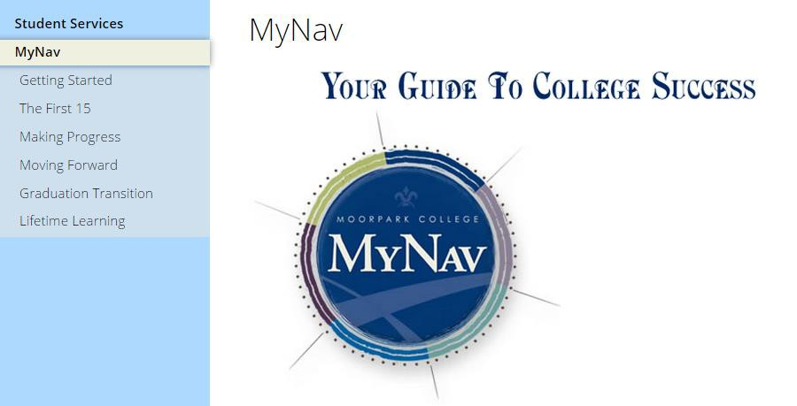

|  |  |
| --- | --- |
| **Special Program** | **Number of Students Attending**  **Orientations for FY 2014-2015** |
| ACCESS (DSPS) | 97 |
| Nursing---Mandatory Orientation | 89 |
| Rad Tech-Mandatory Orientation | 31 |
| Athletics | 374 |
| Math Summer Bridge | 110 |
| EOPS | 225 |
| CalWORKs | 38 |
| EATM | 94 |
| Financial Aid | 981 |

|  |  |  |  |  |  |
| --- | --- | --- | --- | --- | --- |
| *Special Population Orientations*  ● Special programs (DSPS, EOPS, Nursing, EATM, etc.) also require additional orientation for their specific programs to supplement the general online orientation required of all new students. Many other discipline-related orientations and welcomes are optional. These additional and specialized orientations designed to increase student success in all areas are funded by general funds or specific categorical funds. We will conduct similar activities during  2015-2016.  5. Complete the chart below outlining the staff associated with orientation and the source used to fund the position. These staff listed below should match those in your budget plan. Additional lines may be added. | | | | | |
|  | **# of FTE** | **Title** | **Role** | **Funding** |  |

|  |  |  |  |  |  |
| --- | --- | --- | --- | --- | --- |
|  |  |  |  | **Source (SSSP/Match/GF)** |  |
|  | Counselors | Facilitate New Student  Workshops, Orientation to College classes, New Student Welcome Day, Preview Days | GF |
|  | Counselor Assistants | Assists with “New  Student” workshops, Preview days, New Student Welcome Day | GF |
|  | Office Assistant | Provides clerical  support for Orientation functions. | SSSP |
|  | Technical Data  Specialist | Assists students with  completion of core services and on-line instructional support as well as development of orientation online components. | SSSP |
|  | Research Assistant | Assists with  development,  implementation, and analysis of program assessment surveys for SSSP. | SSSP |
|  | Outreach Specialist | (35% )-Schedules and  presents orientation activities for HS Counselors and students both at the high school site as well as on campus; coordinates Welcome Day, campus tours, Assisted Orientation, Counselor Breakfast, and Student Ambassador Tours. Conducts preview orientation activities at community events to reach/inform targeted student populations. | SSSP |
|  | Student  Ambassadors/Workers | Conduct student tours,  field questions at the Welcome Center, and assist with preview days | SSSP |
|  | Professional Experts | Production of updates  to the online orientation; “just-in- time” videos; additional | SSSP |

|  |  |  |  |  |  |
| --- | --- | --- | --- | --- | --- |
|  |  |  | multi-media to support  SSSP |  |  |
|  | Orientation Facilitator | Provides additional  assistance/coaching to students through the orientation process; assists with registration |  |
|  | Director of SSSP | Under supervision of  the Dean of Student  Learning, coordinates SSSP and Orientation Navigators |  |
|  | Discipline Faculty | Meet and greet students at the Preview Day, New Student Welcome |  |
|  | Multi-media Specialist | Design mobile phone apps and other technological tools to further reach students for orientation. |  |
| 6. Complete the chart below outlining all other orientation related expenditures, including the  direct cost to purchase, develop or maintain technology tools specifically for orientation services. These expenditures should correspond to those in your budget plan. Additional lines may be added. | | | | | |

**C. Assessment for Placement**

|  |  |  |  |
| --- | --- | --- | --- |
| **Budget Code** | **Expenditure Title/Description** | **Funding Source (SSSP/Match/GF)** | **Amount** |
| 4000 | Office Supplies | SSSP | 20,000 |
|  | General Supplies | SSSP | 20,000 |
| 5000 | Faculty Travel | SSSP | 15,000 |
|  | Employee Travel | SSSP | 10,000 |
|  | Mileage | SSSP | 3,000 |
|  | Printing/Duplicating | SSSP | 16,000 |
|  | Contracts/Transportation | SSSP | 30,000 |
|  | Software maintenance | SSSP | 30,000 |
| 6000 | Equipment<1000 | SSSP | 4,723 |
|  | Equipment>1000 | SSSP | 10,000 |

1. Were adjustments made to your assessment for placement process and/or procedures based on outcomes from your 2014-15 plan?

ASSESSMENT AND ADJUSTMENTS

● We wanted to address areas noted in state recommendations regarding student placement in ESL and World Languages classes. We consulted with discipline faculty to clarify the process of student placement in those disciplines and confirm compliance with assessment regulations.

● In July 2015, we began surveying students after they complete the self-assessment and will review feedback for ways in which we can improve the process. Key highlight of the survey showed that 90% of the students completing the English assessment felt that it helped them feel confident in selecting the appropriate English course. We will soon be evaluating the survey data from the Math assessment as well.

*Survey Data since July 2015*

● 2276 students started the English assessment.

● 2014 students finished the assessment and made the following course selection:

o 1126 - English M01 - English Composition (56%)

o 547 - English M02 - Introduction to College Writing (27%)

o 298 - English M03 - Writing Skills (15%)

o 43 - ESL M01, M02, or M03 (2%)

● As of July 2015, 1980 students answered the optional question of how do you feel after taking this self-assessment

o Out of those 1980 students, 1794 (90.6%) chose “I feel like I have a good idea of which class

to take after completing this self-assessment.”

o The remaining 186 students chose “I am still not sure which course to choose after completing this self-assessment. I would like to meet with a counselor, English faculty member, or with someone at the Writing Center to determine the best course for me. I will return to this self-assessment later after doing more exploration.”

o We will certainly want to evaluate how we can assist students who start assessment but do

not complete as well as students who are still uncertain about course placement after completing the self-assessment.

2. a. How many students were provided assessment services in 2014-15?

● Moorpark College has been using an informed self-assessment/self-placement instrument for students in English and math since 2000. Originally designed by English and math faculty as a “paper-pencil” self-assessment/self-placement these instruments have been regularly monitored, up-dated, and improved over the past 14 years with continued input from counselors, matriculation personnel and discipline faculty. It was most recently evaluated

in 14-15 and student success data will be compiled in 15-16.

● Students have used these instruments to self-assess their own academic skills and personal readiness for a specific class and they are then able to place themselves into pre-transfer and transfer level English M01 and pre-transfer math classes of their choice. These self- placements are now online and they are the suggested starting point for the 3-step assessment/orientation/abbreviated EdPlan process for all students new to Moorpark.

● In 2014-2015**, 3976 new students** completed the self-assessment.

b. What percentage of the target population does this represent?

TARGET POPULATION

● This self-placement is a required prerequisite for pre-transfer level math and transfer level English classes. Results and decisions feed directly into Banner and the prerequisite clearance for these classes. We monitor the results of this self-placement process by comparing the success rates for students who have self-placed to state-wide success rates of students placed into classes in various other ways. We have found self-placement to be at least equal and usually better than standard assessment/placement tools, and superior to students being placed based on high school transcripts alone. Moorpark College feels strongly that when students are given the respect, autonomy, and the right information, they will make an informed self-placement decision based on a self-evaluation of skills and additional factors regarding personal commitment, time constraints, and course expectations. We feel they will make a better decision for themselves and have a higher level of commitment to making it a successful decision. As we track our students we find this largely to be true.

● All students who enroll in math or English courses who have not completed the prerequisite course at Moorpark are expected and strongly encouraged to complete the self-placement prior to enrolling in a course. Student who may have completed a prerequisite class elsewhere are still encouraged to complete the self-placement as the self-placement contains multiple measures and additional and important information regarding study skills, time commitment and course expectations that will assist students in making an informed choice even though they may technically already have completed a prerequisite.

● As stated above, in 14-15, 3976 students completed the self-assessment. This represents a

**79% completion rate** of new students directed to assessment/placement.

c. What steps are you taking to reduce any unmet need or to ensure student participation? ENSURING STUDENT PARTICIPATION

● Prior to the implementation of our three-step new student process in spring 2014, students could complete the self-placement any time before registering for math or transfer level English classes. Since implementation, both self-placements are the first step the student takes prior to orientation and completion of the abbreviated EdPlan and the expectation is that they will both be completed prior to enrollment in any classes. This enables us to maximize the number of students completing assessment.

● As we increase the number of HS visits, students are able to complete assessment at their schools, thereby improving the ease and opportunity to take the self-placement.

● Participating in assessment assists students in appropriate course selection beyond English and Math classes. Students can be better informed of knowing if they are ready for transfer level general education coursework based on their self-assessment.

3. Give a brief and specific overview of the assessment process. Include a description of the test preparation that is available.

ASSESSMENT PROCESS

● New Students are directed to Assessment after applying for admission and receiving confirmation that they can log onto their MyVCCCD portal.

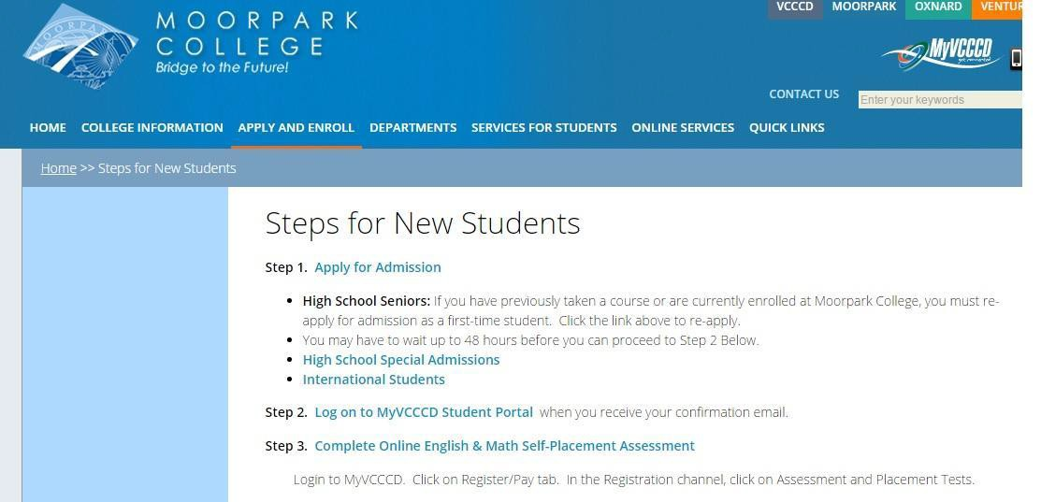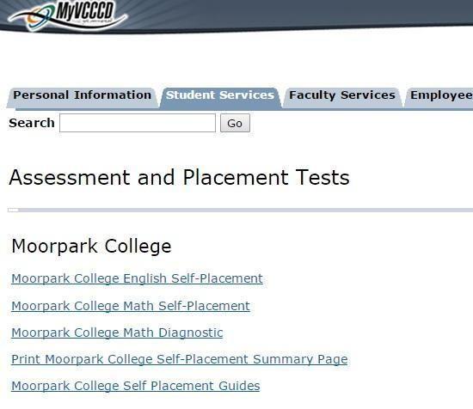

TEST PREPARATION

● As we use a self-assessment/self-placement process there is no need for “practicing” the assessment; however, in summer 2014 our math department piloted a preparation bridge for students who want to begin in transfer level math, have the prerequisite from high school, but need a prerequisite skills refresher that may not be as intense as a full course. The bridge to fall

2014 appeared to be well received by the 108 students who participated. We conducted a similar bridge for summer 2015 and will be compiling success data this upcoming year.

4. a. Identify any assessment test(s) used for placement into English, mathematics, and ESL courses.

Provide specific information about any second-party tests, including the versions and forms used.

SELF-ASSESSMENT/PLACEMENT

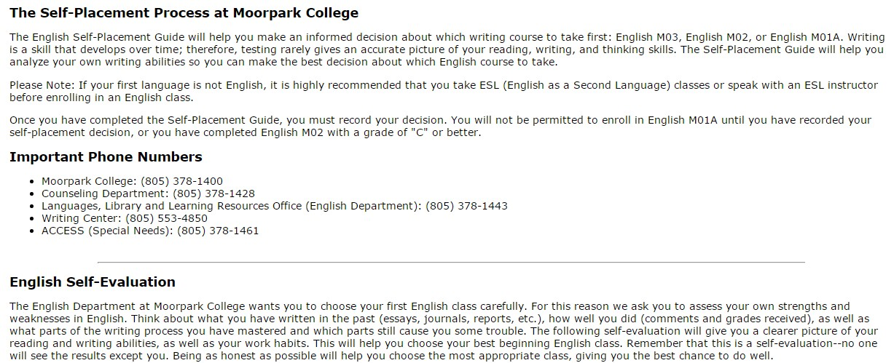

● The Moorpark College Self-Assessment/Self-Placement for pre-transfer math and pre-transfer and transfer level English M01 is a college-designed instrument and is designed to be entirely online. It takes a relatively short time to complete and there is no cost to the student or the college to complete the self-placement. If required, paper/pencil and other 1:1 accommodated self-placements are also available upon request. The self-assessment/self-placement is designed, monitored, and updated by discipline faculty under the leadership of the Department Chair for Math and the Department Chair for English.

● District IT staff build and maintain the instruments to our specifications, up-load them to the website and connect the results to feed into the Banner and MIS systems.

● College Information Technology staff (Technical Data Specialist and Information Tech Support Specialist) will work in coordination with district IT to maintain campus SSSP technology systems, support SSSP activities, provide technical training, and work with District IT staff to maintain instruments and support MIS data collection.

● Currently, there is no additional assessment for ESL students. With 3 levels of ESL, students enroll in the ESL course offered that semester as none of the levels have prerequisites.

● Because our on-line assessment employs multiple measures and facilitates informed decision making on the part of the student, all students are strongly encouraged to take the online English and Math self-assessment and placements regardless of any outside test results; however, we will accept a few “third party” tests for use in placement decisions. We accept results from the following testing agencies:

o AP scores for Math and English placement o CLEP exam scores for Math only

o IB scores for Math only

b. When were tests approved by the CCCCO and what type of approval was granted?

● N/A. Moorpark College utilizes a student self-placement/assessment.

c. When were disproportionate impact and consequential validity studies last completed?

● N/A. Moorpark College utilizes a student self-placement/assessment.

5. a. What multiple measures are used?

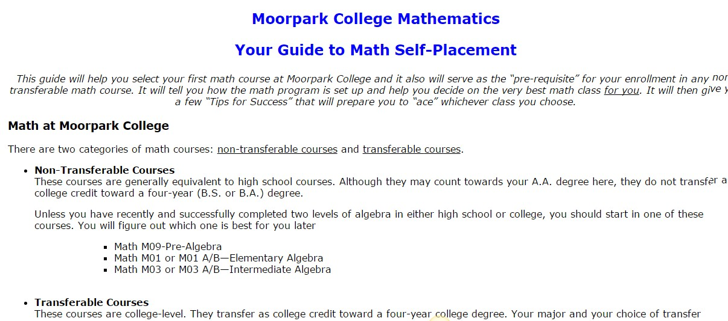

● Our Self-Assessment/Self-Placement is used for both math and English placement recommendations. In addition to a self-assessment of individual skills these instruments guide students to consider their previous experience and success in each subject, outline course expectations and required number of study hours needed, as well as factoring in self-evaluation of recency, personal discipline, study habits, and commitment. This multiple way of

determining readiness assists students in choosing the correct self-placement based, on not

only previous classes or skill level, but on their personal readiness for all aspect of course demands. In addition, counselors and discipline faculty are available to advise students and evaluate student skills. As students self-place and are not forced into any specific class there is no need to appeal decisions.

● Advanced and continuing students can submit transcripts to the Counseling Department and/or the respective department chairs for higher-level clearance; however, all incoming students are strongly encouraged to complete the self-placement as this instrument is designed to assist students to make an informed choice using multiple measures no matter what the skill level or course completion has been.

● World Languages utilizes an online assessment tool which serves only as an informal means of information and part of the multiple measures process. With the tool they assist students in assessing their own knowledge, so they can find what course is recommended at their level of

language. Discipline faculty work with counselors to ensure that appropriate prerequisites are met and that students enroll in the right courses, increasing student success and retention.

b. How they are integrated into the assessment system (as part of an algorithm included in the test scoring process, applied by counselors, etc.)?

INTEGRATION OF MULTIPLE MEASURES

● The self-assessment relies heavily on multiple measures; students not only are asked to identify previous English and Math courses but to actually consider the application of their learning to best select their proficiency levels.

● In addition, Discipline faculty or Counselors can recommend placement other than the one identified through self placement based on transcripted classes from other accredited institutions, high school transcripts and test scores, placement scores from other institutions, and other multiple measures and experiences that may have prepared a student for the class they wish to take. These are each addressed on an individual basis and often involve a counselor recommendation and discipline faculty concurrence.

c. Do these measures meet the multiple measures requirement per title 5, sections 55502 and

55522?

APPROPRIATE MULTIPLE MEASURES

● Per Title 5, section 55502, “Multiple measures” are a required component of a district’s assessment system and refer to the use of more than one assessment measure in order to assess the student. Other measures that may comprise multiple measures include, but are not limited to, interviews, holistic scoring processes, attitude surveys, vocational or career aptitude and interest inventories, high school or college transcripts, specialized certificates or licenses, education and employment histories, and military training and experience.

● Moorpark College’s self-placement utilizes appropriate multiple measures as outlined above.

6. Describe the policy on the acceptance of student assessment scores and placement results from colleges within a multi-college district, from colleges outside of the district, or from adult education programs.

ACCEPTANCE OF OTHER PLACEMENT RESULTS

● It is not our policy to accept scores and placement from within and outside the District as students are directed to complete the self-assessment; however, counselors using multiple measures will review all student provided information to make a holistic review for appropriate course enrollment.

● We will use equivalent college courses in regards to prerequisite clearance for Moorpark courses but we strongly encourage all students to take the Moorpark Math and English placement exams if requesting placement into our English and Math classes even if they have college coursework from other colleges.

● We require new students needing pre-transfer and first level transfer classes to complete the self placement for the other information contained. As students self-place there is usually no resistance to completing this simple set of self-placement tools as the preliminary step to the required orientation.

7. How are the policies and practices on re-takes and recency made available to students? RETAKES AND RECENCY

● Students can re-take both the English and Math self-assessment.

● There is no policy on recency in regards to using test scores/transcripts for prerequisite clearance for transfer level placement. Our “practice” is to counsel students to be conservative in using scores/grades from years ago, typically suggesting taking a class a level below to refresh older learned skills.

8. Complete the chart below outlining the staff associated with assessment for placement and the source used to fund the positon. These staff listed below should match those in your budget plan. Additional lines may be added.

|  |  |  |  |
| --- | --- | --- | --- |
| **# of**  **FTE** | **Title** | **Role** | **Funding Source (SSSP/Match/GF)** |
|  | Technical Data  Specialist | provide technology support for assessment activities related to MIS Data | SSSP |
|  | Info Tech Supp Spec II | provide technology support for assessment  activities | SSSP |
|  |  |  |  |

9. Complete the chart below outlining all other assessment for placement related expenditures, including the direct cost to purchase, develop or maintain technology tools specifically for assessment for placement services. These expenditures should correspond to those in your budget plan. Additional lines may be added.

|  |  |  |  |
| --- | --- | --- | --- |
| **Budget Code** | **Expenditure Title/Description** | **Funding Source (SSSP/Match/GF)** | **Amount** |
|  |  |  |  |
|  |  |  |  |
|  |  |  |  |

**D. Counseling, Advising, and Other Education Planning Services**

1. Were adjustments made to your counseling services process and/or procedures based on outcomes from your 2014-15 plan?

ASSESSMENT AND ADJUSTMENTS

● Motivated by student feedback on satisfaction surveys that they wanted more time with counselors in appointments and to shorten wait-times to make an appointment, appointments were increased from 30 minutes to 45 minutes, and scheduling to 1 week out rather than 2 weeks.

● We plan on requesting additional Counselors (including a First-Year Experience (FYE) Counselor, Early Alert/At-Risk Counselor, and General Counselors) as well as Counselor Assistants.

● We will continue to innovate and collaborate as evidenced by our planned activities with discipline faculty and K-12 partners.

● The hiring of additional counselors in 14-15, allowed for increased student counseling appointments as well as the assignment of counselors to specific instructional departments, increasing collaboration and opportunity to better support students’ education planning.

● Increase use of technology (example: online counseling, GradesFirst, DegreeWorks) to improve student participation in services.

● Broaden education planning to include discipline faculty and peer mentors; collaboration with Student Equity planning on First Year Experience (FYE) program and faculty career coaches/mentors.

● With a 77% increase in the number of Associate Degrees for Transfer (ADT) approved in Spring

2015 and a 251% increase since two years prior, there is incredible demand by students for counseling and education planning related to ADTs.

2. a. How many students were provided counseling, advising and education planning services in 2014-

15?

SERVICES PROVIDED

● Counseling, advising, and education planning services are provided at a number of locations on campus: in counseling faculty offices by appointment, in drop-in “Express Counseling,” in classroom presentations, online counseling, and in other support service locations such as the Career/Transfer Center, EOPS/CalWorks, and ACCESS. Student orientations, probation workshops, and group counseling for cohort programs such as Nursing and Radiologic Technology are also conducted to assist students with their educational planning.

● We provide specific data related to the delivery methods of scheduled appointments, drop-in counseling, online counseling, counseling courses, and education planning services in the sections below.

b. What percentage of the target population does this represent? TARGET POPULATION

● Our campus typically has between 14,000-15,000 students at any one time—this can result in over 33,000 counseling contacts in a year. All students are encouraged to meet with counselors on a regular basis. Students in specific majors or in special programs may have requirements to meet with specific counselors. Counselors have specialty disciplines and students are encouraged to work with counselors who specialize in their chosen field of study but, in general, students may choose whichever counselor they wish.

● Of the 5027 new students, over 80% of these students received counseling/advising and 70%

completed an abbreviated education plan in 2014-2015.

c. What steps are you taking to reduce any unmet need or to ensure student participation? ENSURING STUDENT PARTICIPATION

● Utilization of MyVCCCD student portal with News Updates reminding students to meet with counselors regarding transfer admission applications , Associate Degree petitions, etc.

● New students must complete an abbreviated ed plan using DegreeWorks and/or attending a

New Student Orientation Workshop to maintain priority registration.

● Email campaign to follow-up with students missing ed plans encouraging them to meet with a counselor.

3. a. Describe the service delivery methods (in person, workshops, FTES generating course, etc.).

SERVICE DELIVERY METHODS

*Appointments*

● One-to-one Counselor Appointments are the primary and most essential and intense service that Counseling provides. Counselors typically meet with; students in 1:1 appointments which prior to June 2015 were 30 minutes in length but have since been increased to 45 minutes. Veterans, student with disabilities, and other special populations may be scheduled for sixty- minute appointments as necessary to meet individual needs. Students currently can make appointments in person or via phone with a Counseling Administrative Assistant or Student

|  |  |  |  |
| --- | --- | --- | --- |
|  | **FY 2012-2013** | **FY 2013-2014** | **FY 2014-2015** |
| Appointments | 12, 562 | 12,560 | 16,902 |

|  |  |  |  |
| --- | --- | --- | --- |
|  | **FY 2012-2013** | **FY 2013-2014** | **FY 2014-2015** |
| Online Counseling | 1251 | 1891 | 2575 |

|  |  |  |  |  |
| --- | --- | --- | --- | --- |
| Workers. In the future, we plan in using GradesFirst to allow students to schedule  appointments online.  ● There has been a 25% increase in the number of scheduled appointments over the previous year.  *Online Counseling*  ● Students can submit questions to “On-line Counseling” 24/7 by sending an email to the online counselor via a link on the counseling page of the Moorpark College website. On almost a daily basis during the academic schedule, the on-line counselor then will either answer the question(s) or refer the student to the appropriate place for answers.  ● Previously, our online counseling only provided basic advisement but beginning Fall 2015, we will be able to provide counseling appointments online utilizing technology enabling students to have “virtual” appointments. We can authenticate students by having them log onto their MyVCCCD portal first before the appointments begin.  ● Online counseling allows us to offer comprehensive counseling services to our distance education students as well as those who may not be physically able to come in to the Counseling Office.  ● There has been a 26% increase in the number of students using Online Counseling.  *Career Transfer Center*  ● Moorpark College has a very active Career Transfer Center as a part of the Counseling Department. They have a separate facility and a vibrant website where students can complete career and aptitude assessments as well as explore internships, job opportunities both on and off campus, and receive career and transfer advisement.  ● As evidenced by the data, both scheduled appointments and drop-in have dramatically increased as the college transfers a large percentage of its student population. | | | | |
|  |  | **FY 2013-2014** | **FY 2014-2015** |  |
| Career Transfer-Appointments | 1021 | 2319 |
| Career Transfer- Drop-in | 1596 | 6210 |

|  |  |  |  |
| --- | --- | --- | --- |
| **Course** | **Title** | **Sections**  **(2014-2015)** | **Students** |
| COUN M01 | Student Success | 4 | 61 |
| COUN M02 | Career Development | 3 | 92 |
| COUN M20 | Self-Paced Career  Assessment | 3 | 59 |
| COUN M03 | Orientation/Moorpark  College | 15 | 402 |

|  |  |  |  |  |
| --- | --- | --- | --- | --- |
|  | University Rep Appointments | 633 | 464 |  |
| *Counseling Classes*  • We offer a selection of Counseling classes designed to prepare and support students throughout their college career. These classes are taught by Counseling Faculty.  *Counselor Classroom Visits- Discipline Related*  ● Discipline faculty often invite Counseling Faculty to speak to specific classes regarding careers, degree, and transfer information directly related to the subject matter. This has proven to be an excellent way to reach students with subject information directly targeted to their interests. The added benefit is that Discipline faculty members also hear the most up-to-date information regarding transfer requirements and this makes them more effective when advising students in the discipline.  *Workshops, Presentations, and Events*  • Throughout the academic year a variety of workshops, presentations, and events are held that are marketed and open to the campus at large. Typical of these events are:  o *Hot Jobs of the Future*  o *Pre-Professional Health Science Planning*  o *Undecided Students Group Counseling*  o *“Ask the Counselor”*  o *TAG Transfer Workshops*  o *Honors Orientation*  o *Internship Orientations*  o *Meet the University Reps*  o *Career Workshops*  o *Transfer Day*  o *Job & Career Expo*  o *Major Awareness Week*  o *Transfer Basics*  o *Transfer Planning*  o *Field Trip to UCLA* | | | | |

o *Transfer Social*

o *CSUN/CSUCI Transfer Day*

o *CLU Instant Admissions*

o *Associate Degree for Transfer*

o *New Student Workshops*

*Special Programs*

We have several special programs that have Counselors as part of their teams. These counselors are a part of, and work closely with, the general Counseling department:

o Equal Opportunity Programs and Services (EOPS/CARE)

o California Works Opportunity and Responsibility to Kids (CalWORKs)

o Disabled Student Programs and Services (DSPS)—ACCESS

o Articulation

|  |  |  |  |
| --- | --- | --- | --- |
|  | **FY 2012-2013** | **FY 2013-2014** | **FY 2014-2015** |
| EOPS/CARE—Appointments | 2012 | 2261 | 2805 |
| EOPS/CARE—Drop-in | 160 | 367 | 326 |
| CalWORKs—Appointments | 413 | 426 | 329 |
| CalWORKs—Drop-in | N/A | 249 | 309 |
| DSPS/ACCESS-Appointments | 633 | 676 | 1650 |
| DSPS/ACCESS-Drop-in | 909 | 1015 | 3175 |

● All special program counselors are counselors first, and meet the same minimum qualifications as our other faculty Counselors, although they may also need to meet additional qualifications for the program requirements. In addition, special programs may have coordinators or specialists who may not be academic counselors but serve as advisors and have the required expertise to meet the specific needs of the population. Although students who are part of these programs can seek out the services of any Moorpark College Counselor, these programs provide additional counselor access and expertise that students find advantageous. Students

in these programs are often required to have several appointments each semester which

requires a higher student to counselor ratio to remain in compliance. When specific discipline counseling expertise is required, Counselors and Specialists collaborate to provide the student the optimum counseling experience.

● The Articulation Specialist works closely with discipline faculty and the Curriculum Committee to assure our curriculum meets all state requirements and articulates with other colleges and our transfer intuitions.

*Collaboration with Discipline Faculty*

• Academic advising from discipline Faculty typically occurs on an informal basis during office hours and within the relationship of student/teacher interaction. It is widely recognized that

Classroom Faculty are essential in sharing the discipline information in partnership with

Counseling Faculty.

• We plan to implement a faculty/student networking program, connected with both counseling and discipline faculty, as part of the educational planning development

• We are currently working with Film/Television/Media (FTVM) faculty and students to offer ***The Counseling Hour*** – a radio broadcast show, which would include weekly interviews with a Counselor on a variety of relevant topics for students.

• The Art Department plans to offer lunch-time workshops (co-facilitated by counseling and discipline faculty) for students to introduce AA-Ts in Art and Art History as well as career and education planning regarding the programs.

b. Is drop-in counseling available or are appointments required?

DROP-IN COUNSELING

● Drop-In counseling is another essential and daily opportunity for students to receive counseling and advisement. Students have access to professional and para-professional staff during business hours and until 7:00 two evenings a week. Drop-in counseling is designed to answer quick, 5 minute course related questions, clear simple prerequisites, and receive referrals to other services. Students with question requiring more in-depth interaction and analysis are directed to make appointments. There was a substantial increase in the number of students served on drop-in for the 14-15 year.

● There has been a 30% increase in the number of students seen on Drop-In Counseling.

|  |  |  |  |
| --- | --- | --- | --- |
|  | **FY 2012-2013** | **FY 2013-2014** | **FY 2014-2015** |
| Drop-Ins | 16,704 | 15,401 | 21,809 |

*Para-Professional/Academic Advising*

● Paraprofessionals or Counselor Assistants provide a good portion of the advising on Drop-in.

They assist students to understand the information and answer the types of questions where the information can be found in the catalog. Counselor Assistants do not provide counseling regarding course selection that is not clearly evident in written materials available to the public. Our Counselor Assistants can also clear prerequisites based on a given rubric of acceptable options. They are essential to the smooth exchange of information that students require on a daily bases.

c. What is the average wait time for an appointment and drop-in counseling?

STUDENT WAIT TIME

● The Counseling department strives to meet the needs to the best of their ability of Moorpark College students despite the high ratio of students to counselors. The Counseling staff serves students academically and personally with over 33,000 student interactions a year comprised of one-on-one appointments and Drop-In Counseling.

● Appointments were previously scheduled 2 weeks out but were moved to 1 week, minimizing the wait for students to make appointments. While students can make appointments sooner, this has resulted in appointments filling even more quickly. During peak times, appointments are filled within 1-2 hours.

● Express or Drop-In counseling allows for students to get immediate assistance, advising, or referrals. The wait time on Express Counseling is usually 5-15 minutes but may go up during peak registration periods.

● In 14-15, we implemented “Counselors of the Day” (COD) to provide emergency or “same-day” counseling as needed. In addition, CODs can provide additional assistance for Express Counseling or cover appointments for counselors who are out ill or unavailable, thereby minimizing cancelling student appointments.

● Hiring additional Counselors and Counseling Assistants have improved the counseling/advising services available and we plan on requesting more positions to help meet the mandates of SSSP and student demand.

4. a. Describe the type of assistance provided to students to develop an abbreviated student education plan and the scope and content of the plan.

ABBREVIATED EDUCATION PLAN

● Title 5, section 55524 defines “Abbreviated Ed Plans, which are one to two terms in length and designed to meet immediate scheduling needs or for students for whom a comprehensive plan is not appropriate. For example, abbreviated plans may be completed prior to course enrollment for students who are completing a short-term certificate program or new students who have not declared an educational goal or course of study.” This is the scope of the content included in the abbreviated education plans provided to our students.

● DegreeWorks is the tool used to create and house online Abbreviated Education Plans which allows both student and Counselor to have 24/7 on-line access to this information.

● Completion of the online Orientation, links students directly into DegreeWorks--the online tool used by students to develop their Abbreviated Ed plan. In addition, there is a “how to” video, available online, which helps navigate students through DegreeWorks to set up their Abbreviated Ed Plan. Students who need additional assistance are encouraged to attend a

New Student workshop where individual, in-person assistance is provided by counseling staff.

The scope of the plan includes the selected level of English and Math courses via the self- placement results in addition to choices from general education, major prep, and electives.

**New Student Workshops Summer 2015**

|  |  |
| --- | --- |
| **Month/Year** | **Students Attended** |
| **May 2015**  7 workshops | 43 |
| **June 2015**  16 workshops | 146 |
| **July 2015**  31 workshops | 261 |
| **August 2015**  7 workshops | 48 |
| **Total**  61 workshops offered | 498 |

● Express or Drop-in counseling is available for assistance with abbreviated education plan questions.

● Additionally, students who enrolled in COUN M03 Orientation Class completed both the

Abbreviated and Comprehensive Education Plans as part of the class requirements.

● Future plans include offering both the COUN M03 and New Student workshops online to increase student participation and completion of their abbreviated ed plans.

b. Describe the type of assistance provided to students to develop a comprehensive education plan and the scope and content of the plan.

COMPREHENSIVE EDUCATION PLAN

● Title 5, section 55524 defines “Comprehensive Education Plans, which must cover all of the terms needed for students to achieve their course of study. The comprehensive plan addresses the education goal and course of study requirements, “such as the requirements for the major, transfer, certificate, program, applicable course prerequisites or co-requisites, the need for basic skills, assessment for placement results, and the need for referral to other support and instructional services as appropriate. The comprehensive student education plan is tailored to meet the individual needs and interests of the student and may include other elements to satisfy participation requirements for programs such as EOPS, DSPS, CalWORKs, veterans’ education benefits, athletics, and others.” This is the scope of content included in the Comprehensive Education Plans provided to our students.

● DegreeWorks is the tool used to create and house online Comprehensive Education Plans which allows both student and Counselor to have 24/7 on-line access to this information.

● Students can begin to independently complete their own Comprehensive Education Plans and then submit them to a Counselor for approval during an appointment.

● One to One Counseling Appointments are available for assistance in creating and discussing/approving the Comprehensive Education Plans.

● Students who complete COUN M03 Orientation Classes will complete both the Abbreviated and Comprehensive Education Plans as part of the class requirements.

● We plan to use the new GradesFirst software to become proactive and reach out via “appointment campaigns” to connect with those students who have not yet completed their Comprehensive Education Plans. Students will be encouraged to make an online appointment to meet one-on-one with a Counselor to develop their plan.

5. Identify any technology tools used for, or in support of, counseling, advising and other education planning services, such as an education planning tool or degree audit system.

EDUCATIONAL PLANNING TECHNOLOGY

● DegreeWorks is the software used for creation and on-line storing of both the Abbreviated and Comprehensive Education Plans. Students access DegreeWorks via their MyVCCCD student portal account. DegreeWorks is both a degree audit system as well as education planner. Students are able to run a degree audit “worksheet” listing their met and unmet course/degree requirements based on their stated program of study/goal. Students are able to run “what if” scenarios which can show alternate degree pathway requirements. The student planner allows students to create their abbreviated and comprehensive education plans. The comprehensive plan is “locked” once reviewed and approved by a Counselor.

● GradesFirst is additional software used for many of the student service areas (Counseling, Financial Aid, Tutoring, etc.). For Counseling, GradesFirst is used to schedule all student contact for Drop-in, Appointment, and Workshops. Through GradesFirst, all student contact is documented, providing MIS data for Counseling, Probation, Career, Follow Up Orientation, etc. GradesFirst is also an effective communication tool as it allows for easy instant messaging via emailing/text with students.

● As GradesFirst is more fully integrated into the campus it will be used to send Early Alerts from instructors, monitor tutoring referrals and facilitate and document communication between students, faculty, and staff.

● Both the Research Assistant and the Technical Data Specialist will work in coordination with district IT to maintain campus SSSP technology systems, support SSSP activities, provide technical training, and work with District IT staff to maintain instruments and support MIS data collection.

6. Complete the chart below outlining the staff associated with counseling, advising and education planning services and the source used to fund the position. These staff listed below should match those in your budget plan. Additional lines may be added.

|  |  |  |  |
| --- | --- | --- | --- |
| **# of**  **FTE** | **Title** | **Role** | **Funding Source (SSSP/Match/GF)** |
|  | Counselors | Provide Counseling service and fulfill other counseling related responsibilities | SSSP |
|  | Counselor Assistants | Provide para-professional counseling and  related services | GF |
|  | Student Workers | Provide clerical support to counselors;  schedule appointments, staff phone line | SSSP |
|  | Student Services  Assistant II | Provide clerical and administrative support  for counseling/education planning services | SSSP |
|  | Research Assistant | To assist with development,  implementation, and analysis of program assessment surveys for SSSP | GF |
|  | Technical Data  Specialist | To assist the Research Assistant. | GF |
|  | IT Specialist | To provide technology support for  Counseling/Educational Planning activities  (GradesFirst, DegreeWorks) |  |
|  | Discipline Faculty | To provide educational planning assistance  through career/major advising |  |

7. Complete the chart below outlining all other counseling, advising and education planning related expenditures, including the direct cost to purchase, develop or maintain technology tools specifically for these services. These expenditures should correspond to those in your budget plan. Additional lines may be added.

|  |  |  |  |
| --- | --- | --- | --- |
| **Budget Code** | **Expenditure Title/Description** | **Funding Source (SSSP/Match/GF)** | **Amount** |
| 4000 | Office Supplies | SSSP | 10,000 |
|  | General Supplies | SSSP | 9,241 |
| 5000 | Faculty Travel | SSSP | 15,000 |
|  | Employee Travel | SSSP | 10,000 |
|  | Student Travel | SSSP | 15,000 |
|  | Mileage | SSSP | 3,000 |
|  | Printing/Duplicating | SSSP | 10,000 |
| 6000 | Equipment<1000 | SSSP | 10,000 |
|  | Equipment>1000 | SSSP | 10,000 |

**E. Follow-Up for At-Risk Students**

1. Were adjustments made to your follow-up services and/or procedures based on outcomes from your 2014-15 plan?

ASSESSMENT AND ADJUSTMENTS

*Probation Survey and Data results*

• In Spring and Summer 2015, we administered a survey to students who attended our Probation workshop. We asked the students to identify reasons why they were on Academic Probation

or Dismissal. Their top 3 responses were:

o Procrastination

o Math skills need improvement

o Difficulties doing well on tests

● Based on survey results we will begin improving our New Student and Probation Workshops to identify strategies and resources to assist students in these areas. Also, we will collaborate with Student Equity planning, Learning Resources, and discipline faculty to target those areas of concern for students.

● We will continue to conduct email campaigns to Probation/Dismissed Students using

GradesFirst encouraging them to see a counselor and seek support services.

● As part of the Early Alert program, we plan on offering GradesFirst training for discipline and counseling faculty to assist in early intervention for students.

● We want to ensure coordination of activities with Student Equity and Basic Skills to maximize resources and minimize duplicative effort.

● Having a counselor dedicated to At-Risk Students and Early Alert will enable increased student follow-up and contact with this important student population; we plan on requesting this position in the upcoming year.

● Addressing the need for study skills especially for at-risk students, a video series was created under the *Study Skills of the Week Program* offered through Basic Skills planning.

● Improve data tracking for at-risk students.

2. a. How many students were provided follow-up services in 2014-15?

SERVICES PROVIDED

● Title 5, section 55525 requires colleges to evaluate the academic progress of, and provide support services to, at-risk students. As part of this evaluation, colleges must track academic progress and refer students experiencing academic difficulty to specialized services or

|  |  |
| --- | --- |
| **At-Risk Students** | **Percentage of**  **Total Student Population (14-15)** |
| Students without declared  majors/course of study or educational goals | 13% |
| Students without Abbreviated or Comprehensive Education Plans (of new first-time/transfer students) | 20% |
| Students on or nearing  probation status | 28% |
| Students enrolled in basic skills  courses | 4% |

|  |  |  |  |  |
| --- | --- | --- | --- | --- |
| curriculum offerings pursuant to title 5, section 55523. Follow-up services, including  counseling, shall be targeted to students who are enrolled in basic skills courses (credit or noncredit), have not identified an education goal and course of study, are on academic or progress probation, or are facing dismissal. For noncredit courses, follow-up should be directed to students who are enrolled in basic skills courses or students who have not identified an education goal and course of study.  ● Moorpark College addresses the needs of those student populations listed above as well as a wider audience of “at risk” students with support from SSSP and other categorical programs and general funds. As we continue to work closely with the research from Student Equity we will also include that information to better serve all students we designate as “at risk” which include:  o Students without declared majors/course of study or educational goals  o Students without Abbreviated or Comprehensive Education Plans  o Students on or nearing probation status  o Students enrolled in basic skills courses  o Students eligible for EOPS/CARE, CalWORKs, or ACCESS (DSPS)  o Students experiencing behavior/conduct/psychological issues interfering with the completion of their educational goals.  b. What percentage of the target population does this represent?  TARGET POPULATION | | | | |
|  | At-Risk Students | At-Risk Students Receiving  Services in  14-15 | Percentage of Target  Population (total # receiving services/total # of students in that  population) |  |

|  |  |  |  |  |
| --- | --- | --- | --- | --- |
|  | Students without declared majors/course of study or educational goals |  |  |  |
| Students without Abbreviated  or Comprehensive Education Plans (of new first-time/transfer students) |  |  |
| Students on or nearing  probation status |  |  |
| Students enrolled in basic  skills courses |  |  |
| c. What steps are you taking to reduce any unmet need or to ensure student participation? ENSURING STUDENT PARTICIPATION  ● Utilize GradesFirst email Campaigns to reach out to at-risk students and encourage them to see a counselor and seek additional support services.  ● Targeted Career Transfer Center workshops for Undecided Students and continued work by  Counseling Assistants assigned to follow-up with at risk students.  ● Coordination with discipline faculty on Early Alert to increase the number of students receiving follow-up assistance.  ● Emphasize to Probation/Dismissed Students that their registration holds and loss of priority registration are results of their academic status.  3. a. What types of follow-up services are available to at-risk students? FOLLOW-UP SERVICES  *Students without declared majors/course of study or educational goals*  ● Moorpark College’s student population is about 14,000 students and approximately 1,820, or  13% of all students indicate “undecided” as their educational goal. With the recent implementation of the SSSP, Moorpark College has made the identification of and the reduction in the number of undecided students a priority. We will provide early intervention efforts targeted at the “undeclared” at-risk student populations. | | | | |

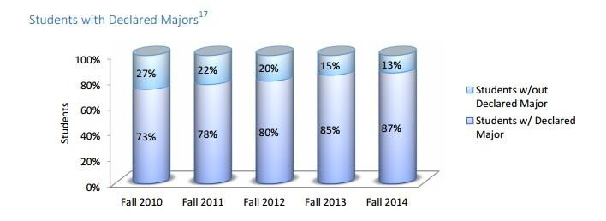

● This process will begin in phases. Students who have completed between 12-35 units at Moorpark College and listed “undecided/undeclared” as their major, with the help of the district information technology department, will be identified. These students will be notified via email of the different services and resources available on campus that can assist them in identifying a goal and ultimately they will develop a comprehensive educational plan.

● The Career Transfer Center (CTC) will take the lead on identifying and providing service to students who do not have a declared major, course of study, or identified goal. They will build the expectation for students to focus on a major, and they will contact undecided students via email. The CTC will:

o encourage students to attend workshops and participate in events such as:

▪ Choosing a Major Workshops

▪ Major Awareness Week

▪ Transfer Day

▪ Career Panels

▪ Job/Internship assistance

o encourage them to visit the CTC to complete specific interest inventories and electronic career assessment/interest tools to include on-ground and on-line opportunities such

as:

▪ Eureka

▪ Career Bridges

▪ Career Cruising

▪ California Career Café

▪ ONet Online

▪ Occupational Outlook Handbook

▪ What Can I do with this Major?

▪ CPP (SkillsOne Program)

▪ MBTI/Strong Inventory

▪ Kuder Journey

▪ Other career assessments

o Visit basic skills classes and English M01 classes to catch student at the beginning of their college career to assist in helping student select majors as well as reminding declared students to continuously re-assess their goals and majors as fields and requirements change.

o Offer career choice/explorations classes; specifically invite undeclared students to register for:

▪ Counseling M01 (Student Success)

▪ Counseling M02 (Career Development)

▪ Counseling M03 (Orientation to Moorpark College)

▪ Counseling M20 (Self-Paced Career Assessment)

o Interact with clubs and club activities to assist students to develop relationships in their fields and focus on goals and majors.

o Provide a specialized career exploration experience for students with 30+ units.

*Students without Abbreviated or Comprehensive Education Plans*

● New students missing an abbreviated ed plan (20% of new students) are contacted by the District within their first semester to notify them that they will need to complete all core SSSP services to maintain their priority registration.

● The first phase of the Comprehensive Ed Plan Completion project will target those undeclared students who have completed between 12 and 35 units at Moorpark College. The Counseling Department is the lead department which engages in collaborative efforts with other areas to address the needs of these at-risk students. The facilitator of this project will be the Counselor Assistants in both Counseling and the CTC, in coordination, to assist students in first selecting a major and then meeting with Counseling staff and then Faculty to prepare and complete the Comprehensive Ed Plan.

● The second phase of this process will focus on students who have declared majors but do not have current Comprehensive Educational Plans. In 14-15, this was 757 students. As in phase one, students with 12-35 units will be targeted and guided to begin working with DegreeWorks to build a Comprehensive Plan prior to meeting with a Counselor for discussion and approval. Phase two will be facilitated by the Counselor Assistant through the pre-approval stage of the Comprehensive Educational Plan, and then referred to Counseling Faculty for further discussion and Plan approval.

● In order to initiate contact with undecided students who require a Comprehensive Educational Plan, the GradesFirst software will be used to send email messages. Using GradesFirst allows the Counseling Department to target specific groups of students and will enable students to

schedule counseling appointments on their own. In the near future, GradesFirst will enable the

Counseling Department to use text messages to contact students.

● During the student’s individual and group counseling or workshop, counselors and counselor assistants access a variety of websites as teaching tools, such as csumentor.edu, the UC Transfer Admission Planner, and the CCC Transfer Counselor Website.

● Once completed, the counselor assistant shows the student how to access and begin to build the Student Educational Plan through their DegreeWorks account online.

● Students will then be referred to academic counselors to finalize a Comprehensive Educational

Plan.

*Students On or Nearing Probation Status*

● In 14-15 we had 3172 Academic and/or Progress Probation and 866 students in dismissal status. A total of 4038 or 28% of our population is in academic “at risk” status.

o Academic Probation is defined as a student who has attempted 12 or more units whose grade point average is below 2.0.

o Progress Probation occurs when more than 50% of all units attempted, results in grades

of “W”, “F,” “I,” or “NC.”

o Dismissal occurs when a student’s GPA falls below 1.75.

● Our focus will be twofold: intervention and a new focus on prevention.

INTERVENTION: Currently students on probation are required to attend a “Probation and Student Success (PASS) workshop if they want to take more than the unit limit proscribed by their level of probation status or meet with a counselor is they are on dismissal status.

While we have seen a dramatic increase in the number of students attending a PASS workshop (74% increase of students attending since the previous year), an inherent problem is that students who don’t want to take more units have no incentive to attend and can remain in probation limbo between 1.75 and 2.00 GPA indefinitely with little incentive to improve. We expect the implementation of registration priority loss after two semesters of probation to increase the interest in getting off probation status and we will aggressively disseminate this information to this group of students via email and GradesFirst.

o We will explore different models employed at other colleges to improve our ability to assist this population.

o We will consider requiring students on level 2 probation to take a Student Success class as part of any unit increase granted over the 6-unit limit and students on Dismissal to take a Student Success class before any additional units are granted.

o We will research and consider implementation of “hope theory” as part of our current

workshop and instructional model thus helping students develop appropriate strategies

toward a positive growth mindset instead of a fixed mindset. OnCourse theory implementation is another possibility.

o We will redesign our delivery model for our workshops, using this captive audience to

make sure these at risk students have declared goals and Comprehensive Educational

Plans as well as providing training in study skills and available campus services. We will explore the possibility of offering PASS workshops on-line.

PREVENTION: In addition to helping students to get off of probation/dismissal status, embracing the philosophy that it is easier to prevent a problem than correct it, Moorpark College will institute a “probation prevention” program aimed at keeping students nearing probation status from “falling over the edge”. We will target students who, after only one or two semesters, are close to losing good academic standing. This group is defined as those students with 12-30 units who have a GPA greater than 2.0 but less than 2.25. Currently, this represents a target group of 325 students.

o We will email and/or text students in this “danger zone” status with probation

information and consequences and available services that may assist them.

o We will invite students to attend PASS Workshops as a preventative measure.

o We will create an awareness program for all students in this “danger zone”.

o We will cross reference this group with students who may not have declared goals or majors or Comprehensive Educational Plans.

*Students Enrolled in Basic Skills Courses*

● Basic Skills students represent about 4% of the total student population.

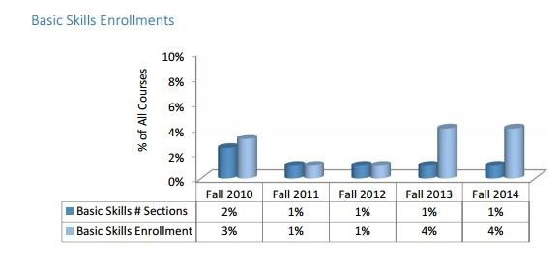

● Moorpark College’s Basic Skills Initiative embeds counseling and academic support in identified

sections of Math and English one level below transfer. Students self-select into these sections

with the understanding that there is additional support and requirements both in and out of class, forming cohorts, as noted in the schedule. Math, English, ESL, Counseling and Academic Support instructors meet regularly and attend local and regional BSI initiatives on effective programmatic, student development, and instructional practices. Counseling support includes brief in-class information sessions where students sign up to meet with the counselor to complete education plans and obtain individualized student assessment and referral to needed support services. Academic Support includes trained Supplemental Instruction Coaches that are also available for additional tutoring through the Math and Writing Centers. This cross- functional student services and instructional team works collaborative to develop students in terms time management, study skills, overcoming motivational setbacks, etc. A goal has been set to increase student success in these course sections by 10%. Baseline data was collected in

2006; the cohort sections are compared each yearn to the baseline data as well as the non- cohort sections at the same level within each discipline. This integrated systems cohort model has been consistently implemented and longitudinal data has been collected on its effectiveness. We will conduct similar activities during 2015-2016.

● While data from the State Chancellor’s Data Mart indicates that Basic Skills Students are primarily successful in moving onto a transfer level course, continued coordination with Student Success and Basic Skills Committees will ensure their numbers will improve in the next coming years.

|  |  |  |
| --- | --- | --- |
| MIS Data Mart | Fall 2014 and Spring 2015 | |
| Basic Skills Subject | **Total number of students** | **Success Rate** |
| **English (1 level below transfer)** | 595 | 76% |
| **Math (1 level below transfer)** | 799 | 63% |
| **ESL (2 levels below transfer)** | 73 | 83% |

*Students eligible for EOPS/CARE, CalWORKs, or ACCESS (DSPS)*

● Moorpark College students engaged in special categorical programs receive all the regular service the college offers as well as the additional orientation and special service offered by these programs. Student may engage in some or all of their counseling and follow-up services with these programs. Special targeted workshops are frequently part of the services students receive. As part of the campus community these identified “at risk” students will also be beneficiaries of all the additional services supported by SSSP funding.

b. How and when are students notified of these services? NOTIFICATION OF AVAILABLE SERVICES

● Students will be notified via GradesFirst campaigns, emails, and general announcements on news portals.

● As mentioned earlier, “just in time” orientation videos will serve as positive reminders for students to avail themselves of student support resources.

● Counselors assigned to target student populations like probation/dismissal, Basic Skills, undecided students, and students missing education plans will continue to implement strategies to improve student participation in coordination with other support services and discipline faculty.

c. Describe the service delivery method (in groups, workshops, etc.) and any technology tools used. SERVICE DELIVERY METHOD

• The service delivery methods outlined in the previous section included group counseling, workshops, scheduled appointments, Express/Drop-in, Counseling courses, and class presentations.

*Technology Tools*

● **GradesFirst** assists with emailing students within a target group and allows us to gather a group of students currently enrolled in a term. This program allows us to email specific target groups and allow them access to schedule their own appointments. Target groups can be searched easily and it gives us capability of searching students by major, GPA, units completed, and special populations. This product also allows counseling and Classroom Faculty the ability to email and text the student with necessary information. Another feature of this program is that

it gives counselors and counselor assistants the ability to easily communicate with student’s instructors. Finally, counselors are able to make appointments available for students in a specific population to schedule themselves.

● **DegreeWorks** is the tool used to create and house on-line Abbreviated and Comprehensive Education Plans. DegreeWorks allows both student and Counselor to have 24/7 on-line access to this information.

● **Banner** is the main college database and holds all student records that would control registration and house records. Banner is a tool that we use to also identify students by checking academic standings, how many units a student is limited to, transcripts, registration appointments etc. DegreeWorks is a tool used to help students plan their courses and monitor their progress. Counselors and Counselor Assistants can assist students with looking at this technology tool.

● We plan to utilize social media and create a phone APP enabling students to access educational planning tools at their convenience.

d. Are instructional faculty involved in monitoring student progress? Do they participate in early alert systems?

|  |  |  |  |  |  |
| --- | --- | --- | --- | --- | --- |
| INSTRUCTIONAL FACULTY INVOLVEMENT WITH AT-RISK STUDENTS  ● As in all areas, follow-up with at risk students at Moorpark College integrates discipline and support services faculty in sharing the responsibility for student success. We have a long history of using Early Alert notices to students. For many years this was done “in-house” and many Classroom Faculty participated with typically over 1000 notices sent each year.  ● With the implementation of GradesFirst, this will allow for the migration to an online Early Alert Program. It is the expectation that faculty will use GradesFirst as a positive and encouraging Early Alert systems to inform students of at-risk academic progress, suggest support services, and communicate with the Counseling Department regarding students in need of intervention. Faculty will also be able to make their schedules available for students.  Students will be able to make appointments with them during their office hours via GradesFirst online. Faculty will need to be trained on the functionality of GradesFirst before utilizing this technology to impact student success.  ● We plan to develop/implement a Faculty-Student Connections program to increase student support and engagement.  4. Complete the chart below outlining the staff providing follow-up services and the source used to fund the position. These staff listed below should match those in your budget plan. Additional lines may be added. | | | | | |
|  | **# of**  **FTE** | **Title** | **Role** | **Funding Source (SSSP/Match/GF)** |  |
|  | Counselors | Provide counseling to all students,  particularly targeting basic skills students, those on probation/dismissal, who are undecided, or missing education plans. | GF |
|  | Counseling Assistants | Providing para-professional counseling  services with a specific focus on educational goals, EdPlan completion, or probation intervention and prevention | SSSP |
|  | Technical Data  Specialist | provide technology support for follow-up  activities related to MIS Data | SSSP |
|  | Admissions & Reg  Tech | Evaluator who will review transcripts for equivalencies and input into DegreeWorks to support Education Planning | SSSP |
|  | Professional Experts | Create online videos of Probation  Workshops and website development for  Probation Services | SSSP |
|  | Research Assistant | Provide data analysis support for SSSP  follow-up activities | GF |
|  | Director of SSSP | Provides coordination of SSSP functions |  |

|  |  |  |  |  |  |
| --- | --- | --- | --- | --- | --- |
|  |  | Discipline Faculty | Provide mentoring/coaching to at-risk students through faculty networking/teams |  |  |
| 5. Complete the chart below outlining all other follow-up services related expenditures, including the direct cost to purchase, develop or maintain technology tools specifically for these services. These expenditures should correspond to those included in your budget plan. Additional lines may be added. | | | | | |

**F. Other SSSP/Match Expenditures**

|  |  |  |  |
| --- | --- | --- | --- |
| **Budget Code** | **Expenditure Title/Description** | **Funding Source (SSSP/Match/GF)** | **Amount** |
|  |  |  |  |
|  |  |  |  |
|  |  |  |  |

1. Describe any institutional research directly related to the provision and/or evaluation of SSSP services. List any related expenditures in the table below. These expenditures should correspond to those in your budget plan.

|  |  |  |  |
| --- | --- | --- | --- |
| **Budget Code** | **Expenditure Title/Description** | **Funding Source (SSSP/Match/GF)** | **Amount** |
| 2000 | Research Assistant | SSSP | 17,175 |
|  | Technical Data Specialist | SSSP | 10,611 |
| 3000 | Benefits- Research Assistant | SSSP | 7,919 |
|  | Benefits- Technical Data Specialist | SSSP | 5,492 |
|  |  |  |  |

2. List any match expenditures not previously accounted for in the plan. These expenditures may include Admissions and Records, Transfer and Articulation Services, Career Services, Institutional Research (unrelated to SSSP), instructionally funded tutoring and supplemental instruction costs for at-risk students. These expenditures should correspond to those in your budget plan.

|  |  |  |  |
| --- | --- | --- | --- |
| **Budget Code** | **Expenditure Title/Description** | **Funding Source** | **Amount** |
| 2000 | Dean/SSSP Coordinator | SSSP | 84,011 |
|  | Administrative Assistant to support  Dean/SSSP Coordinator and other SSSP  functions | SSSP | 11,176 |
| 3000 | Benefits-Dean | SSSP | 27,197 |
|  | Benefits- Administrative Assistant | SSSP | 5,205 |
| 1000 | Counselors | Match | 827,079 |
| 2000 | Counselor Assistants | Match | 79,102 |
|  | Admissions and Records | Match | 407,337 |
| 3000 | Benefits- Counselors | Match | 380,266 |

|  |  |  |  |
| --- | --- | --- | --- |
|  | Benefits- Counselor Assistants | Match | 37,872 |
|  | Benefits- Admissions and Records | Match | 209,362 |

**SECTION III. POLICIES**

|  |  |  |
| --- | --- | --- |
| A. | **Exemption Policy** |  |
| 1. Provide a description of the college or district’s adopted criteria and process for exempting  students from SSSP-required services in accordance with title 5 section 55532.  EXEMPT STUDENTS  ● Students may opt to exempt themselves from orientation, assessment, counseling, advising, or education plan development services if they meet one or more of the following criteria:  o has completed an associate degree or higher  o has enrolled at the college solely to take a course that is legally mandated for employment as defined in Title 5 section 55000 or necessary in response to a significant change in industry or licensure standard  o has enrolled at the college as a special part-time or full-time admit student pursuant to Education Code section 76001  ● Exempt students shall be notified that they may participate in SSSP services. Students who opt to exempt themselves from one or more of the services shall be advised that they will not receive priority registration that is granted to students who complete all of the services. To file for exemption, students would contact Admissions and Records or the Counseling Department for more information.  2. What percentage of your student population is exempt (list by category)? DATA FOR EXEMPT STUDENTS  ● In 14-15, there were 297 exempt students which accounts for almost 2% of the student population. | | |

|  |  |  |
| --- | --- | --- |
| B. | **Appeal Policies** |  |
| 1. Describe the college’s student appeal policies and procedures. If these policies are posted on the  college’s website, also provide the link below.  STUDENT APPEALS  ● The district and its colleges shall notify students of their right to challenge any alleged violation of the provisions of administrative procedure, and the steps required to do so. | | |

o (1) Challenges and complaints relative to this administrative procedure shall be submitted pursuant to the requirements of the district Student Grievance Process.

o (2) If a challenge contains an allegation that a college or the district has violated the

provisions of Title 5, section 55522(2), the district shall, upon completion of the challenge procedure established herein, advise the student that he or she may file a formal complaint of unlawful discrimination pursuant to subchapter 5 (commencing with section 59300) of chapter 10. Completion of the challenge procedure shall be deemed to be an effort at informal resolution of the complaint under section 59327.

● Information regarding student appeals for priority registration is found in the [College](http://www.moorparkcollege.edu/sites/default/files/files/apply-and-enroll/catalog/mc_15-16_catalog.pdf)

[Catalog](http://www.moorparkcollege.edu/sites/default/files/files/apply-and-enroll/catalog/mc_15-16_catalog.pdf). (excerpt listed below)

o Students who have lost registration priority due to having more than 90 earned degree-applicable units, or for being on probation for two consecutive semesters or dismissal, may appeal for reinstatement of their priority due to extenuating circumstance. The appeal must be supported by verifiable extenuating circumstances. Students who lose their registration priority due to their academic standing may appeal for reinstatement of that priority if they can demonstrate extenuating circumstances.

o Extenuating circumstances, for this purpose, are defined as:

▪ Accident

▪ Illness

▪ Other circumstances beyond the control of the student Extenuating circumstances must be supported by verifiable documentation; examples of such documentation include statements from doctors or hospitals, police or insurance accident reports. Approval will result in reinstatement of registration priority.

● Students on Probation or Dismissal can also appeal for an increase in unit load, continued registration or reinstatement. Information regarding these procedures can be found in the College Catalog (excerpt listed below):

o A student who is dismissed has the right of appeal. An exception to academic dismissal may be made only in the event of extreme and unusual medical and/ or legal circumstances that can be supported by evidence provided by the student, or in the event of improved scholarship. The petition for this purpose, Petition for Continued Enrollment or Readmission, is available in the Counseling Office.

o CONTINUED ENROLLMENT OR READMISSION: A student applying for continued enrollment or readmission must submit a petition to explain what circumstances or conditions would justify continued enrollment or readmission. A student applying for readmission shall not be reinstated until a minimum of one semester has elapsed after academic dismissal. A student who is petitioning shall receive counseling to assess his or her academic and career goals and must have counselor approval of his or her educational program prior to registration. The petition for this purpose,

Petition for Continued Enrollment or Readmission, is available in the Counseling

Office.

|  |  |  |
| --- | --- | --- |
| C. | **Prerequisite and Corerequisites Procedures** |  |
| Provide a description of the college’s procedures for establishing and reviewing prerequisites and  corequisites in accordance with title 5 section 55003 and procedures for considering student  challenges. If these policies are posted on the college’s website, also provide the link below.  PREREQUISITES AND COREREQUISITES REVIE  ● Determinations about prerequisites and co-requisites shall be made only on a course-by- course or program-by-program basis, including those establishing communication and computational skill requirements (per Title 55003(a) and (j) respectively).  A. Establishing Prerequisites and Co-requisites  In order to establish a prerequisite or co-requisite, the prerequisite or co-requisite must be determined to be necessary and appropriate for achieving the purpose for which it is being established (per Title 5 55003(b)(1)). Necessary and appropriate shall be understood to mean reasonably needed to achieve the purpose that it purports to serve: absolute necessity is not required (per Title 5 55000(h)). Prerequisites and co-requisites may be established only for any of the following purposes (per Title 5 55003(d)).  1. The prerequisites or co-requisite is expressly required or expressly authorized by statute or regulation; or  2. The prerequisite will assure that a student has the skills, concepts, and/or information that is presupposed in terms of the course or program for which it is being established, such that a student who has not met the prerequisite is highly unlikely to receive a satisfactory grade in the course (or at least one course within the program) for which the prerequisite is being established; or  3. The co-requisite course will assure that a student acquires the necessary skills, concepts, and/or information, such that a student who has not enrolled in the co- requisite is highly unlikely to receive a satisfactory grade in the course or program for which the co-requisite is being established; or  4. The prerequisite or co-requisite is necessary to protect the health or safety of a student or the health and safety of others.  B. Level of Scrutiny  The level of scrutiny required for establishing prerequisites, co-requisites, and advisories on recommended preparation are content review or content review with statistical validation (per Title 5 55003(a)). | | |

1. Content review is a rigorous, systemic systematic process conducted by discipline faculty that identifies the necessary and appropriate body of knowledge or skills students need to possess prior to enrolling in a course, or which students need to acquire through simultaneous enrollment in a co-requisite course (per Title 5 55000 (c )). At a minimum, content review shall include the following;

a) Careful review of the course including components such as course outline of record (COR) syllabi, sample exams, assignments, instructional materials, and/ or grading criteria

b) Using the CORs of both the target and proposed prerequisite course, identification of required sills/knowledge student must have prior to enrolling in the target course and matching those skills/knowledge to the proposed prerequisites course

c)Documentation that verifies the above steps were taken.

2. Statistical validation is a compilation of data according to sound research practices that shows a student is highly unlikely to succeed in the course unless the student has met the proposed prerequisite or corequisite (per Title 5 55003(f)). When this level of scrutiny is used, the college shall follow the guidelines specified in Title 5, 55003(g).

C. Exemption from Scrutiny

1. A prerequisite or co-requisite shall be exempt from scrutiny if it satisfies any of the following criteria (per Title 5 55003(e)):

2. It is required by statue or regulation; or

3. It is part of a closely related lecture-laboratory course pairing within a discipline; or It is required by a four-year institution; or

4. Baccalaureate institutions will not grant credit for a course unless it has a particular communication or computational skill prerequisite.

D. Curriculum Review Process

Each college’s Curriculum Committee is responsible for the curriculum review process, and its membership is determined in a manner that is determined by the college’s Academic Senate (per Title 5 section 55002(a0(1)). A college Curriculum Committee reviews and approves the establishment of prerequisites, co-requisites, and advisories on recommended preparation only upon the recommendation of the Academic Senate except that the Academic Senate may delegate this task to the Curriculum Committee without forfeiting its right or responsibility under Title 5 sections 53200-53204.

When content review is used to establish prerequisites or co-requisites in reading, written expression, or mathematics for degree applicable courses not in a sequence, the college Curriculum Committee will do all the following:

Provide training to Curriculum Committee members on the establishment of co- requisites/prerequisites

Inform faculty about regulations regarding the establishment of co- requisites/prerequisites using content review

Direct faculty to the college’s Office of Institutional Research to help with do the following: a) identify courses that may increase the likelihood of student success with the establishment of a prerequisite or corequisite; b) prioritize which courses should be considered for the establishment of new co-requisites or prerequisites; c) monitor any disproportionate impact that may occur based on the establishment of a prerequisite or co-requisite

Assure through communication with the college’s Executive Vice-President’s Office that prerequisite course, co-requisites courses, and courses that do not require prerequisites or co-requisites, whether basic skills or degree-applicable courses, are reasonably available.

1. Standards for Approval of Prerequisites and Co-requisites. A college’s Curriculum Committees will review the course outlines to determine if a student would be highly unlikely to receive a satisfactory grade unless the student has knowledge or skills not taught in the course. The course outline will be reviewed to determine if success in the course is dependent upon communication or computation skills, in which case the course shall require as prerequisites or corequisites eligibility for enrollment in associate degree credit courses in English and/or mathematics, respectively (per Title 5 55002(a)(2)(D) and (E). If a course requires pre-collegiate skills in reading, written expression, or mathematics, the college will do the following (per Title 5 55003(l)).

a. Ensure these courses and sections are offered with reasonable frequency

b. Monitor progress on student equity in accordance with title 54220 as follows:

The college will conduct an evaluation to determine if the perquisite has a disproportionate impact on student success.

Where there is disproportionate impact on any group of students, the college will, in consultation with the Chancellor President or designee, develop and implement a plan setting forth steps the district will take to correct the disproportionate impact.

2. Periodic review of Prerequisites and Co-requisites Using an appropriate level of scrutiny, the college will review all established Career and Technical Education (CTE) courses and program prerequisites, co-requisites, and advisories every two years to ensure they remain necessary and appropriate; all other established course and program prerequisites, corequisites, and advisories will be reviewed every six years (per title 5

55003(b)(4)).

E. Challenging Co-requisites and Prerequisites

Whenever a prerequisite and/or co-requisites courses are established, sufficient sections shall be offered to reasonably accommodate all students who are required to take the

pre- or co-requisite. A prerequisite and/or co-requisite shall be waived when space in the pre- and/or co-requisite course is not available (per Title 5 section 55003(m)). A student may challenge any prerequisite or co-requisite by submitting a challenge form at the time of registration to the Admission and Records/Records and Registration Office or other designee. The student will be enrolled in the requested class if space is available. The challenge will be reviewed and the student notified of the decision within five (5) working days per AP 5052. If the challenge is denied, the student will be dropped from the class and refunded all applicable fees (per Title 5 55003(o)).

Grounds for challenge are as follows (per Title 5 55003(p)):

1. The prerequisites or co-requisites have not been established in accordance with the

district’s process for establishing prerequisites and co-requisites

2. The prerequisites or co-requisites is in violation of Title 5 55003

3. The prerequisite or co-requisite is either unlawfully discriminatory or is being applied in an unlawfully discriminatory manner

4. The student has the knowledge or ability to succeed in the course or program despite not meeting the prerequisite or co-requisite

5. The student will be subject to undue delay in attaining the goal of his or her educational plan because the prerequisite or co-requisite course has not been made reasonably available.

**SECTION IV. PROFESSIONAL DEVELOPMENT**

Describe plans for faculty and staff professional development related to the implementation of SSSP.

PROFESSIONAL DEVELOPMENT ACTIVITIES

• *On Course Workshop*

o September 3-4, 2015 at Moorpark College

o The On Course Workshop is a highly experiential professional development event

designed to provide individuals with innovative strategies for empowering students

to become active, responsible and successful learners. These learner-centered strategies—representing best practices from innovators in higher education, business, psychology, sports and personal effectiveness—help students become full and active partners in their own education.

o Strategies presented in this workshop improve both student success and retention.

o Participants include faculty and classified staff working particularly with orientation,

assessment, and education planning.

o Survey will be administered to participants asking them to identify how they will utilize workshop information to impact core services of orientation, assessment, and education planning.

• *Project ALAS Regional Transfer Success Summit*

o Fri September 25-26, 2015 at CSUCI

o Sponsored by the ALAS (Aligning Learning and Academic Success) project to serve as a

venue for disseminating best practices information on engaging pedagogies and

facilitating discussion on effective instructional and high impact practices. Facilitating successful transitions in the regional transfer pipeline will be the primary focus of the Transfer Success Student Academy.

o Participants include faculty and administrators supporting orientation, assessment, and education planning.

o Survey will be administered to participants asking them to identify how they will utilize workshop information to impact core services of orientation, assessment, and education planning.

• *SSSP Coordinators Training*

o October 1-2, 2015 at Sacramento, CA

o Participants include SSSP Coordinator/Dean and Counselor assisting with revision of

SSSP Plan.

• *Strengthening Success Conference*

o October 7-9, 2015 at Oakland, CA

o Participants include faculty and administrators working with orientation, assessment,

and education planning.

o Survey will be administered to participants asking them to identify how they will utilize workshop information to impact core services of orientation, assessment, and education planning.

• *MBTI/STRONG Interest and Career Assessment Training*

o October 29-30, 2015

o Participants include faculty supporting educational planning.

• *Conference for Online Education SP 16*

**SECTION V. ATTACHMENTS**

The following attachments are required:

Attachment A, *Student Success and Support Program Plan Participants*. Please complete the form below of all individuals with their job title, who were involved with creating the SSSP Plan.

Attachment B, *Organizational Chart*. Please attach a copy of your colleges’ organization chart and highlight the Student Success and Support Program Coordinator’s position. Please include all positions that work directly in the program providing SSSP services, including those listed in the narrative above.

If your district has a district SSSP Coordinator in addition to the college SSSP Coordinator, or other district staff included in your plan, please attach a copy of the district organization chart and highlight the district SSSP Coordinator's position (if it is not identified as such on the chart).

Attachment C, *SSSP Advisory Committee*. Attach a list of the members of the college's SSSP Advisory Committee. This can be a list of individuals and their positions or simply the positions. If the committee is chaired by someone other than the SSSP Coordinator, please highlight the chair on the list of members, and identify the correct name of the committee, (advisory committee, coordinating council, steering committee, etc.). If the committee has standing or formalized subcommittees (e.g., SEP, orientation, budget, training, etc.), please list those also.

**Attachment A**

**Student Success and Support Program Plan Participants**

title 5 Section 55510 (11)(b) requires that the Student Success and Support Program Plan for each college "be developed in consultation with representatives of the academic senate, students, administrators, and staff with appropriate expertise." Please list the persons and their stakeholder group (e.g., Student Senate, Academic Senate, Curriculum Committee, etc.), of the individuals who participated in the development and writing of this Plan. Add more pages as needed.

|  |  |  |  |  |  |  |
| --- | --- | --- | --- | --- | --- | --- |
| ***STUDENT SUCCESS AND SUPPORT PROGRAM PLAN PARTICIPANTS*** | | | | | | |
|  | **Name** | |  | **Job Title** |  | **Stakeholder Group** |
| Allan |  | Abutin | IT Specialist |  | Assessment | |
| Traci |  | Allen | Counselor, Department Chair | | Faculty |  |
| David |  | Anter | Registrar |  | Student Success & Equity Committee | |
| Lori |  | Bennett | Excecutive Vice President | | Office of Student Learning | |
| Wendy |  | Berg | Counselor, CTC | | Faculty |  |
| Nenagh |  | Brown | History |  | Student Success & Equity Committee | |
| Christine | | Cole | Math Instructor | | Faculty |  |
| John |  | Cooney | District IT |  | MIS/Assessment | |
| Linda |  | Corrigan | Placement Project Specialist | | CalWorks | |
| Sherry |  | D’Attile | ACCESS Coordinator | | ACCESS |  |
| April |  | Demars | Classified Senate President | | Classified Senate | |
| Patricia |  | Ewins | Dean of Student Learning | | Student Success & Equity Committee | |
| Amanuel | | Gebru | Dean of Student Learning | | Dean’s Council | |
| Angie |  | Hernandez | Counselor |  | EOPS |  |
| Marisol |  | Hernandez | Counselor Assistant | | Counseling | |
| Kimberly | | Korinke | Financial Aid Coordinator | | Financial Aid | |
| Ashley |  | Lajoie | Counselor Assistant | | Counseling | |
| Gloria |  | Miranda | Counselor |  | EOPS |  |
| Donald |  | Munshower | Counselor, CTC | | Faculty |  |
| Inajane |  | Nicklas | Dean of Student Learning | | Dean’s Council | |

|  |  |  |
| --- | --- | --- |
| Lisa Putnam | Dean of Student Learning | Dean’s Council |
| Judith Ramos | ESL Instructor | Faculty |
| Ashley Rasmussen | President, Student Rep. | Associated Student Government |
| Mary Rees | Academic Senate President | Academic Senate |
| Trulie Thompson | Counselor | Faculty |
| Chelsea Vanicek | Student Representative | Associated Student Government |
| Helga Winkler | World Languages | Faculty |
| Obalid Yoonan | Student Services II | MIS/Assessment |

**Attachment B Organizational Chart**

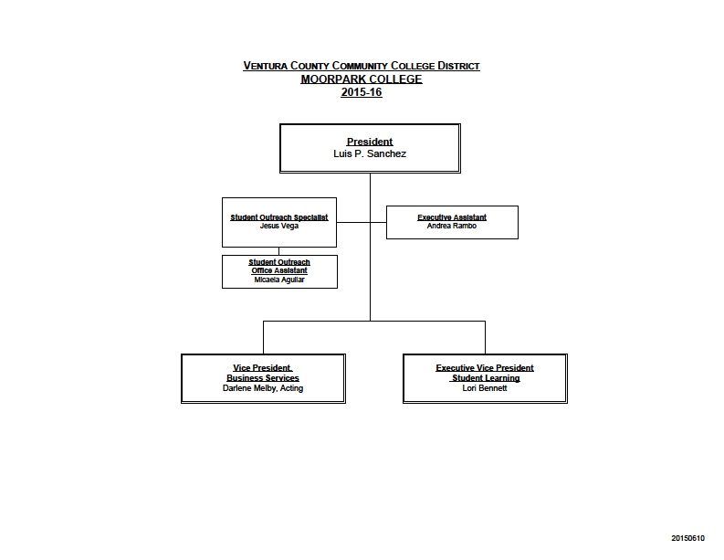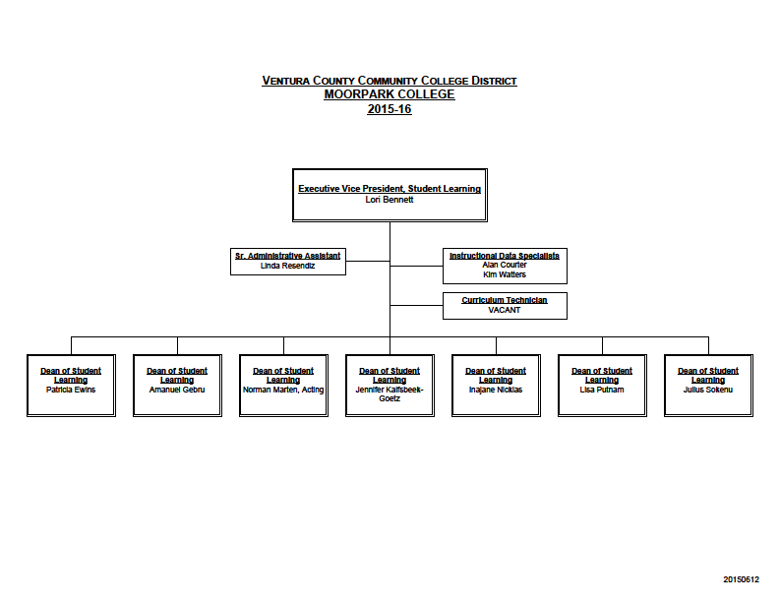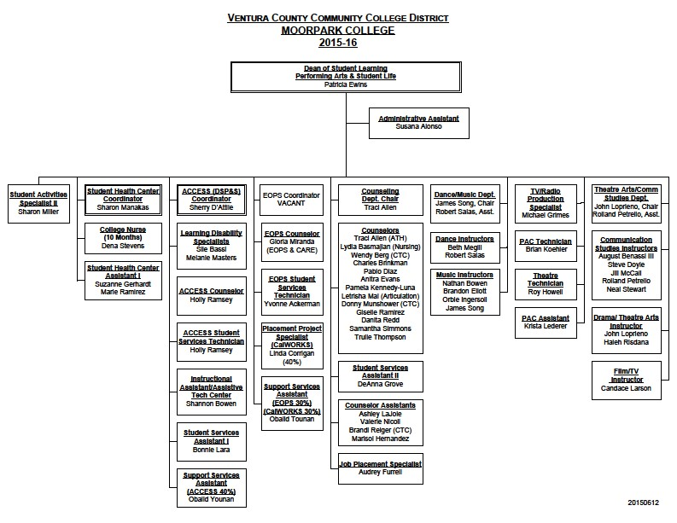

**DEAN/SSSP COORDINATOR**

**Attachment C**

**The following are 2015-2016 members of the Student Success and Equity Committee**

|  |  |  |  |  |  |  |  |  |
| --- | --- | --- | --- | --- | --- | --- | --- | --- |
|  |  | | **Divisions** | **Rep 1** | | **Rep 2** | |  |
| **Co-Chairs** | Beth Gillis-Smith, English |  | **Language & Information** | Diane Scrofano, English |  | Tracy Tennenhouse,  English |  |  |
| Patricia Ewins, Dean |  | **Math & Physical Sciences** | Cindy Reed, Math |  | David Mayorga, Math |  | Phil Abramoff , Math  Thanh Trinh, Math |
| **Deans** | Lisa Putnam, Dean  Co-chair Equity Sub group |  | **EATM, Health, & Life Sciences** | Carrie Geisbauer, Health  and Life Sciences |  | Rachel Messinger,  Anthropology |  |  |
| Amanuel Gebru, Dean |  | **Athletics, Arts & Institutional**  **Effectiveness** | Howard Davis, Athletics |  | Erika Lizee, Art |  |  |
| **Student**  **Services** | Trulie Thompson, Counselor  Co-Chair 3SP Sub group |  | **Performing Arts & Student**  **Life** | Jill McCall,  Theatre/Communication  Studies |  | Sharon Manakas, Health  Center |  | Sherry D'Attile, ACCESS  Sile Bassi, ACCESS |
| Pam Kennedy Luna, Counselor  Co-chair Equity Sub group |  | **Behavioral & Social Sciences** | Susan Kinkella, History |  | Nenagh Brown, History |  |  |
| Dave Anter, Registrar |  | **Business, Science, & Child**  **Development** | Tim Weaver, Business |  | Cynthia Sheaks McGowan,  Child Development |  |  |
| Jesus Vega, Outreach  Specialist |  | **Student Representative** | Chelsea Vanicek |  |  |  |  |

**ADDITIONAL INFORMATION**

Questions regarding the development of the college SSSP Plan may be directed to:

Mia Keeley

California Community College Chancellor's Office [mkeeley@cccco.edu](mailto:mkeeley@cccco.edu)

(916) 323-5953