New Faculty Orientation

Meeting Dates for 2017-2018
3:00-5:00 pm, location TBD
August 8
September 14
October 12
November 9
December 7*
January 11
February 8
March 8
April 12
May 10: Celebration!
2017-2018
Welcome to Moorpark College!
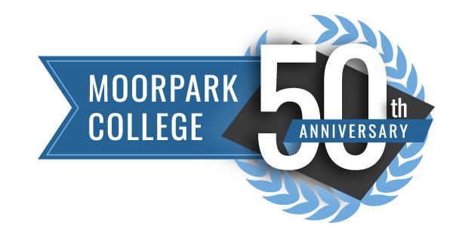

Loay Alnaji- Computer Information Systems
Adam Black- Kinesiology/Volleyball Coach
Katie Booth- English
Veronique Boucquey- Psychology
Tamarra Coleman- English
Brian Herlocker- Philosophy
Trevor Hess- Counseling
Melanie Klein- Sociology
Shannon Macias- Accounting
Vance Manakas- Athletic Director
Jenna Patronete- Communications
Roger Putnam- Geology
Wayne Snyder- Computer Network System Engineering

Course Objectives:
New Faculty will:

- Demonstrate through discussion and application the Students First mentality of our college community.
- Identify, discuss, and integrate in to the campus culture.
- Develop connections and professional relationships with members of the college.
- Develop professional collegiality.
- Develop knowledge and awareness of campus programs, services, and departments.
- Identify and discuss curriculum.
- Develop an appreciation of the teaching, leadership, and innovation responsibilities of full-time faculty members.
- Develop knowledge of classroom technology, alternative delivery, and availability of on-campus technological services and equipment.

Course Content:

- Interaction with the Moorpark College administration, classified staff, faculty, and students.
- Introduction to the Moorpark College governance structure.
- Introduction to Student Services, Instructional Support, and Student Life.
- Curriculum (Course outline development and revision, Student Learning Outcomes, program plans, accreditation).
- Pedagogical topics (teaching strategies, learning environments, classroom management, teacher- and student-centered learning).
- Classroom and on-campus access to technology (open labs, staff resource center, IT staff).
- Illustrate and discuss new faculty participants’ areas of specialty.

Typical Activities:

- Introduce staff, administrative, and service representatives to new faculty.
- Present and discuss academic programs and administrative procedures.
- Introduce faculty to curriculum procedures.
- Discuss and role-play classroom strategies and procedures.
- Schedule campus tours to feature facilities and their significance to students, campus employees and the community.
- Visit on-campus technological sites.

Questions, concerns?

Patty Colman 805-553-4736
Cell:818-642-6939
pcolman@vcccd.edu

Nils Slattum 805-553-4889
nslattum@vcccd.edu

