Moorpark College Guided Pathways
Fall 2018 Status Report
** DRAFT **

Program Mapping Design Team
- Focus and Mission for Design Team
- Create templates for programs to generate maps without locking them in
- Set clear pathway for classes with and without prerequisites to lead to a path to success
- Support electives to keep programs alive
- Have a resource (map) to make faculty better mentors
- Emphasize math and English requirements
- Create a tool for people (students and parents) to have an idea for what courses should be taken in order to make counseling appointments a more efficient process
- Results
- Developed worksheets for mapping certificates, AA degrees and transfer pathways
- Created a template that will be used for publication of maps online and in print (currently being edited for accessibility with screen readers)
- Presented GP Mapping Design to Academic Senate and Life Sciences Division
Meta-Majors Design Team
- Focus and Mission for Design Team
- Survey students regarding potential meta-major structures
- Develop framework to be presented to campus in early spring 2019
- Plan and hold y’all come event in early spring to finalize the placement of programs within the meta-major framework
- Results
- Surveyed roughly 200 students; 168 viable responses collected
- Framework draft to be completed in December meeting
Student Support Design Team
- Focus and Mission for Design Team
- Create flow-chart of student experience from pre-enrollment through graduation/transfer
- Analyze each “step” for potential gaps or barriers
- Results
- Rough flow-chart developed
- Discussion of Maslow’s needs being aligned with student support needs
- Developed draft of detailed steps for pre-enrollment; identified potential barriers for future
- Discussed creating an diagnostic needs assessment survey that would be mandatory for all new students upon completing their application which would then help us identify which students need help at what level and with which services. Additionally, if it could include some sort of career/major assessment type of questionnaire as well it could possible lead into the “meta-major” groupings in which we could align student service personnel to as support circles for each group.
Career and Educational Alignment Design Team
- Focus and Mission for Design Team
- Develop relationships with local area high schools
- Move dual enrollment programming to a pathways model, minimizing the offerings of stand-alone courses
- Results
- Developed relationships with Simi Valley Unified and Los Virgenes Unified
- Identified dual enrollment course offerings for spring 2019
- Developed strategic plan for dual enrollment course scheduling with the work of Simi Valley Consultant
- Next Steps
  - Coordinate with Math and English Departments to address AB705 needs in hopes that we can begin offering some pre-transfer-level courses at local high schools as part of Dual Enrollments
  - Coordinate with CTE workgroup to design career pathways with local area high schools
  - Collaborate with local area high schools to brainstorm data-sharing opportunities – particularly in sharing Get Focused/Stay Focused educational plans.

Meta-Major Survey Results: Fall 2018
Students were given the below examples and asked to rank them as most helpful to least (1 being most- 8 being least). The survey was completed by 168 students. About 40 additional surveys were incomplete, so I excluded them from the results. The students were provided 8 examples from the following schools:
Example A: Valencia College
-Arts, Humanities, Communication & Design
-Business
-Education
-Health Sciences
-Public Safety
-Science, Technology, Engineering, & Math (STEM)
-Social & Behavioral Sciences & Human Services

Example B: Cabrillo College
-Creative Arts & Design
-Science, Technology, Engineering, and Mathematics (STEM)
-Health and Public Service
-Entrepreneurship and Business
-Global and Human Studies

Example C: Mount Sac.
-Arts & Design
-Public Service & Social Science
-Plants & Animals
-Humanities & Communication
-Teaching & Education
-Health & Wellness
-Business Programs
-Science, Technology, Engineering, and Mathematics (STEM)

Example D: Pasadena City College
-Arts, Communication & Design
-Business & Industry
-Health Sciences & Wellness
-Liberal Arts
-Social & Behavioral Sciences
-Science, Technology, Engineering, and Mathematics (STEM)

Example E: Bakersfield College
-Health Sciences
-Business/Computer Sciences
-Public Safety
-Industrial Technology
-Math/Science
-Social/Behavioral and Human Services
-Arts/Humanities/Communication

Example F: Moorpark College Student
-Theater Arts
-Math/Science
-Technology
-Social Science
-Business/Law
-English/History
-Children

Example G: Moorpark College Student
-Art/Design
-Entertainment
-Humanities
-Physical Science
-Technology
-Business/Law
-Social Science

Example H: Moorpark College Student
-Science
-Humanities
-Arts
-Law
-Mathematics
-Teaching

Results
The group selected the most for number 1 was Example C (Mount Sac). Example A (Valencia College) was ranked most for number 2. Example D (Pasadena City College) was ranked most for number 3.
Example A: Valencia College was ranked 1,2, or 3 the most with 96 students listing it in the top three.
Example C: Mount Sac.: 87 students listing it in the top three.
Example D: Pasadena City College: 87 students listing it in the top three.
One question asked of students was: “What is something that would have helped you when you first started at Moorpark College in selecting your major?”
All the responses were reviewed, and the following categories were created:

- Early and more interaction with counselors
  - “Getting in touch with a counselor before choosing classes”
  - “More in depth time with counselors discussing what colleges to look into…I wish I had known these things when I first started and the counselors were more detailed in earlier discussion.”
  - “Immediately talking to a counselor
  - “Talk to someone”
  - “An automatic session with a counselor”
- Career exploration and understanding how majors/careers align
  - “Knowing which careers are associated with which degrees”
  - “Knowing more about each major in detail, what job opportunities, recommended degree requirements, salary, just general info”
  - Information about possible careers beyond the basic jobs everyone already knows about”
  - “career fair with booths and you could go around learning about different careers”
- Course Selection
  - “Clear requirements”
  - “Having someone help me pick my classes”
  - “A more clear layout of what I needed to transfer”
  - “being helped in finding which courses to take with my major”
  - “Knowing what classes to take…”
- Orientation course
  - “At another community college, it was recommended we take a counseling class as an intro to college. It was helpful.”
  - “Maybe take a mandatory class everyone has to take online that helps you pick the major”
  - “Having major workshops to show us different majors”
  - “Classes that help with which classes to take”
  - “A major orientation class, a short class that would explain the general list and career opportunities.”
  - “Maybe a class for people who are undecided.”
Notable finding:
- Almost all of the students who indicated nothing would have helped them since they already knew their major coming into MC were STEM students.

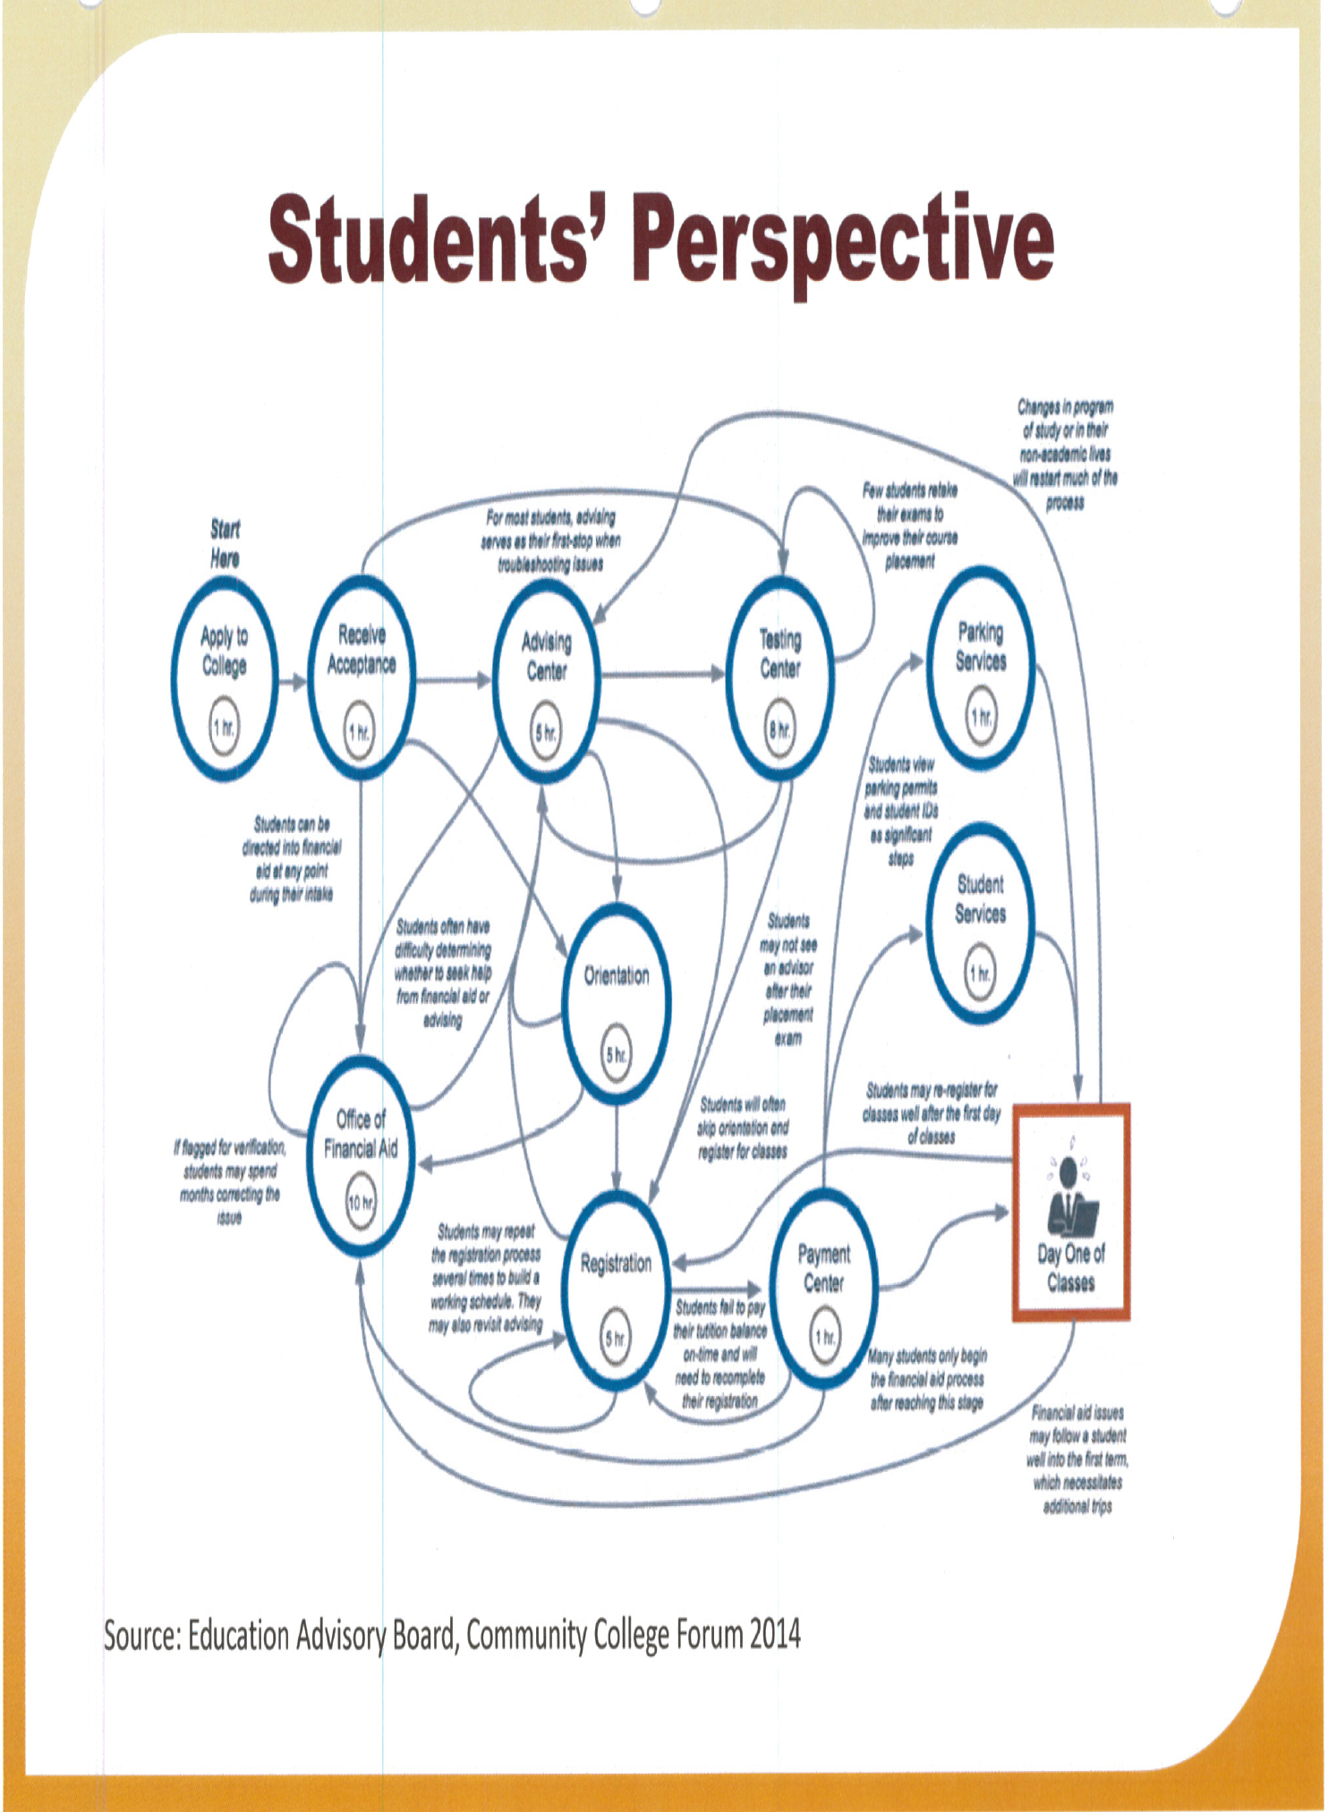

Student Support Design Team
September Meeting:
The student support design team began their first meeting discussing how we wanted to approach inquiring about where the barriers are in the student experience for our students. We discussed how to break down the different stages as a way to manage such a large task. We debated organizing the student experience into the 4 Guided Pathways pillars, into the My Nav segments (0-15, 15-30, etc.), or as new students, continuing students, returning students, etc. After lengthy discussion we decided to use the below chart as a guide, and we added our own bubble “Prior to Apply/Outreach” that would go first prior to the Apply to College bubble.

October Meeting:
We continued exercise to go through the various critical stages as outline in the above graphic and noted all barriers and sticking points for students. Through the dialogue and activity of these exercises, it was agreed we need to have a much deeper understanding/diagnostic form of understanding who are students are from the point of application to provide them the services they need. It is very evident students come in with different levels of basic support needs to a one stop system of what’s needed at “0-15” units is not necessarily the most effective strategy for supporting students as well as for being effective with our resources. For example, a high school 4.0 UCLA bound, third student in family to go to college does not necessarily need the same support as a first generation student with food insecurities and undecided on educational goals. While these are two very different students, many of our student support apply the same strategies ( ie: same orientation, workshops, communication, follow up) . It was suggested at this meeting number one priority would be to create some sort of online diagnostic basic needs assessment that would be required for all students to take upon obtaining their admission email. This would provide student support services with a follow up plan to provide the appropriate level of support and specific types of support students need to the right student. These results could feed into a way to categorize students into a high tough, med, low touch type of follow up system. This was the essence of how this design team can create a required student support related activity which would address equity by understanding different types of students need different types of strategies and interventions. Ideally, if career assessment type of questions could also be built into this same mandatory assessment it could provide students a suggestion into what would become our designed “meta-majors”. Additionally, it would be ideal to “assign” appropriate student services personnel to each “meta=major” as an assigned support circle for each group.

November Meeting: Cancelled.

