Academic Senate Goals for 2019-2020
These are the goals of the Academic Senate Council as ranked by vote of its senators, combining ideas gathered at the AS General Meeting on August 16 and at the AS council meeting on September 3. Council appreciates that 90% of its time will be spent on the usual tasks of reviewing AP/BP’s, examining initiatives and plans, carrying out faculty prioritization, and the like. These are the action items it will focus on for the remaining 10% of the time that it can dedicate to tasks of its choosing.
1. Strengthen the Academic Senate role in enrollment planning and growth
2. Finalize “normal” (compressed) calendar discussions within the VCCCD
2. Ensure continued faculty leadership in the development of Guided Pathways towards its initial implementation for Fall 2020
4. Increase proportion of full-time faculty at Moorpark College in relationship to the VCCCD Faculty Obligation Number
5. Continue and expand emphasis on campus safety
6. Continue building and practicing integrated processes for planning
7. Increase the faculty voice in building and operationalizing dual enrollment
8. Strengthen support of adjunct faculty within the Academic Senate’s academic and professional purview

Academic Senate Goals for 2019-2020
Please rank each AS Goal for 2019-2020 from 1 to 8, with 1 being the most favored and 8 being the least favored. (15 responses)
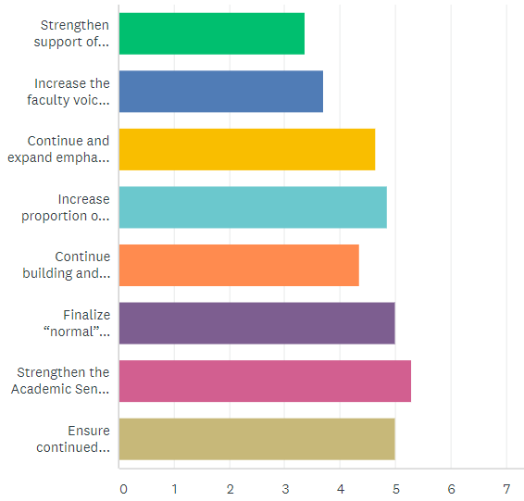
9.3%

10.2%

12.8 %

13.4%

12.0%

13.8%

14.63%

13.8%

1.

2.

3.

4.

5.

6.

7.

8.

1. Strengthen support of adjunct faculty within the Academic Senate’s academic and professional purview
2. Increase the faculty voice in building and operationalizing dual enrollment
3. Continue and expand emphasis on campus safety
4. Increase proportion of full-time faculty at Moorpark College in relationship to the VCCCD Faculty Obligation Number
5. Continue building and practicing integrated processes for planning
6. Finalize “normal” (compressed) calendar discussions within the VCCCD
7. Strengthen the Academic Senate role in enrollment planning and growth
8. Ensure continued faculty leadership in the development of Guided Pathways towards its initial implementation for Fall 2020

