Moorpark College Guided Pathways Update November 19, 2019
Program Mapping:
- Program maps are being generated by teams of 1 counseling faculty and 1-2 discipline faculty
- Maps are being made for Associates degrees, CSU/ADT and the UC campus where most Moorpark students apply and transfer; some disciplines are also making maps for certificates
- 45 out of 49 Programs are drafted or are in the process of being drafted
- Vetting of maps:
  - GP Program Mapping Design Team has been looking over some of the maps and has recommended both specific and general changes. Some updates include: including transfer application deadlines, recommending COMM M01 on most UC maps to give students flexibility to transfer to CSU, including links to the TAG and Honors programs on UC maps
  - Counseling faculty during in-service days in December and January
  - Maps will be reviewed by Consultation Council (President, VPs, AS and Cl.S. Presidents)
  - After vetting, maps will be posted.
- Faculty have flexibility to recommend GEs, but students are able to choose many of their GE courses. Maps will include a hyperlink to the portal.
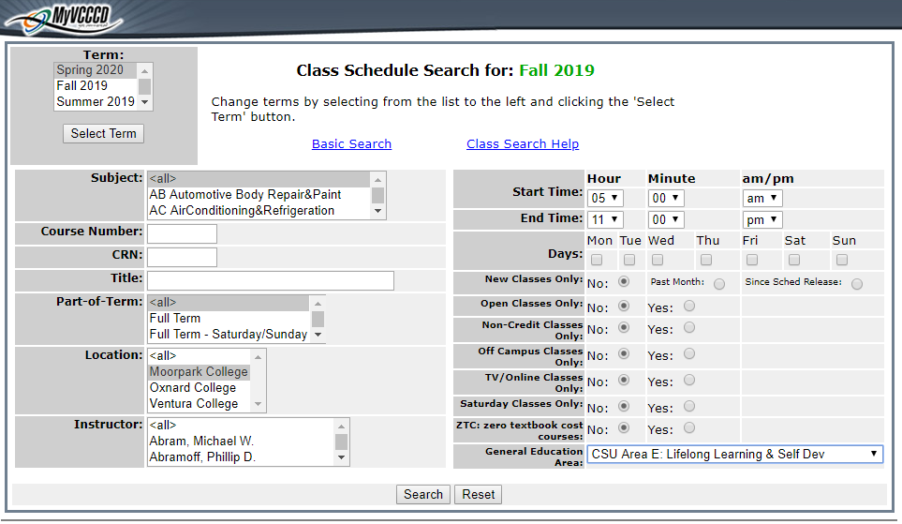

Areas of Interest:
All programs have been organized into 1 or 2 areas of interest. Branding is being developed for these areas. The landing page on the VCCCD website will have a link to access these which will read:
I’m interested in……Explore All Programs

Onboarding/Student Support:
- The Design Team has been looking into data analytics to help specifically tailor information and support to students most in need of particular services such as counseling, mentoring, tutoring, and transportation. Possible technologies to identify students in need of support include Starfish (currently being used by counseling) and MyPath. MyPath is software provided by the state and is used in the application process. Specific simple yes/no questions can be added to the application.
- A workgroup is meeting to focus on improving Onboarding process for local feeder high school seniors including revamp of how we do Preview Days, Application workshops, Raider Registrations, etc
- Looking at Student Success Team models aligned with 8 Areas of Interest as a way to provide case management support/data review, etc

Dual Enrollment
The Dual Enrollment facilitator position has been advertised. The Facilitator will be overseeing the Dual Enrollment Advisory Workgroup and will be developing a handbook to help instructors who teach high school students.

Professional Development:
It will be important for all faculty and staff to be familiar with Guided Pathways so they can support students during implementation. Upcoming:
- Annual Strategic Planning Retreat
- District-wide summit
Scale of Adoption Self-Assessment: AS council Jan. 21 and Feb. 4, certification due March 1

