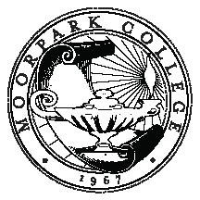

MOORPARK COLLEGE

Committee on Accreditation and Planning – Education

Responsible to plan, monitor and evaluate the college-wide educational master planning process: Annual Program Planning ~ Educational Master Plan ~Accreditation Self-Study Process Implementation

GOALS
2013-2014
# | GOALS | ACCOMPLISHMENTS
1 | Evaluate our program planning process
2 | Accreditation: Review accreditation standards and conduct a gap analysis
3 | Become informed about Student Success Scorecard & Institutional Goals/Benchmarks
4 | Create timeline for the full accreditation report in 2016
5 | Address Midterm Report response, if applicable

Approved 5/16/2013

