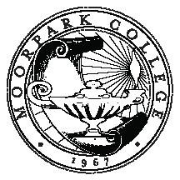

MOORPARK COLLEGE

Faculty Development Standing College Committee

Charter: The Faculty Development Committee makes recommendations on the direction of professional development activities for full-time and part-time faculty.
GOALS
2012-2013
# | GOALS | ACCOMPLISHMENTS
1 | Create, market, implement, and assess development opportunities appropriate to new, continuing, and seasoned faculty, as well as continuing technology training services.
2 | Create and implement an online repository for development resources that is easily accessible.
3 | Facilitate effective transition of New Faculty Orientation facilitator from the oversight of the Faculty Development Committee to that of the college President’s office.
4 | Administer Travel Funds dispersal fairly and efficiently
5 | Continue to assess faculty training and development needs of faculty on a regular basis.
6 | Develop creative training and development opportunities meet assessed needs.

