MLA
moorparkcollege.edu/writingcenter

Getting Started
Style
- Times New Roman, font size 12
- Double-Spaced
- 1-inch Margins
- Running head with last name page number in the top, right corner
Example: Jones 1
Formatting the first page:
- The first page starts with the running head in the top, right corner.

- Next, the following information should be given left-justified, on the top, left side of the page, with each component on a separate line.
First Name Last Name
The Professor’s Name
The Class
The date is written day month year
Example:
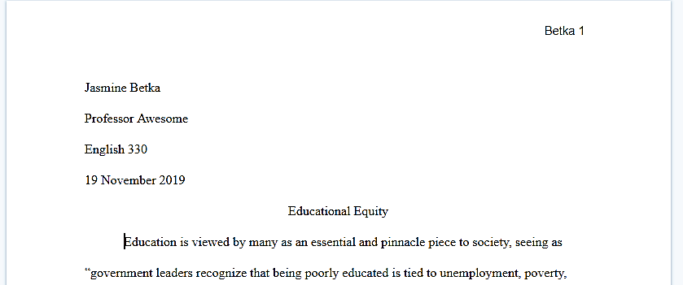

Stephanie Jones
Professor Awesome
English M01A
27 September 2019

- The title is centered above the first paragraph

- All information should be double-spaced with no extra spaces

In-text Citations
In-text citations are used to give credit to ideas and information that is not your original thought or common knowledge.
Do I need to cite it?

- Is it common knowledge like who the President is?
  - Do not cite it.
- Is it an original idea or thought?
  - Do not cite it.
- Is it a direct quote?
  - Cite it!
- Is it a figure, chart, or image that you used?
  - Cite it!
- Is it a summary of something?
  - Cite it!
- Did you paraphrase something?
  - Cite it!

In-Text Citations:
The first time introducing a source, the author’s name should go in a signal phrase. A narrative citation establishes the source’s authority.
Example:
- University California Los Angeles’s public health researcher Ronald Hays explains…
- Historian Barbara Tuchman makes the point that…
After this, the author’s name can go in the parenthetical citation or within the sentence. The page number always goes in parenthesis at the end of the sentence before the period.
One Author:
Example:
- In Educational Governance for the Twenty-First Century by Patrick Mcguinn, Mcguinn expresses how with less federal requirements and oversight, “states are likely to respond by devoting less effort and resources toward improving schools” (407).
- Some believe that with less federal requirements and oversights, “states are likely to respond by devoting less effort and resources towards improving schools” (Mcguinn 407).
Multiple Authors:
Two Authors: Use both of the author’s names separated by and
Example:
- In accordance with Watkin and Wilber’s delineation of personal perspective regarding a problem, the dimension that humans operate in can affect the ability to solve wicked problems (30).
- Furthermore, “the interconnected nature of the causes and symptoms also means that binary ‘right’ and ‘wrong’ assessments are impossible” (Watkin and Wilber 43).
Three or more authors:
List the first author’s name and replace the other names with et al.
Example:
- Morris et al. go on to explain how, without proper certification, schools cannot hire certain professionals because they will not pass the federal audit process (136).
- For instance, under federal law, it is required that teachers are “highly qualified” (Morris et al. 135).
No known Author:
For no known author, use a shortened title or what comes first on your works cited page.
Example:
  - “Educational Structures” goes on to argue that federal regulations increase national performance (18).
  - Federal regulations influence national performance (“Educational Structures” 18).
Internet Source:
For internet sources, there will often not be a page number to include. Give enough information for the reader to be able to find your source on your works cited page.
Example:
  - “Education Today” states that “school across the country vary in equitable funds.”
  - A primary concern for educational equity is that “schools across the country vary in equitable funds” (“Education Today”).
Works Cited
General Rules:
- Start the works cited page on a new page
- Continue with double-spacing, but do not add extra spaces between sources
- Continue with a header

General Template:
- Author.
______________________.
- Title of Source.
______________________.
- Title of the Container,
______________________,
- Other Contributors,
______________________,
- Version,
______________________,

- The first line of an entry should have a 1 inch margin, and subsequent lines within that entry should be indented an additional .5 inch to create a hanging-indent
- Alphabetize your entries

- Number,
______________________,
- Publisher,
______________________,
- Publication Date,
______________________,
- Location.
______________________.

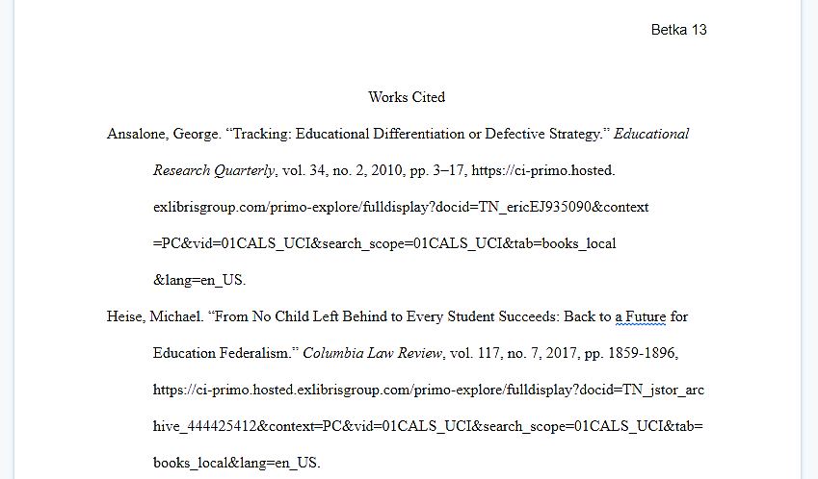
Citation Steps:
Book:
- 1 Author-
Last Name, First Name. Title of Book. City of Publication, Publisher, Publication Date.
- 2 Authors-
Last Name, First and Last Name, First. Title of Book. City of Publication, Publisher, Publication
Date.
- 3 or more Authors-
Last Name, First, et al. Title of Book. City of Publication, Publisher, Publication Date.
Electronic Sources:
Author. "Title." Title of container (self contained if book), Other contributors (translators or editors), Version (edition), Number (vol. and/or no.), Publisher, Publication Date, Location (pages, paragraphs and/or URL, DOI or permalink). 2nd container’s title, Other contributors, Version, Number, Publisher, Publication date, Location, Date of Access (if applicable).
No Author:
If there is no author, use the title as the first piece in your citation.
“Title.” Title of the Container, Other contributors, Version, Number, Publisher, Publication Date,
Location.

Having trouble with formatting? Try these tips for Word:
- Go to the ‘View’ tab at the top of the page
- Make sure that you have ‘Ruler’ selected so that you can see the ruler around your page
- Select the text on your reference page
- The ruler on the top of the page has two triangles. They should be lined up at this point. Drag the bottom triangle over .5 inch. This should format your subsequent lines over to a 1.5 inch hanging indent.

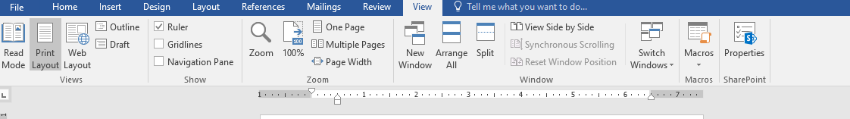

Containers:
MLA uses containers to cite information. A container is the larger whole that holds a source. Containers are like nesting dolls; they are smaller pieces inside of bigger pieces.
Common examples include:
A short story inside of a book
An article inside of a database
An article inside of a magazine
Common Template for Multiple Containers
# | Core Elements | What are they?
1 | Author. | Last, First
2 | Title of source. | “ “ if short story or article, or Italics if book
3 | Title of container, | Is this part of a larger whole?
4 | Other contributors, | Look for words like introduced by, narrated by, translated by
5 | Version, | Is this an edition?
6 | Number, | Is this from a multi-numbers set?
7 | Publisher, | Who produced this? Ex. Penguin Press
8 | Publication date, | Write the full date as you find it on the version you are using
9 | Location. | Page numbers signified pp. #-# or the DOI or URl if there is no larger container
3 | Title of Container | Is this part of an even larger whole?
4 | Other contributors | Look for words like introduced by, narrated by, translated by
5 | Version | Look for words like introduced by, narrated by, translated by
6 | Number | Is this from a multi-numbers set?
7 | Publisher, | Who produced this? Ex. Penguin Press
8 | Publication date | Write the full date as you find it on the version you are using
9 | Location. | Is there a doi/URL or was this located in a place?

An example of an article in a database:
# | Core Elements | What are they?
1 | Author. | Smith, Bob
2 | Title of source. | “How to Cite MLA”
3 | Title of container, | The MLA Review
4 | Other contributors, | NA
5 | Version, | NA
6 | Number, | vol. 8, no. 1
7 | Publisher, | NA
8 | Publication date, | 2015
9 | Location. | pp. 67-75
3 | Title of Container | EBSCO
4 | Other contributors | NA
5 | Version | NA
6 | Number | NA
7 | Publisher, | NA
8 | Publication date | NA
9 | Location. | www.EBSCO/578357

Smith, Bob. “How to Cite MLA.” The MLA Review, vol. 8, no. 1, 2015, pp. 67-75. EBSCO,
www.EBSCO/578357.

