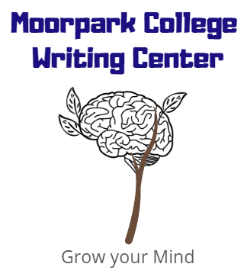
Top 5 Errors
moorparkcollege.edu/writingcenter
Top Five Errors: These are some of the most common errors made by writers. Learn about how to avoid them in future writing.

- Passive Voice:
When the subject is placed in an object position
No: There was a job that was offered to me.
Yes: The company offered me a job.
Yes: I received a job offer.

Detect by looking for “be” verbs (is, are, were, was, am). Solve by making the person, place, thing, or idea that does an action the subject of the sentence (put sentence into the active voice).

- Run-On Sentences:
When two independent clauses join without conjunctions or punctuation.
No: I began as a telephone sales person later I promoted to become a store manager.
Yes: I began as a telephone salesperson, but later I became the store manager.
Yes: I began as a telephone sales person; later, I became the store manager.
Yes: Although I began as a telephone salesperson, later I became the store manager.

Correct a run-on sentence through one of these methods: (1) use a coordinating conjunction (such as and or but) with the comma, (2) use a semicolon (or semicolon and transitional word), (3) turn the single sentence into two sentences, or (4) use subordination to make one independent clause into a dependent clause.

- Comma splice:
When two independent clauses join with only a comma (no coordinating conjunction, such as and or but).
No: John plans to attend college, first he must finish his military service.
Yes: John plans to attend college, but first he must finish his military service.

Correct a comma splice error the same way as a run-on.

- Mixed Sentences/ Construction (faulty predication):
A mixed sentence begins with one idea, but it moves on to another idea. It also may use a stream of incomplete phrases.

Mixed due to faulty predication
No: During my work at the hospital was very challenging for being calm under pressure.
Yes: My work at the hospital challenged me to be calm under pressure.
No: Thinking about my future, a career in medicine matched my desire to be of service.
Yes: As I thought about my future, I realized that a career in medicine matched my desire to be of service.

- Subject-Verb Agreement:
Subjects and verbs must agree in number. Be sure you know which noun is the subject of the sentence and make sure the verb agrees with it.

Subject-Verb Agreement
No: The sound of the pounding waves beckon. (The underlined prepositional phrase modifies/describes sound, so waves is not the subject. Sound is the subject
Yes: The sound of the pounding waves beckons.
No: My goals for the new semester is to learn to ask for help and to stop procrastinating.
Yes: My goals for the new semester are to learn to ask for help and to stop procrastinating.
Practice

- Correct the Following Run-On and Comma Splice sentences

I love grammar it teaches me how to write correctly.

I love grammar, it teaches me how to write correctly.

- Turn this passive sentence into an active sentence

The test was given to me by the teacher.

- Clarify the mixed sentence

Considering that I want to get a good grade, a job at a good company would be desirable.

