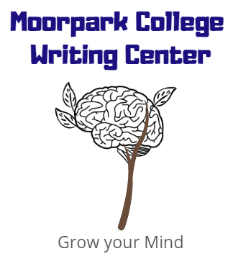
How to Write an Essay
moorparkcollege.edu/writingcenter
Here are some tips and templates to help you get started:
- Brainstorm!
  - Try to get your ideas down by whatever method works for you (freewriting, listing, clustering, mapping, drawing, talking, etc.)
  - Start to form your main idea and sub-points
  - If you need to do research, start researching your topic
- Decided how to arrange your body paragraphs
  - Time: Chronological order or Sequential order
  - Location
  - General to Specific
  - Specific to general
  - Least important to most important
  - Problem to solution
- Develop a working thesis statement
- Outline
- Start your introduction
- Draft each body paragraph
What is in an introduction?

What is in a body paragraph?
What is in a conclusion?
Restate the thesis in a new way.
Remind the reader of your main points and what you wanted them to know.
End on a big idea that is memorable, a call to action, or why this topic matters.
Brainstorm:

Outlining process:
Questions to help you with an outline:
What is your thesis?
How do you plan on arranging your paragraphs? Ex: Time, location, general to specific, problem to solution
Order your ideas:
Body paragraph 1:
Body paragraph 2
Body paragraph 3:
Body paragraph 4:
What kind of connections do you see?
What other information will you need?
Thesis: Fake news is bad.

Body Paragraph Outline
- Topic Sentence:
- Context Transition:
- Evidence/Examples/Quotation:

- Analysis:

- How does this example connect to the next piece of evidence?
- Evidence/Examples/Quotation:

- Analysis:

- How does this all come together and lead to the next paragraph?

