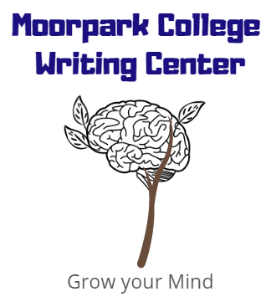
Poetic Devices
moorparkcollege.edu/writingcenter
Common Poetic Devices
- Allegory: A story, poem, or other written work that can be interpreted to have a secondary meaning.
- Alliteration: The repetition of sound or letter at the beginning of multiple words in a series.
- Allusion: An indirect reference to something.
- Assonance: The repetition of a vowel (vowels) in one or more words found close together.
- Blank verse: Is poetry written without rhyme, particularly poetry that is written in iambic pentameter.
- Consonance: The repetition of consonant sounds close together.
- Couplets: A pair of lines in poetry.
- Diction: The choice of words and style of expression that the author uses.
- Enjambment: Is the continuation of a sentence beyond a line break, couplet, or stanza without a pause.
- Hyperbole: An exaggerated statement that is not meant to be taken seriously.
- Iambic pentameter: Is a specific type of meter that contains five iambic feet (iambic foot=unit of rhythm), which consists of one unstressed syllable followed by one stressed syllable.
- Irony (basic): When something said does not match the true meaning.
- Irony (situational): It can be described as an unexpected event that occurs, and the result often creates dark humor.
- Metaphor: The author compares one thing to another.
- Meter: The rhythm of a poem.
- Ode: A short, lyrical poem that is often used in honor or praise of something.
- Onomatopoeia: Words that describe its sound, like boom or moo.
- Personification: An animal, plant, or inanimate object is given human-like characterizations.
- Pun: A play on words used to make a joke.
- Repetition: The process of repeating certain words or phrases.
- Rhetorical question: Used to make a point rather than elicit an answer.
- Rhyme: The repetition of syllables at the end of words.
- Rhythm: The pattern of long, short, stressed, and unstressed syllables in writing that create a “sound.”
- Simile: A comparison of one thing to another using like or as.
- Sonnet: A strict fourteen-line poem that usually follows iambic pentameter.
- Stanzas: Poems can be broken up into stanzas, which are a group of lines. Although stanzas can be irregular, they often have common features like length, rhyme, or rhythm.
- Tone: The attitude or perspective of a writer towards a specific subject or audience. For example, the author can take a humorous or solemn tone.
Citing Poetry
- Less than three lines: “line/line/line” (Author line #-#).
Example: The poem goes on to say “And his big hairy paws/
In the buttery dish” (Silverstein lines 11-12).
- If the lines extend to a new stanza, use a //: “Line/Line//line” (Author line #-#).
Example: Hughes directs the reader to think about deferred dreams, and he asks “Does it dry up/Like a raisin in the sun?//Or fester like a sore—“ (lines 2-4).
- If citing more than three lines, use a block quote and maintain the original structure.
Example: Hughes uses imagery to give a dream emotion:
What happens to a dream deferred?
Does it dry up
Like a raisin in the sun?
Or fester like a sore--
And then run?
Tips for analyzing poetry
What do you think about the title?
Read the poem.
Reread the poem.
What is your initial reaction/thoughts?
Who is the narrator?
What is the mood or tone? How does it make you feel?
What is the message?
Reread the poem. Make sure to make annotations and write down questions or reactions.
What structure is it in? Does it rhyme? Is it freeform?
How does diction create images? Does the author appeal to the senses?
Are there any symbols?
How does the author’s background contribute to the message?
What is the message or significance of the poem? How is it conveyed?

Getting started on a thesis:
What is the message/purpose?

How is it conveyed? What elements/devices are used?

