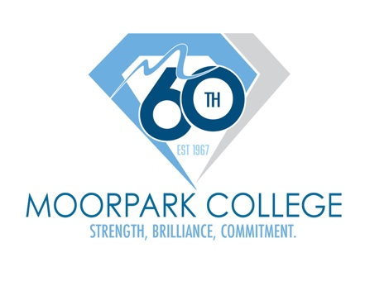
FOR IMMEDIATE RELEASE

Moorpark College Awarded Grant to Lead 9/11 Day Service Project Benefiting U.S. Service Members
Student Day of Service joins a nationwide movement to transform the 25th anniversary of 9/11 into the single largest day of doing good in American history

MOORPARK, Calif. (Aug. 28, 2026) — To honor the 25th anniversary of 9/11, Moorpark College is joining a nationwide movement to transform the anniversary into America's Day of Doing Good, reclaiming September 11 as an annual moment of national reflection, unity and action. Funding received through the 2026 9/11 Day Grant Program, administered by the nonprofit 9/11 Day in collaboration with AmeriCorps, will support a Student Day of Service hosted by Moorpark College and the Moorpark College Foundation on Wednesday, September 16, 2026.
The 9/11 Day Grant Program is a $3 million grant program to support community-led service projects by and for students across the nation commemorating the 25th anniversary of 9/11. These events aim to bring people together across political, geographic, generational and cultural lines to address urgent local needs while educating participants about the lasting legacy of service inspired by that day. Funding for this grant program is provided by AmeriCorps and the Popeyes Foundation.
With more than 100 million Americans now having little or no personal memory of September 11, 2001, local service projects help ensure future generations remember not only the tragic events of that day, but also the extraordinary compassion, courage, selflessness and spirit of unity that emerged in its aftermath.
The Moorpark College Student Day of Service, is taking place on September 16, 10 a.m. and will bring together more than 100 volunteers to assemble care packages for active-duty U.S. military personnel deployed overseas, benefiting service members through a partnership with ForTheTroops.org.
The event will also feature a Tribute Walk, inviting students, faculty and staff to reflect on the events of 9/11, as they follow a campus path, guided by commemorative decals and interpretive signage highlighting the timeline of the day, honoring those who lost their lives and recognizing the resilience, courage and unity that emerged in its aftermath.
“The 25th anniversary of 9/11 offers a profound opportunity to honor those we lost, the survivors, and the brave first responders who rose in service by stepping up to help our neighbors,” said Dr. Julius Sokenu, president of Moorpark College. “By bringing our campus community together to serve others and express our gratitude to those serving our nation, we are demonstrating the power of collective action to strengthen communities, bridge differences and inspire civic responsibility. We are proud to stand with communities across America in turning this day into America's Day of Doing Good through meaningful, lasting action.”
In addition to the Student Day of Service, Moorpark College will host a Tribute to Those Lost on September 11 on Friday, September 11, 2026, at 10 a.m. at the Moorpark College Campus Flagpole. The campus community is invited to gather for a solemn ceremony honoring the nearly 3,000 lives lost during the terrorist attacks of September 11, 2001, while recognizing the courage and sacrifice of first responders and all those who answered the nation's call in the years that followed.
Together, the events will honor the past, serve the present and inspire the next generation of civic leaders through remembrance, gratitude and meaningful community engagement.

About Moorpark College
Moorpark College is one of three colleges in the Ventura County Community College District and annually serves more than 18,000 students. Founded in 1967, Moorpark College is fully accredited and has the highest six-year completion rate within the California Community College System. An Aspen Institute Top 10 Finalist for 2023 and 2025, Moorpark College has also been named a 2020 Champion of Higher Education by The Campaign for College Opportunity for the Associate Degree for Transfer Pathway. It is also a designated Hispanic-Serving Institution. The college’s signature career/technical programs include nursing, radiologic technology, biotechnology, and cybersecurity. The college’s America’s Teaching Zoo is the only associate degree animal care and training program in the country. To learn more, visit MoorparkCollege.edu or follow @MoorparkCollege on social media.

About the 9/11 Day Grant Program & AmeriCorps Support
Founded in 2002, the nonprofit 9/11 Day led the successful effort to establish September 11 as a federally recognized National Day of Service and Remembrance. Each year, tens of millions of Americans observe the day by performing good deeds in honor of those who perished, were injured or sickened; the survivors; the first responders; and all who rose to serve in the aftermath of the September 11, 2001, terrorist attacks. Learn more at 911day.org.
Media Contact:
Debi Klein
dklein@vcccd.edu
805-553-4760

