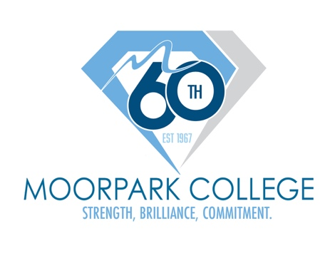
FOR IMMEDIATE RELEASE

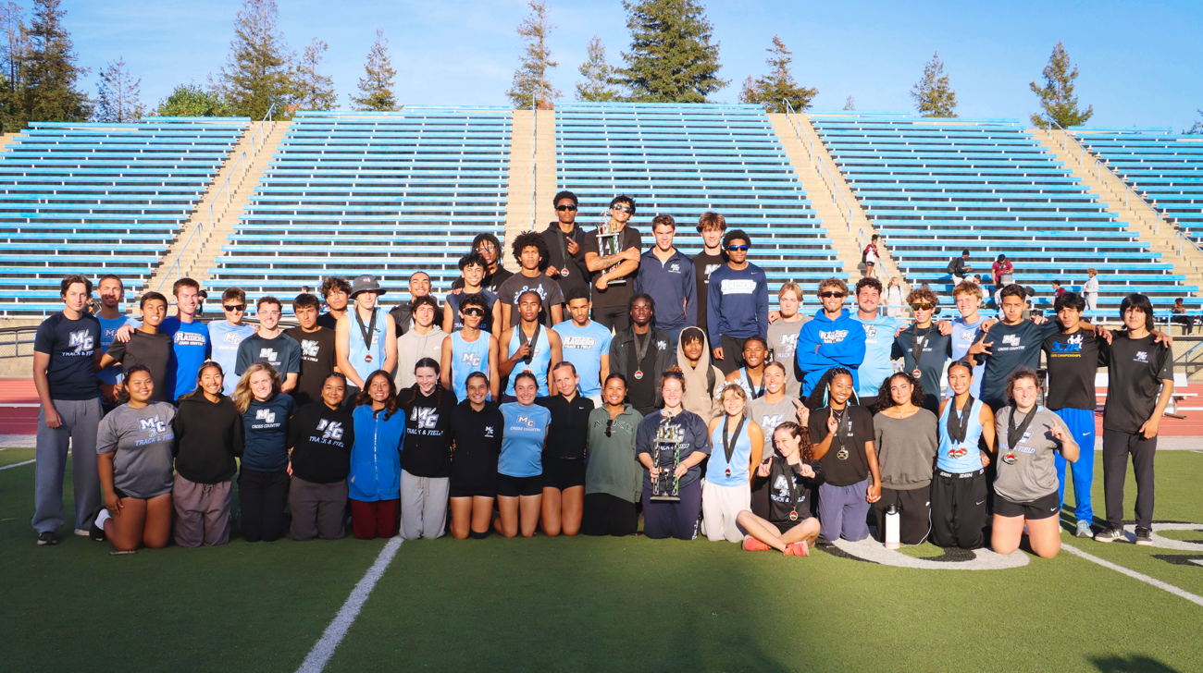
Moorpark College’s men’s and women’s track and field and cross country student-athletes celebrate their 2025 Western State Conference championships

Moorpark College Wins 2025-26 Western State Conference Commissioner’s Cup
Raiders took home five conference titles and posted the WSC’s highest student-athlete GPA of the year

MOORPARK, Calif. (Sept. 9, 2026) — Moorpark College’s student-athletes turned a championship-heavy year and conference-best academics into the Western State Conference’s (WSC) 2025–26 Commissioner’s Cup title.
The prestigious recognition, previously known as the Conference Supremacy Award, recognizes colleges for their athletic excellence in WSC competition in the conference’s 20 sponsored sports coupled with academic achievement as a department. Moorpark Raiders teamed up to take home the win by earning five WSC titles in the 2025-26 academic year and posting the best overall GPA of 3.37 among its student-athletes.
“This recognition reflects the dedication our student-athletes bring to every part of their Moorpark College experience,” said Dr. Julius Sokenu, president of Moorpark College. “Their achievements in competition and in the classroom demonstrate the perseverance, teamwork and commitment to excellence that define our college community.”
“We are so proud of our athletic and academic achievements that led to this amazing accomplishment,” said Lindsay Samaniego, first-year director of the Athletics department. “The credit goes to our student-athletes, coaches and staff for their success last season. We truly have special people representing Moorpark College and our athletic department.”
Moorpark College won titles across men’s cross country, women’s cross country, women’s basketball, men’s track and field and women’s track and field and achieved runner-up finishes in women’s volleyball, men’s basketball, women’s beach volleyball and softball.
With scores calculated based on conference athletic finishes and cumulative GPA points divided by the number of conference sports sponsored by the institution, Moorpark ran away with the win with a score of 8.69 points, followed by Santa Barbara in second place with 6.82 points and Cuesta in third place with 6.40 points.
To learn more about Moorpark College Athletics, visit MoorparkCollegeAthletics.com

About Moorpark College
Moorpark College is one of three colleges in the Ventura County Community College District and annually serves more than 18,000 students. Founded in 1967, Moorpark College is fully accredited and has the highest six-year completion rate within the California Community College System. An Aspen Institute Top 10 Finalist for 2023 and 2025, Moorpark College has also been named a 2020 Champion of Higher Education by The Campaign for College Opportunity for the Associate Degree for Transfer Pathway. It is also a designated Hispanic-Serving Institution. The college’s signature career/technical programs include nursing, radiologic technology, biotechnology, and cybersecurity. The college’s America’s Teaching Zoo is the only associate degree animal care and training program in the country. To learn more, visit MoorparkCollege.edu or follow @MoorparkCollege on social media.

Media Contact:
communications@vcccd.edu
805-652-5502

