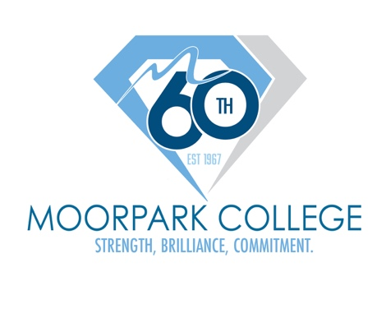

FOR IMMEDIATE RELEASE



$3 Million Federal Grant Brings Applied AI Training to Moorpark College Students
Five-year Title III investment will support applied AI education, faculty training and employer partnerships

Moorpark, Calif. (Oct. 22, 2026) — Moorpark College has been awarded a five-year, $3 million federal Title III Strengthening Institutions Program grant to launch the Applied AI Initiative for Workforce Readiness, Faculty Capacity, and Economic Mobility. The initiative will help students and faculty prepare for a workforce where artificial intelligence is quickly becoming part of everyday work.

The grant will fund a new interdisciplinary Applied Artificial Intelligence certificate that students can pair with their main field of study, from business and communication to cybersecurity and film and television. Rather than training AI specialists, the program will help students become professionals who can use AI effectively, responsibly and critically in their chosen careers.

“Artificial intelligence is reshaping work in every field, not just technology,” said Dr. Julius Sokenu, president of Moorpark College. “Our students deserve to be ready for that change regardless of their major or their means, and this grant allows Moorpark College to provide that preparation as part of an affordable public education.”

Moorpark College's grant will also fund AI-focused professional development for at least 50 faculty across 10 or more disciplines, along with an Applied AI Advisory Board that connects students with regional employers through internships and applied projects.

“This initiative reflects what Moorpark College is nationally known for: excellent teaching and learning that prepares students for high-quality careers and transfer,” said Dr. John Forbes, vice president of Academic Affairs at Moorpark College. “We do that work together, and this grant lets our faculty and employer partners collaborate to bring thoughtful, responsible AI use into every discipline.”

The initiative is designed to continue beyond the five-year grant, with the College aiming to have at least 100 students pursuing the certificate by year five.

For more information about Moorpark College and their work supporting the workforce of the future, visit moorparkcollege.edu.

About Moorpark College
Moorpark College is one of three colleges in the Ventura County Community College District and annually serves more than 18,000 students. Founded in 1967, Moorpark College is fully accredited and has the highest six-year completion rate within the California Community College System. An Aspen Institute Top 10 Finalist for 2023 and 2025, Moorpark College has also been named a 2020 Champion of Higher Education by The Campaign for College Opportunity for the Associate Degree for Transfer Pathway. It is also a designated Hispanic-Serving Institution. The college’s signature career/technical programs include nursing, radiologic technology, biotechnology, and cybersecurity. The college’s America’s Teaching Zoo is the only associate degree animal care and training program in the country. To learn more, visit MoorparkCollege.edu or follow @MoorparkCollege on social media.

Media Contact:
communications@vcccd.edu
805-652-5502

