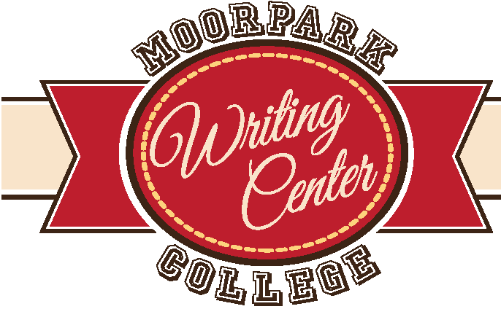
Introductions and Conclusions
moorparkcollege. edu/writingcenter
Definition

Introductions provide context/background in order to establish a setting for the thesis; indicate the claim or position you will support in the essay; define key terms that are pertinent to the subject; establish a tone: informative, persuasive, serious, humorous, personal, impersonal/objective, formal, or informal; and capture the reader’s attention, but do so with genuine, honest writing.

Try to Avoid
- Overly generalized phrases or statements of the obvious, such as Crime is a big problem. In this fast-passed world, TV is a popular form of entertainment. Since the beginning of time, the sexes have been in conflict. Yeah, yeah, yeah…We have all heard those tired intros already!
- Announcing your writing intentions: In this essay I will… The purpose of this essay is to … This essay will prove that…
- Restating the assignment: In class, I was asked to explain the ways in which one technology differs from another.
- Beginning with questions, such as “Have you ever…”

Sample Introduction
From “The Inheritance of Tools” by Scott Russell Sanders

At just about the hour when my father died, soon after dawn on a February morning when the ice coated the windows like cataracts, I banged my thumb with a hammer. Naturally, I swore at the hammer, the reckless thing, and in the moment of swearing, I thought of what my father would say: “If you’d try hitting the nail, it would go in a lot faster. Don’t you know your thumb’s not as hard as a hammer?” We both were doing carpentry that day, but far apart. He was building cupboards at my brother’s place in Oklahoma; I was at home in Indiana, putting up a wall in the basement to make a bedroom for my daughter. By the time my mother called with news of his death—the long distance wires whittling her voice until it seemed too thin to bear the weight of what she had to say—my thumb was swollen. A week or so later, a white scar in the shape of a crescent moon began to show above the cuticle, and month by month it rose across the pink sky of my thumbnail. It took the better part of a year for the scar to disappear, and every time I noticed it, I thought of my father.

Conclusions balance the essay by referring to or reminding readers of something from the introduction (Come full circle in tone/style/narrative); remind the readers of the thesis by showing how it has played out, end with strength by using any of the following: arguments, quotations, questions, suggestions, anecdotes/stories from the intro, insightful comments, humorous comments, a call to action, or a look toward the future. The conclusion should make your reader understand why it was important to read your essay.

Try to Avoid:

- Using the identical wording that you used in the introduction
- Moving on to an entirely new idea. New points demand more details and thus more essay.
- Contradicting your own ideas: These are important, but, when I think about it, they really don’t matter.
- Over generalizations, stereotypes, assumptions, such as The entire legal world is corrupt. All Americans are stressed-out.

Sample Conclusion
From “The Inheritance of Tools” by Scott Russell Sanders

I went down into the basement, opened a drawer in my workbench, and stared at the ranks of chisels and knives. Oiled and sharp, as my father would have kept them, they gleamed at me like teeth. I took up a clasp knife, pried out the longest blade, and tested the edge on the hair of my forearm. A tuft came away cleanly, and I saw my father testing the sharpness of tools on his own skin, the blades of axes and knives and gouges and hoes, saw the red hair shaved off in patches from his arms and the backs of his hands. “That will cut bear,” he would say. He never cut a bear with his blades, now my blades, but he cut deer, dirt, wood. I closed the knife and put it away. Then I took up the hammer and went back to my own work on my daughter’s wall, snugging the bottom plate against the joists overhead, plumbing the studs with my level, making sure before I drove the first nail that every line was square and true.

Practice:

Draft a powerful first sentence that captures the reader’s attention or puts them in the moment or makes them want to read the paper due to an alarming statistic or problem. Sometimes this great first sentence is already in a draft of your paper. Just find it and move it!

Now draft a great last sentence, something that you want people to feel or know at the very end of your paper. Your last sentence should communicate why this all matters. It should answer the question, “So what?”

