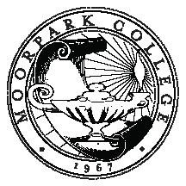

MOORPARK COLLEGE

Faculty Development Standing College Committee

Charter: The Faculty Development Committee makes recommendations on the direction of professional development activities for full-time and part-time faculty.
GOALS
2013-2014

# | GOALS
 | Create, market, implement, and assess development opportunities appropriate to new, continuing, and seasoned faculty, as well as continuing technology training services.
 | Create and implement an online repository for development resources that is easily accessible.
 | Administer Travel Funds dispersal fairly and efficiently
 | Continue to assess faculty training and development needs of faculty on a regular basis.
 | Develop creative training and development opportunities meet assessed needs.
 | Support state and college initiatives such as Student Success and Distance Education, by providing training and informational seminars as appropriate

