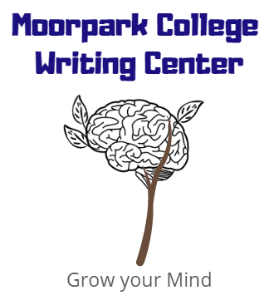

APA 7th Edition

moorparkcollege.edu/writingcenter

Getting Started:
- In APA 7th edition the following fonts are accepted: Times New Roman 12, Calibri 11, Arial 11, Georgia 11, and Lucida Sans Unicode 10
- Double-Spaced
- 1-inch margins
- Use only one space after a period
Parts and order of an APA Paper:
- Title Page
- Abstract (if required)
- Body of work with headings
- References
- Footnotes
- Tables
- Figures
- Appendices
Formatting the Title Page:
*APA 7th edition no longer includes a running head in student papers
- The page number goes in the top, right corner
- The title should be placed three to four lines down from the top of the title page and is centered and in bold font. Capitalize major words. If the title extends past one line, it should be double-spaced.
  - Example: The Impact of Social Media on Formal Writing
- Include one double-spaced blank line between the title and the author’s name(s). If there are two authors, use the word “and” between the names. For three or more, separate the names with commas and use “and” before the last name. Center author’s name(s).
- Next, centered on the next double-spaced line, include the affiliation. For students. This is the institution where the student attends. Include the name of any department and the name of the institution, separated by a comma.
  - Example 1 Author: Jane Doe
  - Example 2 Authors: Jane Doe and Jon Morris
  - Example 3 Authors: Jane Doe, Jon Morris, and Ken Smith
- On the next double-spaced line, include the course number (as displayed on instructional material) followed by a colon and the course name
  - English M01A: English Composition
- On the next double-spaced line, include the instructor’s name for the course
  - Example: Dr. Sarah Smith
- On the next double spaced line, include the date the assignment is due
  - Example: June 16, 2020
Sample Student Title Page:
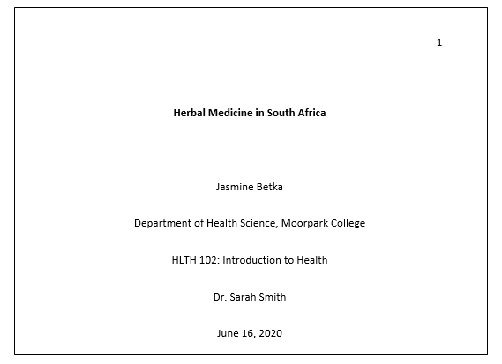
Headings
Student papers only include the page number in the top, right corner of the page

First-Level Heading Centered
Second-Level Heading Flush Left, Bold
Third-level Heading: Flush Left, Italics
Fourth-level Heading: Indented, Bold, End with a Period.
Fifth-level Heading: Indented, bold, italics
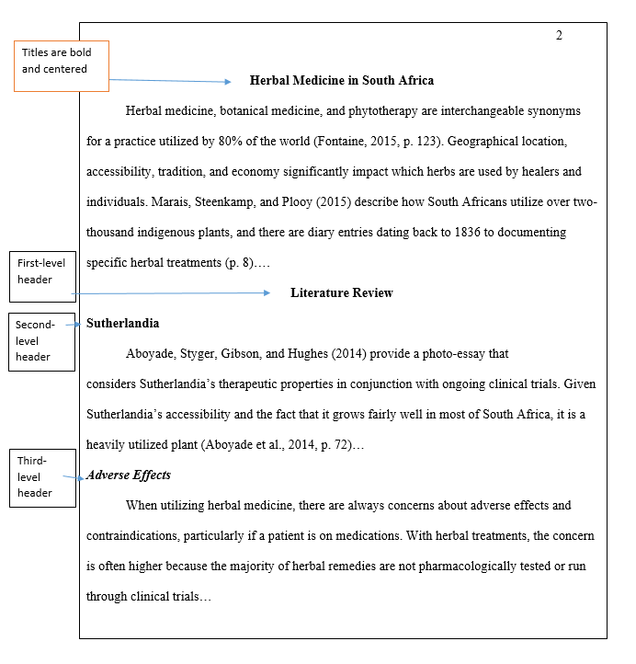

In-Text Citations
APA uses the author-date citation system.
(Last name, year)
For two authors:
(Last name & Last name, year)
Both paraphrasing and quotations require a citation! But, if quoting information, the author, date, and page number must be given. If there is no page number, the paragraph can be used.
(Last name, year, p. #)
(Last name, year, para. #).
When there is no author, APA 7th edition has established the following guidelines for including contributors other than authors:
Media Type | Include as the Author
Film | Director
TV Series | Executive Producer
Podcast | Host or Executive
Webinar | Instructor
Online Streaming Video | Person/group who uploaded the video

When there is no date, use n.d. to stand for no date.
How to cite paraphrased information:
When paraphrasing, only the author and the year are required, but you may add the page number. The page number is particularly beneficial if it helps the reader locate the information easier.
Examples:
- Brown (2016) describes a case study in which various methods were tested for increasing empathy.
- Brown (2016) describes a case study in which various methods were tested for increasing empathy (p. 107).
- Furthermore, in this case study, various methods were tested for increasing empathy (Brown, 2016).
- Furthermore, in this case study, various methods were tested for increasing empathy (Brown, 2016, p. 107).
How to cite quoted material:
When quoting directly, always provide the author, year, and page number of the quotation
Examples:
- Smith (2015) notes that “empathy can be increased with continual exposure to emotional situations” (p. 27).
Reference Page:
Formatting the reference page:
- Use ‘References’ as the title (centered)
- Continue the page number in the top right corner
- Double-space within and between references
- When a reference is longer than one line, use a ½ inch hanging indent
- Alphabetize your entries
Having trouble with formatting? Try these tips for Word:
- Go to the ‘View’ tab at the top of the page
- Make sure that you have ‘Ruler’ selected so that you can see the ruler around your page
- Select the text on your reference page
- The ruler on the top of the page has two triangles. They should be lined up at this point. Drag the bottom triangle over .5 inch. This should format your subsequent lines over to a 1.5 inch hanging indent.
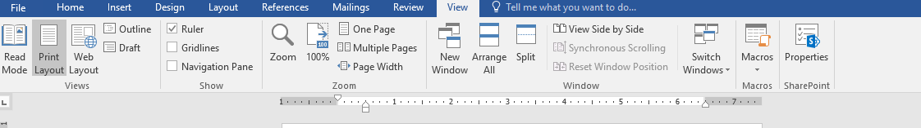

General Rules for Generating Citations:
Print:
Last name, Initial. (Date). Title (edition). Publishing location: publisher.
- Author’s Last Name, Initial(s).
  - 1 author: Smith, J.P.
  - 2 authors: Smith, J.P., & Thomas, L.T.
  - Include all author’s names for up to 20 authors in the reference page. Separate the last author’s name with &
- Publication Date in ().
  - (2017).
- Title with the first letter capitalized and the first letter of a subtitle
  - Citing sources: A writer’s reference
- Name or number of the version you accessed in ().
  - (3rd ed.).
- City and state of publication; use the country if it was published outside of the United States:
  - Washington, DC:
- Publisher
  - Sage
Example: Smith, J.P. (2017). Citing sources: A writer’s reference (3rd ed.). Washington, DC: Sage.

Website:
Last name, Initial. (date). Title. Retrieved date, from URL
In APA 7th edition, DOIs are now formatted as URLS. Also, do not include “Retrieved from” in front of the URL. Unless the website is the author, include the website’s name.
- Author’s Last Name, Initial(s).
  - 1 author: Smith, J.P.
  - 2 authors: Smith, J.P., & Thomas, L.T.
  - Include all author’s names for up to 20 authors in the reference page. Separate the last author’s name with &
- Publication Date in ().
  - (2017, March 19).
- Title with the first letter capitalized and the first letter of a subtitle.
  - Citing sources: A writer’s reference
- Since information changes, you must include when you acceded the information
  - Retrieved February 7, 2020, from
- Include the full URL (including http:// or https://)
  - http://apaseventhedition.com
Example: Smith, J.P. (2017, March 19). Citing sources: A writer’s reference. Retrieved February 7, 2020, from http://apaseventhedition.com

Online Journal:
Last name, Initial. (date). Title. Container title. Issue, page range. http://DOI
- Author’s Last Name, Initial (s).
  - 1 author: Smith, J.P.
  - 2 authors: Smith, J.P., & Thomas, L.T.
  - Include all author’s names for up to 20 authors in the reference page. Separate the last author’s name with &
- Publication Date in ().
  - (2017, March 19).
- Title with the first letter capitalized and the first letter of a subtitle.
  - Writing a conclusion and discussion for your dissertation.
- Container title,
  - A container is the larger work that the source appeared in
    - Chapter in a book
    - Web page in a website
    - Article in a newspaper
  - Container titles are italicized
- Issue,
  - If the source consists of multiple volumes, include the volume number.
- Page range.
- DOI formatted as a URL or the URL
  - A DOI is preferable because it never changes
  - If you cannot find the DOI, use a regular or stable URL
Example: Smith, T. (2019). Writing a conclusion and discussion for your dissertation. Scribbr, 1(3), 4–6. https://doi.org/10.1000/182
Reference Page Example:
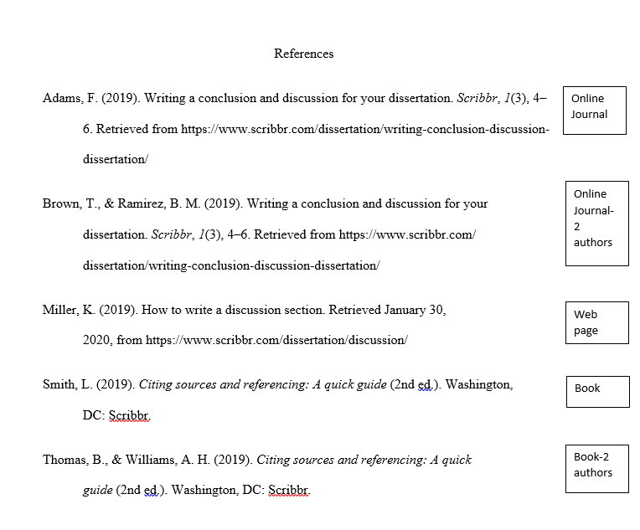
Other noteworthy parts to APA 7th Edition:
- Use inclusive/bias-free language
  - “They” can be used as a gender-neutral pronoun
  - Ex: A researcher’s work depends on how often they are able to get funding.
- Use descriptive phrases instead of adjectives as nouns to label groups
  - Don’t say: The poor, the autistic student, the disabled individual…
  - Do say: People living in poverty, the student with autism, the individual with a disability…
- Use exact age ranges
  - Don’t say: “Over 65”
  - Do say: “65 to 75”

