Moorpark College – High School Dual Enrollment

Faculty Resource Guide

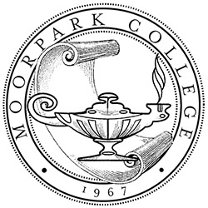

With a "students first" philosophy, Moorpark College empowers its diverse community of learners to complete their goals for academic transfer, basic skills, and career education. Moorpark College integrates instruction and student services, collaborates with industry and educational partners, and promotes a global perspective.

Table of Contents
Moorpark College Values Statement 4
College Vision 4
Dual Enrollment TEAM 5
High School Partnerships 6-7
Academic Support Services 7
Goal of High School Dual Enrollment Partnership 8
What is College and Career Access Pathways (CCAP)? 8-9
Information Sheets 9
Parking 9
Classroom Number and Location 9
Academic Calendar 10
Memorandum of Understanding (MOU) 11
Attendance Roster 12
Add Authorization Codes 12-13
Withdrawal Procedure 14
Census 15
Adding a Student after Census Closes 15
Positive Attendance Responsibilities 15
Student Not Attending/Not Passing the Course 15-16
Grades 16
Entering Grades/Sending Final Grades to High School 16-17
Incomplete Grades 17
Correcting a Grade 17
Partial Grade Entry 17
Grade Availability to Students 18
LDA Requirement 18
IEP’s and Supporting Student Needs 18
Syllabi 18
Textbook 18
Student Use of Canvas 18
How to Log-in to Canvas 19
Who Can I Contact for Canvas Help? 19
Parent Engagement 20
Family Educational Rights and Privacy Act (FERPA) Regulations 20
FERPA Form 21
Application and Enrollment Process 22
Steps for Enrollment Process 22
Student Code of Conduct – College Catalog: Appendix VII 22-24
Leading Research in Classroom ‘Best Practices” 24-25
Community-Based Learning 26
Internships 26
Capstone Courses and Projects 26
Strategies for Engaging Students and Improving Retention 26-28

Values Statement
Our actions and decisions are based on the following values:
- Integrity: Committing ourselves to honesty and ethics in all individual and institutional conduct.
- Collegiality: Cultivating a respectful campus culture that celebrates diversity and is built on a foundation of participatory governance, open dialogue, and varied perspectives.
- Equity & Success: 1) Providing ready access to a high-quality education, 2) Helping students identify and achieve their educational goals, and 3) Minimizing equity gaps and empowering students from all walks of life to thrive in our campus community.
- Excellence: Continuously improving our individual and collective efforts to help our campus community reach its full potential.
- Creativity & Innovation: Supporting new approaches to problem solving, risk taking, and creative expression.

College Vision
We make the following commitments to our students, our community, and each other:
- We will provide equitable educational opportunities through early intervention initiatives, accessible and clearly mapped curriculum, and robust student support services.
- We will help students explore, identify, and expediently fulfill their transfer and career goals.
- We will foster a love for learning across the broad areas of human knowledge and understanding.
- We will engage with our community and support the local economy.
- We will prepare our students for fulfilling careers and promote economic and social mobility.
- We will nurture a civically-minded campus dedicated to engaging and improving our community and democratic republic through a culture of civil discourse and practice.
- We will respect the Earth by cultivating an environmentally-responsible generation and pursuing campus initiatives that are mindful of our natural resources.
- We will provide a safe and secure learning environment on our campus.
- We will promote wellness through self-awareness, self-care, and support of one another to establish and maintain healthy lifestyles.

Dual Enrollment TEAM

Dean: Dr. Khushnur Dadabhoy
(805)553-4137
KDadabhoy@vcccd.edu

Registrar: David Anter
(805) 553-4110
DAnter@vcccd.edu

Faculty Liaison: Dr. Kellie Porto-Garcia
Tuesday, Wednesday
Kellie_Porto1@vcccd.edu

Coordinator: DeAnna Grove, MS, LMFT
(805) 553-4638
DGrove@vcccd.edu

Counselor: Seville Ajiri, MS, PPS
(805) 553-4608 Monday, Tuesday, Wednesday
Seville_Ajiri1@vcccd.edu

High School Partnerships
Agoura High School (818) 889-1262
28545 West Driver Avenue, Agoura Hills, CA 91301
Ayla MirJafarli (818)889-1262 ext. 51374
Calabasas High School (818) 222-7177
22855 Mullholland Hwy., Calabasas, CA 91302
Nicky Goldstein (818)222-7177

Conejo Valley School (805) 498-6646
1402 E. Janss Road, Thousand Oaks, CA 91362
Catherine Kanney (805)498-6646 ext. 109
High School at Moorpark College (805) 378-1444
7075 Campus Drive, Moorpark Trailers, Moorpark, CA 93021
Christopher Fennell (805) 378-1444

Mary B. Perry High School – California Youth Authority
3100 Wright Road, Camarillo, CA 93010
Anthony Marenco (805)485-7951

Moorpark High School (805) 378-6305
4500 Tierra Rejada Road, Moorpark, CA 93021
Carrie Pentis (805)377-9979

Newbury Park High School (805) 498-3676
456 N. Reino Road, Newbury Park, CA 91320
Kristi Konish (805)796-9292
Royal High School (805) 306-4875
1402 Royal Ave, Simi Valley, CA 93065
Aaron Dobson (805)306-4875 ext. 2712
Sue Guy (805)306-4875

Santa Susana High School (805) 520-6800
3570 Cochran Street, Simi Valley, CA 93063
Devyn Thompson (805)520-6800

Simi Valley High School (805) 577-1400
5400 Cochran Street, Simi Valley, CA 93063
John C Baxter (805) 577-1400

Oak Park High School (818) 735-3300
899 Kanan Road, Oak Park, CA 91377
Natalie Smith (818)735-3307

Thousand Oaks High School (805) 495-7491
2323 N. Moorpark Road, Thousand Oaks, CA 91360
Danielle Oliveri (805)495-7491 ext. 1004
Juandeane Doherty (805)495-7491 ext. 1007
Westlake High School (805) 497-6711
100 Lakeview Canyon Road, Thousand Oaks, CA 91362
Heather Godfrey (805)497-6711

Academic Support Services
ACCESS – Located in LMC Building, 1st Floor. Phone (805) 378-1461
Admissions and Records – Located in Fountain Hall, 1st Floor. Phone (805) 378-1429 MCAdmissions@vcccd.edu Registrar, Dave Anter DAnter@vcccd.edu
Career and Transfer Center – Located in Fountain Hall, 1st Floor. Phone (805) 378-1536
Dual Enrollment Office – Located in Fountain Hall, 1st Floor. Phone (805) 553-4608 MCDualEnrollment@vcccd.edu
Library – Located in Library Learning Resources Building. Phone (805) 378-1450
Outreach - Located in Fountain Hall, 1st Floor. Phone (805) 378-1409
Student Business Office - Located in Fountain Hall, 1st Floor. Phone (805) 378-1437
Student Health Center – Located in the Administrative Building, Room 111 Phone (805) 378-1413
The Learning, Math & Writing Center – Located in Library Learning Resources Building, 3rd Floor. Phone Math (805) 378-1556 MCMC@vcccd.edu Writing Center (805) 553-4850 MCWritingCenter@vcccd.edu

Goals of High School Dual Enrollment Partnership
- Increase access to college and offer opportunities for improving degree attainment
- Decrease time and expense in obtaining a college degree
- Prepares students for transition to college by engaging in college-level courses
- Build community and alignment with Post-Secondary Education
- Increase confidence and belief participating students are college material
- Add value and relevance in education for participating students
- Reinforce to students and parents that Moorpark College is their right college

What is College and Career Access Pathways (CCAP)?
AB 288, Holden. Public schools: College and Career Access Pathways partnerships.
Existing law authorizes the governing board of a school district to allow pupils whom the district has determined would benefit from advanced scholastic or vocational work to attend community college as special part-time or full-time students, subject to parental permission. Existing law requires credit to be awarded to these pupils, as specified, authorizes a school principal to recommend a pupil for community college summer session if the pupil meets specified criteria, and prohibits the principal from recommending more than 5% of the total number of pupils from any particular grade level who completed that grade immediately before the time of recommendation for summer session attendance.
This bill would authorize the governing board of a community college district to enter into a College and Career Access Pathways partnership with the governing board of a school district with the goal of developing seamless pathways from high school to community college for career technical education or preparation for transfer, improving high school graduation rates, or helping high school pupils achieve college and career readiness. The bill would require the partnership agreement to outline the terms of the partnership, as specified, and to establish protocols for information sharing, joint facilities use, and parental consent for high school pupils to enroll in community college courses.
The bill would authorize specified high school pupils to enroll in up to 15 units per term if those units are required for these pupils’ partnership programs and specified conditions are satisfied, and would authorize a community college district to exempt special part-time and full-time students taking up to a maximum of 15 units per term from specified fee requirements. The bill would prohibit a district from receiving a state allowance or apportionment for an instructional activity for which the partnering district has been, or will be, paid an allowance or apportionment under a concurrent enrollment partnership agreement. The bill would require, for each partnership agreement entered into under the bill, the affected community college district and school district to provide an annual report, containing specified data, to the office of the Chancellor of the California Community Colleges. The bill would require the chancellor to prepare a summary report, no later than January 1, 2021, that includes an evaluation of the partnerships, as specified. The bill’s provisions would be repealed on January 1, 2022.

Information Sheets
You will be required to attend one of Dual Enrollment Faculty Orientations prior to the start of the semester. At these orientations you will receive an “Information Sheet” with specific information for to the high school you will be teaching at. The information will include how to get the keys for your classroom, how to access the restroom, how to access the internet, making copies, etc. If you have additional needs for your class, you can contact our Dual Enrollment Coordinator, DeAnna Grove, or our Dual Enrollment Faculty Liaison, Kellie Porto-Garcia.
Parking
When you attend our Dual Enrollment Orientation you will be given an “Information Sheet” with as much information as we have from the high schools regarding your first day. If you do not attend the Dual Enrollment Faculty Orientation our Dual Enrollment Coordinator, DeAnna Grove, will e-mail you this information. If we were not provided this information prior to the orientation, you will be given the high school contacts information, so you can reach out to find out about parking on campus. Some schools require a parking permit and assign you a parking spot. You will want to contact the school to find out the school’s policy on parking prior to your first day.
Classroom Number and Location
When you attend our Dual Enrollment Orientation, you will be given an “Information Sheet” at the orientation. If you did not attend the orientation you will receive an e-mail from our Dual Enrollment Coordinator, DeAnna Grove, providing you with as much information as we have been given from the high school. In the event that you were not provided a classroom number and location at the orientation or in the e-mail, you will be given the school contact, to meet on your first day of class, who will assign you your classroom. If you need special items to run your class (i.e. whiteboard access, projector, laptop, etc.), please contact DeAnna Grove, and let her know the items that you require. Please reach out to your Dual Enrollment team if you run into any classroom issues.

Academic Calendar
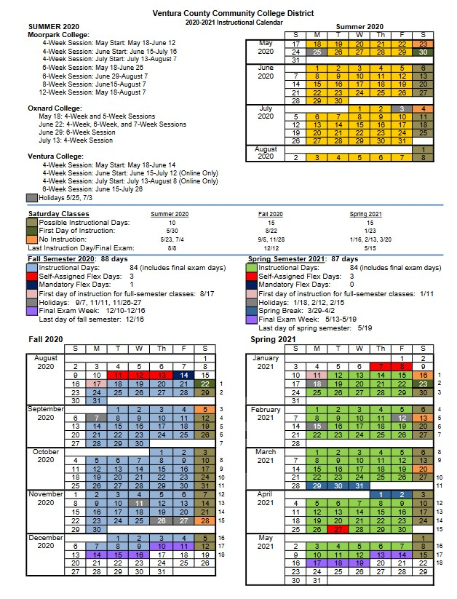
Memorandum of Understanding “MOU”
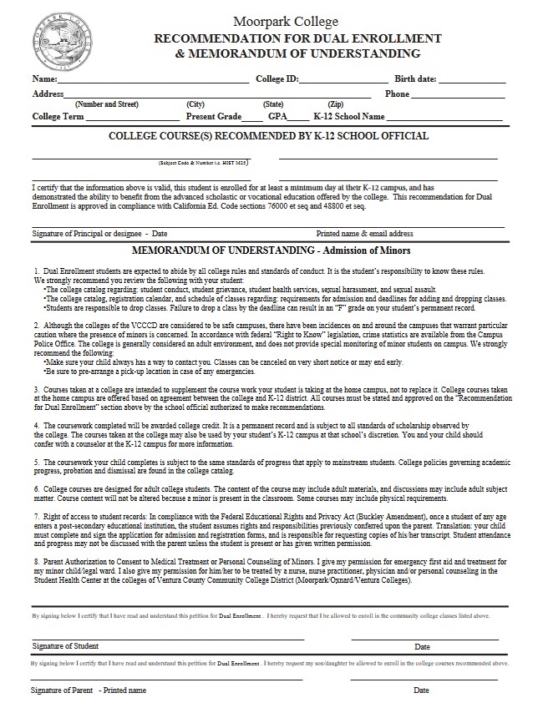
Attendance Roster – My.vcccd.edu allows access to student information, real-time course roster information, the Canvas Learning Management system, and other vital resources for dual enrollment faculty.
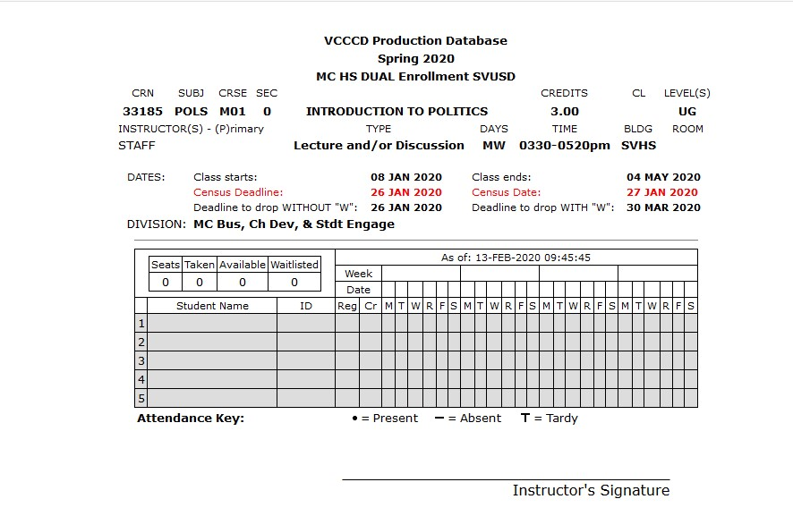Add Authorization Codes
Add codes for each section of your course will be distributed within the first few week(s) depending on your section census deadline. The add code numbers are unique to each CRN, are non-transferable, and can be used only once. Please make sure you keep track of which student (name and 900#) each add code is given to. All classes that began the first week of the semester will require the use of add authorization numbers for registration, even if the class still shows seats available.
If you need to request additional add codes contact your Dual Enrollment team, mcdualenrollment@vcccd.edu, with the request. Authorization codes are created for all courses regardless of the class size. An add code will allow a student to enroll beyond the enrollment cap set in a course.
***Students that were waitlisted in a class and are registering with an add code, must first drop the waitlisted class and then re-add the same class. They will then be prompted to enter the add authorization number. If they neglect to drop the class first, they will receive an error message that says they’re attempting to enroll in a duplicate class.
Add authorization numbers expire as of the Census Deadline. Students not enrolled by that date will not be able to enroll after Census, without permissions and approvals.
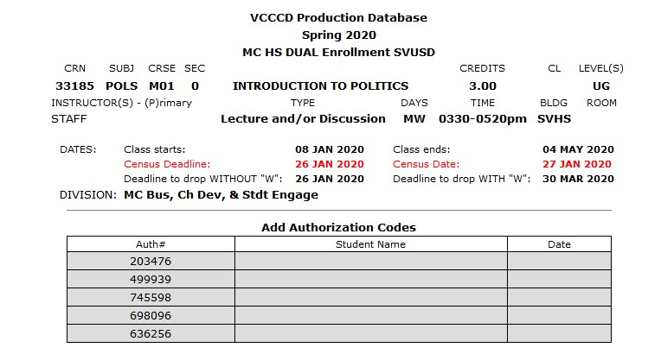
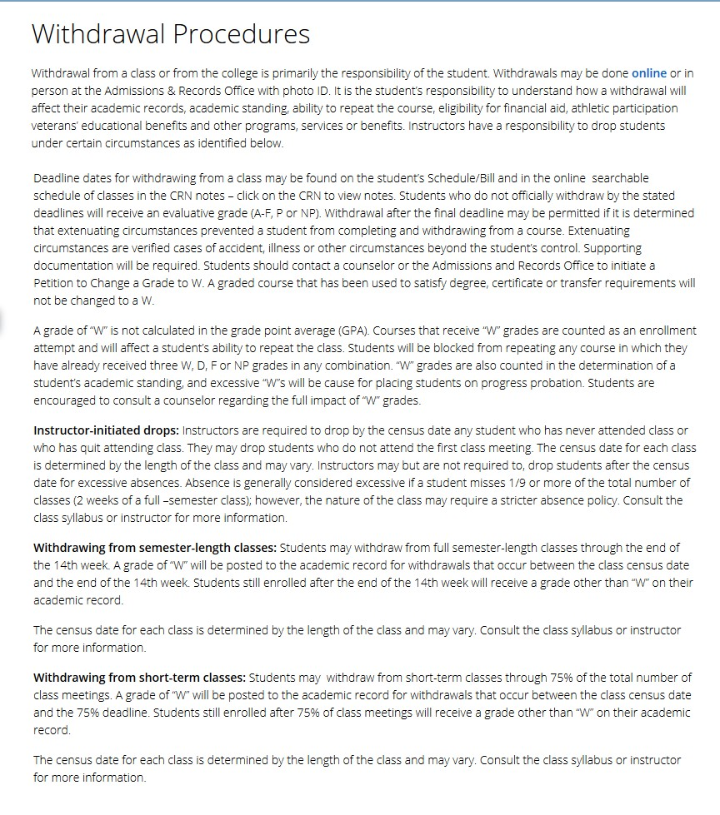

Census
Title 5 section 58004 and VCCCD BP/AP 5070 require that rosters are cleared of inactive enrollment prior to Census. You will receive an e-mail to your vcccd.edu e-mail from the Registrar’s office as a reminder with the date it needs to be completed by.
The census certification process is required for active enrollment in all your classes. The three steps below MUST be completed to certify your course(s):
1. Review your class roster for each class.
2. Drop any "no show" or inactive students, if you have any.
3. Click on the Certify Census button at the bottom of the drop roster. Once you click on it, the button will then be replaced by the date/time you certified your roster. This box will disappear as of the census date as the census reporting deadline will have passed.
Note: The Certify Census button must be clicked to certify and comply with census reporting requirements.
Contact the Admissions & Records Office if you are encountering problems with census reporting or continue to receive this message days after you have complied with census.
Adding a Student After Census Closes
When a student has not registered for the course and Census Closes, you will need to complete the "Late Add Request" link from Admissions and Records in order for the student to be added to the course. This will initiate the process to have that student added to your class. If you need assistance finding the form, please contact the Dual Enrollment Coordinator, DeAnna Grove, or your Dual Enrollment Faculty Liaison, Kellie Porto-Garcia.
Positive Attendance Responsibilities
Faculty must document student attendance. At the end of the semester when final grades are reported for each student (see “Grading” below), faculty will also have to enter these hours (known as positive attendance). Please make sure that you are keeping a record of your roster, as this is important audit information, and we are required to keep these records as documented verification of hours.
Student Not Attending/Not Passing the Class
If a student is not passing your class, please reach out to the student to discuss their options with them. If a student stops attending your class and you are unable to get in contact with them, please contact the Dual Enrollment Team so that they can alert the high school contact of the student’s non-attendance. After all interventions have failed in regards to attendance and a low grade, the last option should be suggesting the student drop the course. If a CCAP student drops or is dropped, they will not have a place to go during the regular school hours.
Grades
Grading Symbols are as follows:
A - Excellent 4 grade points
B - Good 3 grade points
C - Average 2 grade points
D - Poor 1 grade points
F - Failure 0 grade point (no credit)
I - Incomplete. The Incomplete form may be completed by the student at the discretion of the instruction.
W – Withdrawal. Authorized withdrawal no later than the last day of the fifteenth week of the semester. No grade points/no credit.
Entering Grades/Sending Final Grades to High School
In accordance with the current AFT contract, section 5.2.A (1), grades are due (2) two working days after finals.
Please notify your dean immediately if you cannot meet the grading deadline.
GRADING INSTRUCTIONS
1. Go to my.vcccd.edu to access the “Faculty” portal
2. Log in using your “Username” and personal “Password”
3. Click on “Faculty” tab
4. Click on “Post Grades” under faculty self service
5. Select the current term and click the submit button
6. Select the correct CRN and click the submit button
7. Grade students by selecting the appropriate grade from the drop-down box in the Grade column (positive attendance course – post hours).
For each student, select their grade from the drop down box to the right of student’s name. When you’re done, click “Submit Grades”.
For security purposes, the final grade screen will timeout after 30 minutes of inactivity. Click the “Submit Grades” button often as you will lose any grades not submitted within 30 minutes
Record a grade for every student except students who have officially dropped your class; those students will have the “W” already posted so no grade entry is needed. If a student has been dropped, you may reinstate the student. See “Reinstating a Student” below.
Incomplete Grades
When you give a student an “Incomplete” grade, you must also assign a default grade. The default grade is the grade the student will receive if the student does not complete the missing work in one year. Each default grading option is listed: IB, IC, ID, IF, INP (no pass). Click on the grade that corresponds to the grade the student will receive if they do not complete the work. When you assign an incomplete grade, you should also send the student the attached “Notice of Incomplete Grade”. On it you will identify the work the student needs to complete in order to receive a grade in the class. The default grade on the Notice of Incomplete Grade must match the default grade you assign online. The default grade will automatically be assigned in one year if you do not submit a change of grade.
Correcting a Grade
You have only until the close of business on the day you submit your grades to change a grade online. Once grades are rolled to history in the database each day, you can no longer change a grade. You can see if a grade has been rolled by checking the “Rolled” column on the final grade roster. If there is a “Y” in the “Rolled” column contact me via email with the student’s 900 number and the grade you are trying to record. After grades are finalized and Academic Standing is evaluated grade changes will require division approval.
Partial Grade Entry
You do not have to enter all grades for all students in your class in the same grading session. For instance, if you happen to have a student who needs a grade posted immediately, you may grade only that student leaving the remaining students to be graded at a later time.

Grade Availability to Students
Grades are posted to student transcripts daily and are available to students within 24 hours of being posted, including weekends and holidays.
LDA Requirement
Faculty are required to input the “Last Date of Attendance” for any student who receives an “F” or “NP” grade. Your online grade roster already has a field for this information, and it will return an error if an “F” or “NP” is awarded without the attendance date. Please note that an error will prevent all grades from being submitted until the required date is provided!
IEP’s and Supporting Student Needs
Instructors should make some sort of announcement, that if anyone has an IEP, that they send them it immediately, so that they can make accommodations. If an IEP is already in place, the high school will provide you with the accommodations that need to be made for the student.
Syllabi
If requested, your syllabi should be sent to your Dean for approval. Make sure your students have access to your syllabus online and/or a hard copy for them to reference.
Textbooks
- The textbook should be approved by the college’s academic department.
- There should be enough textbooks & materials for all students in the class. CCAP high schools will purchase a classroom set of the textbooks. Non-CCAP high schools will have the students purchase their own textbooks.
Student Use of Canvas
Canvas provides a full-service, comprehensive, learning management system for students to engage in the best online learning and support for both online and on-campus courses at VCCCD.

How to Log-in to Canvas:
We strongly recommend using the Chrome browser. Open the latest version on your browser.
- Navigate to: my.vcccd.edu/canvas/ or search for “VCCCD Canvas”
- Log-in with your student email user name ‘John_Doe1@my.vcccd.edu’ and Canvas password
Who can I contact for Canvas help?
- Phone (844) 505-4656
- Call Center Hours: Monday – Friday 9:00 a.m. – 5:00 p.m. (PST)
- Canvas Support Hotline: (844) 711-7104 Evenings and Weekends Only

Parent Engagement
On occasion, a parent or other outside person may inquire about a student’s progress in a class or request a conference, especially if the student is less than 18 years of age. Please note that faculty should NOT disclose any information to this parent or outside person under any circumstances; in fact, one should not even formally acknowledge that the student is enrolled at the college. Once more, the privacy and confidentiality of the student must be preserved at all times.
It is the responsibility of the student to communicate with the faculty member, and inquiring parents should be advised to talk with their child directly rather than asking for FERPA-protected information from the faculty member. If there is a situation where the student feels their parent should be able to communicate with the faculty regarding grades, attendance, etc., the FERPA form must be filled out and signed by the student requesting SPECIFICALLY what they would like to be released to the parent if/when asked. Moreover, if a student consents to having a parent, guardian, or outside person present during a conference, it is recommended that the meeting occur with the student and all stakeholders at the same time (and not separately).
Example:
Thank you for reaching out to me about your daughter's enrollment in my course. Unfortunately, due to the student's privacy FERPA regulations, I cannot disclose any information about any student without first obtaining a student's written approval. When your daughter applied to Moorpark College, you both signed in agreement, our Memorandum of Understanding detailing a student’s rights to privacy. I will attach a blank MOU for your review of item #6. I'm happy to email a FERPA form to your daughter to complete, authorize, and submit back to me. Only then would I be able to discuss her information with you both.

Thank you for your understanding.

Family Educational Rights and Privacy Act (FERPA) Regulations
While FERPA does provide parents and guardians with rights in the K-12 setting, in a college setting like Moorpark College all privacy rights belong to the student, regardless of the student’s age.

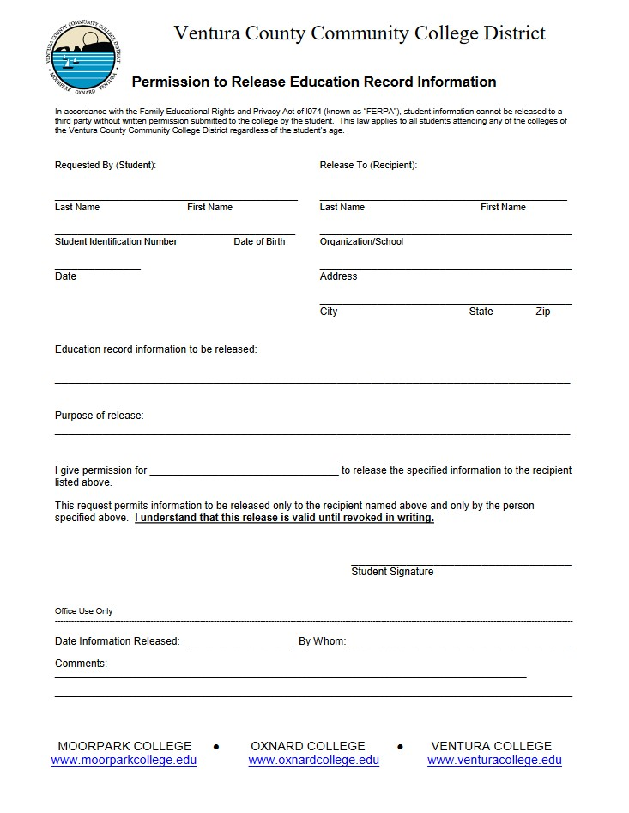

Application and Enrollment Process
Here are the links to the workshops with step-by-step instructions on how to register for classes.
How to Apply, Setup Portal, Submit your MOU and Register for Courses:
https://drive.google.com/file/d/1JBvDZX9pFrwGIXy3_oChYrKI5tW5LRw-/view

Steps for Enrollment process
- Apply to Moorpark College using the California Community Colleges OpenCCC, on the MoorparkCollege.edu website under “Apply and Enroll.” The information in your account is kept private and secure.
- Meet with your high school counselor for course recommendations, to discuss what courses are eligible for credit towards high school graduation, and to receive your counselor’s approval. Submit approved Memorandum of Understanding (MOU) to our Admissions and Records Department at: MCAdmissions@vcccd.edu
- Register for your class in the web portal my.vcccd.edu using the correct CRN number.

Student Code of Conduct College Catalog: Appendix VII
The purpose of these standards is to ensure a safe, respectful and productive learning environment for VCCCD students, staff, faculty and administrators. In order for the colleges and the district to fulfill their mission of student learning achievement, all employees must feel secure in their work setting. Student conduct that negatively impacts the ability of students to meet their educational goals or employees to carry out their professional job responsibilities will be subject to the terms of this procedure.
Definitions: The following conduct shall constitute good cause for discipline, including but not limited to the removal, suspension or expulsion of a student.
The procedures shall be made widely available to students through the college catalog and other means. Students who violate any of the following standards for student conduct while at the district office, on the college campus or during off-campus college-sponsored activities are subject to the procedures outlined in Administrative Procedures 5520: Student Discipline Procedures:
- Causing, attempting to cause, or threatening to cause physical injury to another person or to one’s self.
- Possession, sale or otherwise furnishing a weapon, including but not limited to, any actual or facsimile of a firearm, knife, explosive or other dangerous object, or any item used to threaten bodily harm without written permission from a district employee, with concurrence of the College President or designee.
- Use, possession, distribution, or offer to sell alcoholic beverages, narcotics, hallucinogenic drugs, marijuana, other controlled substances or dangerous drugs while on campus or while participating in any college-sponsored event.
- Presence on campus while under the influence of alcoholic beverages, narcotics, hallucinogenic drugs, marijuana, other controlled substances or dangerous drugs except as expressly permitted by law. (Use or possession of medical marijuana is not allowed on any college property.)
- Committing or attempting to commit robbery or extortion.
- Causing or attempting to cause damage to District property or to private property on campus.
- Stealing or attempting to steal District property or private property on campus, or knowingly receiving stolen District property or private property on campus.
- Willful or persistent smoking (including e-cigarettes or use of similar mechanisms) in any area where smoking has been prohibited by law or by regulation of the college or the District.
- Engaging in intimidating conduct or bullying against another student through words or actions, including direct physical contact, verbal assaults, such as teasing or name-calling, social isolation or manipulation, and cyber-bullying.
- Engaging in harassing or discriminatory behavior. The District’s response to instances of sexual harassment will follow the processes identified in Board Policy and Administrative Procedures 3430.
- Obstruction or disruption of classes, administrative or disciplinary procedures, or authorized college activities.
- Disruptive behavior, willful disobedience, profanity, vulgarity, lewd, or other offensive conduct, on campus or during campus sponsored activities.
- The persistent defiance of authority or abuse of District/college personnel.
- Academic dishonesty, cheating, or plagiarism.
- Dishonesty, forgery, alteration or misuse of District/college documents, records or identification, or knowingly furnishing false information to the District/college or any related off-site agency or organization.
- Unauthorized entry to or use of District/college facilities.
- Engaging in expression which is obscene, libelous, or slanderous, or which so incites students as to create a clear and present danger of the commission of unlawful acts on college/District premises, or the violation of lawful District administrative procedures, or the substantial disruption of the orderly operation of the District.
- Violation of District/college rules and regulations including those concerning student organizations, the use of District/college facilities, or the time, place, and manner (see AP 3900) of public expression or distribution of materials.
- Persistent, serious misconduct where other means of correction have failed to bring about proper conduct.
- Unauthorized preparation, giving, selling, transfer, distribution, or publication of any recording or photography of an academic presentation in a classroom or equivalent site of instruction, including but not limited to written class materials, except as permitted by District policy, or administrative procedure.
- Violation of professional ethical code of conduct in classroom or clinical settings as identified by state licensing agencies (Board of Registered Nursing, Emergency Medical Services Authority, Title 22, Peace Officers Standards & Training, California Department of Public Health). Students who engage in any of the above are subject to the procedures outlined in AP 5520.
For Conduct issues, please contact Dean: Monica Garcia (805) 553-4848
Leading Research in Classroom “Best Practices”
Seven Principles for Good Practice in Undergraduate Education (Chickering and Reisser, 1993)
• Encourage student-faculty contact in and out of class
• Encourage cooperation among students through collaborative assignments and in-class, group exercises
• Encourage active learning by having students apply course content to real-world situations
• Provide prompt feedback throughout the term
• Emphasize time on task by indicating how long students should spend on an assignment
• Communicate high expectations
• Respect diverse talents and ways of learning by providing a variety of learning modes (written, oral, visual) that are culturally relevant
Eight Characteristics of an Effective Teacher (Langlois & Zales, 1992)
• Promotes high expectations of student achievement
• Provides careful delineation of course methods and routines
• Uses varied and appropriate teaching methods and materials
• Creates a supportive, cooperative atmosphere
• Shows enthusiasm, energy, caring, and maintains a nonthreatening atmosphere
• Manifests a belief that their subject is important
• Relates instruction to student interests
• Demonstrates content expertise
Growth Mindset (Dweck, 2006)
Carol Dweck has demonstrated that students who adopt a fixed mindset tend to respond to academic setbacks with a sense of helplessness. Alternatively, those with a growth mindset typically respond to setbacks with a commitment to master the material and succeed. Students with a fixed mindset tend to believe that something is “wrong” with them, and often express these defeatist traits in their academic career. Instead, we want to encourage students by fostering the following positive attributes:
• Thinking “I can see the relevance of this to my future”
• “I am successful in what I have been doing and can actually do this”
• Enhanced enjoyment through active participation in the classroom and increased intellectual curiosity
• Increased motivation
• Decreased anxiety
Those adopting a growth mindset seem to believe that intelligence is changeable, and that people can improve with hard work and perseverance, and moreover, that failure is a natural, healthy part of the learning process.
High-Impact Educational Practices
Research has shown that high-impact practices have considerable benefits for students and can foster student success. Below are just a few selections of high-impact practices faculty might consider employing in their teaching:
Collaborative Assignments and Projects
Collaborative assignments attempt to bring together diverse groups of students in an effort to broaden our understanding by listening to the viewpoints of peers. This can be done through study groups, team-based projects, and cooperative presentations. Such assignments can also be broadened to include global learning projects, which study racial, economic, gender, and other differences found throughout the world.
Community-Based Learning
This type of practice entails experiential learning in local communities, working and learning alongside experts in a wide range of fields. Service learning provides opportunities for students to gain work experience, while often adding value through community outreach, organization, and partnerships. This type of learning also conforms to the broader mission of the college.
Internships (Cooperative Work Experience Education)
Internships are increasingly valuable in today’s competitive job market, and offers hands-on experience in a student’s projected career field. Internships allow students to gain not only experience but also networking skills while working closely with professionals in their field. As part of a course, students draft a paper relating to what has been learned. Please contact our Career Resource Center for more information on the process for offering students an internship.
Capstone Courses and Projects
These projects involve summative experiences, often assigned at the end of a semester, or a student’s college career. Capstones emphasize application of learning, often via research papers, or portfolios.
For more information on high-impact practices, see this link, provided by the American Association of Universities and Colleges, 2008, http://www.aacu.org/leap/documents/hip_tables.pdf.
Strategies for Engaging Students and Improving Retention
Most students decide whether to continue enrollment within the first 6-8 weeks of their first semester. What happens on the first day of class frequently sets the learning climate for the entire semester and may help a student decide whether to stay or leave. The following is a list of suggested classroom activities for the first week that classes that so many faculty members have found to be useful:
• Begin building connections with your students by introducing yourself. Tell students what you would like them to call you and how you can be reached outside of class. Tell them how you chose your field of study and your educational background. If you went to a community college, be sure to let them know that as well. Tell them why you are teaching at Moorpark College.
• Learn about your students. Ask students to complete an informational survey listing name, major, work information, how many hours a week they work outside of class, why they are taking this class, what other courses they are taking, what grade they expect to earn, how much time they expect to study outside of class, their strengths and weaknesses, previous related courses, etc. Ask students to let you know if they have special needs of which you should be aware.
• Learn student names as quickly as possible, and use them when addressing students in class (and out of class). The following suggestions may help you quickly learn names:
o Ask students to introduce themselves (a great way to take attendance without you worrying how to initially pronounce names!) and share something that will help you and the rest of the class learn their names. This can also be done as a paired-activity with students introducing each other. This will encourage student participation and classroom interaction.
o Take pictures and paste them on index cards. Use them as “flash cards” to help you learn names.
o You may want to use name tags or name tents to help class members get to know one another’s name.
• Be enthusiastic. If you act bored or lack passion for teaching or your subject matter, you will impart that attitude to your students. Why would students want to learn your subject if you don’t seem interested or interesting?
• Help students connect with classmates. Encourage students to have an in-class-buddy, study partners, or learning teams, and have them exchange phone numbers and e-mail addresses.
• Set a positive tone that focuses on student success. When students see your syllabus and course requirements, they may feel overwhelmed. Be reassuring. Let students know that you believe they can succeed, and let them know you will help them. The purpose of the initial class session should set up an expectation for success—not scare students away!
• Involve students and encourage participation in first-day activities so that they become active learners early in the course. You may ask students to discuss what they already know about the subject matter of your course or why they signed up for your course.
• Don’t just read the syllabus. Students find that as uninteresting as faculty do! Instead, design a group activity for students to understand both the syllabus and course policies. In this way students will get to know their classmates and begin to make connections as well as learn about the syllabus. When forming groups, use something class related. For example, in a computer programming class, you might ask students to line up according to their birthdays. You can then explain that they just demonstrated the process of “sorting” and as part of the course they will learn how to write programs so that the computer can automate such a task. You can also give a take-home quiz on the syllabus (a great homework assignment for the first class and a great way for students who miss the first class to learn about the requirements!). Scoring the quiz will help you learn what students understand and don’t understand about your expectations and allow you to focus on just those points of the syllabus during the second day of class.
• Determine students’ goals and objectives while discussing your goals and objectives. Let students know how your course can fit in with their personal or career goals and objectives.
• Explore students’ fears and apprehensions. In your class, and perhaps in the college setting, there are students who are entering an unfamiliar environment that carries with it a new set of performance expectations and different social principles. Acknowledge these factors, address students’ apprehensions, and encourage their academic performance.
• Communicate what students can expect of you and what you expect of them. This can be done orally or by writing students a short letter or posting a brief biography on Canvas.
• Help students understand the amount of work that goes into being successful. Explain that being successful in college is less about “brains” and more about willingness to work hard and spend many hours outside of class reading, reviewing, doing assignments, and studying. Help students budget their time by informing them how much time they will need to devote to study outside of class.
• Don’t dismiss class early on the first day. If there is time remaining after your syllabus activity, begin communicating the content of your course, provide an overview of course material and content, explain the relevance and usefulness of the course material (i.e. transferability, prerequisites, vocational applications, etc.).
• Build a sense of community in and out of the classroom. Provide opportunities for students to get to know and learn from other students in the class. Integrating academics and social opportunities increases retention. Use collaborative/cooperative assignments to foster social and academic integration.
Many of these suggestions are not just for the first day. You may want to review these suggestions whenever you are starting a new topic, explaining a difficult assignment, or periodically throughout the course.
**This does not take the place of the Faculty Handbook. This is merely an extra tool created for you by the Dual Enrollment team.

