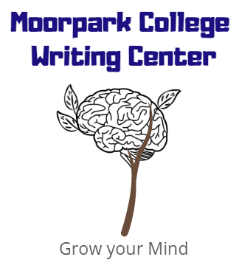
Thesis
moorparkcollege.edu/writingcenter
Defining a thesis statement:
What: The purpose of a thesis is to indicate the essay’s content and to establish a perspective.

Where: The thesis is usually placed as the last sentence of the 1st paragraph, or if the introduction is more than one paragraph, as the last sentence in the introduction.
How: The thesis is not a question or a fact or a problem itself. The thesis is the answer to a question or an opinion/interpretation about something or a solution to a problem.

*It is one statement* that summarizes the central idea of the paper. * A statement is 1-3 sentences.

A thesis should include:

Examples:
In order to evolve into a global society that appreciates and respects diversity, individuals must show the will to perceive life through the experiences of others.

Another thesis on this topic (using 1st person plural) might be…
In order to develop an understanding of diversity, we must be willing to actively listen to all voices, observe what is both similar and different in all of our lives, and then feel the experiences of others; without this conscious effort, we will continue to support the intolerance and apathy that leads to prejudice.

The thesis also could be more generalized as in this example:
In order to end prejudice, humanity must consciously take action that improves understanding of the diversity of the human experience.

How to Create a Thesis
Begin by brainstorming responses to these questions:

What is my guiding question for the paper? Or, what is the prompt asking?

What has my preliminary research, lecture, discussions, or assigned readings shown in answer to that question?

What is your perspective, interpretation, or solution to this issue? In other words, what stance are you taking?

What are some subpoints within this issue?

How do your main points answer the prompt?

Is it argumentative?

If I only had one single, simple statement in which to convey my thoughts, what would that statement be?

Your answer (above) should be your thesis.

Thesis Checklist:

- Did I answer the (entire) question?
- Have I taken a position that someone could challenge/oppose?
- Is my thesis specific?
- Does my thesis pass the “so what” and “how and why” test? Meaning it takes a side that someone could argue against, and it is specific enough that the reader is not left thinking “how or why?”

Thesis Diagram

Thesis Statement
Claim #1
Claim #2
Claim #3
Sub-point
(Evidence + Analysis)
Sub-point
(Evidence + Analysis)
Sub-point
(Evidence + Analysis)
Sub-point
(Evidence + Analysis)
Sub-point
(Evidence + Analysis)
Sub-point
(Evidence + Analysis)
Sub-point
(Evidence + Analysis)
Sub-point
(Evidence + Analysis)
Sub-point
(Evidence + Analysis)

