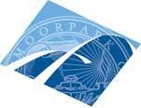 | 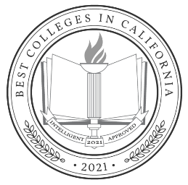 | Moorpark College  7075 Campus Road  Moorpark, CA 93021  805.378.1400  moorparkcollege.edu

For Immediate Release

Moorpark College Named Intelligent.com’s
Best Community College in California

Moorpark, Calif. (March 12, 2021) – Moorpark College is pleased to announce that it has been named Best Community College by Intelligent.com on its 2021 list of Best Colleges in California. A total of 190 accredited colleges and universities in the state were assessed. Of the 49 finalists, Moorpark College ranked sixth.

Intelligent.com evaluated the credit requirements and tuition costs of academic institutions varying in size from large research universities to community and liberal arts colleges with either online or on-site instruction.

The Seattle-based company used a comprehensive scoring system that included a detailed analysis of each institution’s level of student engagement and return on investment. Each institution was evaluated on curriculum quality, graduation rate, reputation and post-graduate employment. Based on these criteria, Moorpark College received a score of 97.44 out of 100.

“Moorpark College not only excels at providing students an excellent education to launch their careers or to transfer to a four-year college or university, we provide students with many enrichment opportunities to enhance their educations,” said Julius Sokenu, Interim President of Moorpark College. “It’s an honor to know that Moorpark College is the only community college to be included on the list.”

“This honor is a testament to Moorpark College’s faculty and staff, who prioritize the educational experience and outcomes of its students,” added VCCCD Board Vice Chair Dianne McKay.

This is the second recognition that Moorpark College has earned in the last six months, having been named a Champion of Higher Education by the Campaign of College Opportunity for the fifth consecutive year.

For more information on the Intelligent.com Best College Award, visit https://www.intelligent.com/best-colleges-in-california/

Information on the more than 150 Associate Degrees for Transfer, Career Education Certificates and Proficiency Awards offered at Moorpark College can be found at MoorparkCollege.edu/Academics.

About Moorpark College
Moorpark College is one of three colleges in the Ventura County Community College District and annually serves more than 14,000 students. Founded in 1967, Moorpark College is fully accredited and has the highest six-year completion rate within the California Community College System. The Campaign for College Opportunity named Moorpark College a 2020 Champion of Higher Education for the Associate Degree for Transfer Pathway. It is also a designated Hispanic-Serving Institution. The college’s signature career/technical programs include nursing, radiologic technology, biotechnology and journalism. The college’s America’s Teaching Zoo is the only associate degree exotic animal training program in the country. To learn more, visit MoorparkCollege.edu or follow @MoorparkCollege on social media.

###
Media Contact:
John Loprieno
Interim Director of IA
Community Relations & Marketing
(805) 378-1469
JLoprieno@vcccd.edu

