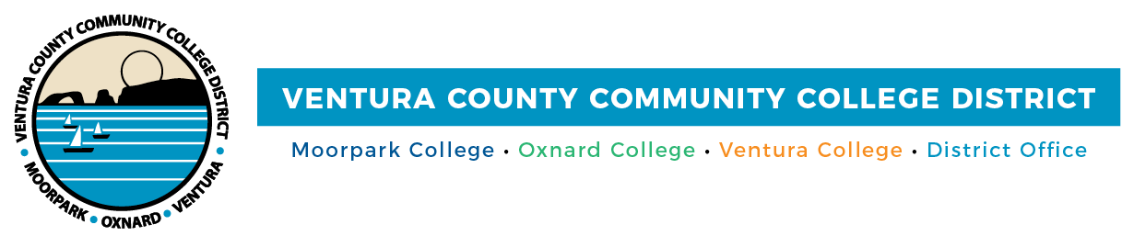

FOR IMMEDIATE RELEASE

Dr. Julius Sokenu Named Moorpark College President

Camarillo, Calif. (April 14, 2021)—The Ventura County Community College District board of trustees announces that Dr. Julius Sokenu has been named the president of Moorpark College, pending contract approval. Sokenu has served as the interim president since 2019 and has been with the college for 14 years.

“Dr. Sokenu is a visionary leader who supports the college’s approximately 14,000 students and the faculty and staff,” said Chancellor Greg Gillespie. “During his tenure as the interim president, he expanded and supported institutional priorities related to equity and diversity, specifically for services to underserved populations.”

“The board is pleased to have Dr. Sokenu as president of Moorpark College, where he can continue the initiatives he launched in the past two years and provide a continuity for the campus. His expertise in strategic planning and organizational leadership is a benefit to the college and District,” said Chair Joshua Chancer.

Sokenu joined Moorpark College as a dean in 2007. Over the years, he has taken on increasing leadership roles. He has 27 years of extensive and progressive leadership experience in community college education with 14 years of managerial oversight of instruction, student services, career technical education, noncredit programs and community relations.

He earned a doctorate in education, with an emphasis in curriculum and teaching, from Boston University and a master of fine arts degree, with an emphasis in creative writing, from Arizona State University. He holds bachelor’s degrees in English creative writing and business administration from the University of Southern California.

“It is an honor to serve Moorpark College as its next permanent president,” said Sokenu. “The college has a student-first philosophy that informs all decisions and serves as a clarion call. We are committed to student excellence, equity, achievement and racial and social justice. I am proud to continue building pathways to prosperity for our students.”

About Ventura County Community College District
The Ventura County Community College District is a member of the 116-campus California Community College system and serves approximately 31,000 students annually. The District's three colleges--Moorpark, Oxnard and Ventura--offer programs in general education for degrees and certificates, transfer to four-year colleges and universities, career technical education, and provide opportunities to engage in co-curricular campus activities. For more information, please visit vcccd.edu.

Media Contact:
Patti Blair
Director, Public Affairs and Marketing
Ventura County Community College District
communications@vcccd.edu

