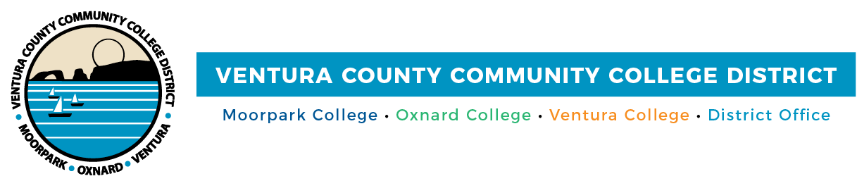

FOR IMMEDIATE RELEASE

Moorpark College Student Receives Statewide Writing Scholarship
Award enables Lauren Rosenthal to pursue her goals of transferring to a four-year university

Camarillo, Calif. (April 29, 2021)—Moorpark College student Lauren Rosenthal was recently awarded a $1,000 scholarship in the annual Community College Public Relations Organization (CCPRO) Writing Scholarship. The award was for her inspiring profile article on Moorpark College alumni Carmel Gutherz, a first-generation American who earned her master’s degree in education from Southern Methodist University and currently works for Teach for America as a corps member in Dallas/Fort Worth, Texas.

Rosenthal started as an intern in the Ventura County Community College District’s Public Affairs and Marketing Department in 2019 and is now a student worker with the department. Throughout her time with the District, she has written a number of articles that appear on the District’s website and in local publications.

“At the Career Transfer Center, we provide services that help students explore majors and careers,” said Dr. Celine Park, project specialist, Moorpark College Career Transfer Center. “Lauren was interested in a career involving writing. The District’s Public Affairs and Marketing Department was looking for a student to help craft press releases and student and employee profile articles, so it was a great match.”

“Lauren began as an intern and was then hired as a student worker because the District was so pleased with her work. We appreciate being able to give students, like Lauren, opportunities for growth and are so proud of all that she has accomplished,” added Raul Torres, career specialist, internship coordinator.

“Not only are opportunities to work at the District or its colleges a great learning experience, they enable students to earn money while in school,” said Trustee Bernardo M. Perez. “This enhances their VCCCD experience and sets them up for continued success in their chosen career path.”

An English major at Moorpark College, Rosenthal plans to transfer to a four-year university when she graduates in May. Her goal is to double major in English and cultural anthropology at UCLA, UC Santa Barbara, UC Berkeley or UC San Diego.

“Working for the VCCCD Marketing Department has taught me so much, not only about the field I hope to work in but also about professionalism and integrity,” said Rosenthal. “That being said, I'm constantly aware of the platform I've been given and my ability to inspire feelings of unity, guidance and advocacy through my writing.”

Rosenthal applied for the scholarship earlier this year. As part of the application, she discussed how the scholarship would impact her academic pursuits while sharing Gutherz’s story of overcoming personal obstacles to accomplish academic success.

Rosenthal will represent Moorpark College and participate in a student journalism panel at the annual CCPRO conference on April 30.

Excited to have received the award, Rosenthal credits her success to her professors and colleagues in the District.

“As I'm involved in writing and sharing news about the District and its colleges, I'm regularly reminded of all my resources and opportunities to achieve both personal and career success,” she added. “I feel surrounded by incredible superiors and co-workers whose attention is vocationally beneficial, motivating and uplifting. I'll always be grateful to those on the VCCCD Marketing team and others at Moorpark College who’ve supported me on my path.”

For students and employers who are interested in learning more about the Career Transfer Center, visit moorparkcollege.edu/departments/student-services/career-transfer-center/career-services.

About Community College Public Relations Organization (CCPRO)
CCPRO is a professional development and service organization that seeks to promote excellence in California’s community college public relations and related professions. The organization serves as a central resource of information and provides counsel and assistance relating to the advancement of community colleges statewide and the professional growth of its members.

About Ventura County Community College District
The Ventura County Community College District is a member of the 116-campus California Community College system and serves approximately 31,000 students annually. The District's three colleges--Moorpark, Oxnard and Ventura--offer programs in general education for degrees and certificates, transfer to four-year colleges and universities, career technical education, and provide opportunities to engage in co-curricular campus activities. For more information, please visit vcccd.edu.

Media Contact:
Patti Blair
Director, Public Affairs and Marketing
Ventura County Community College District
communications@vcccd.edu

