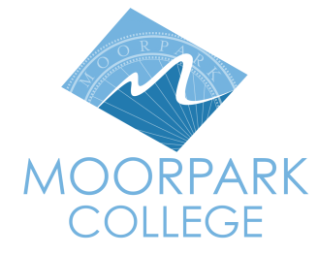 | 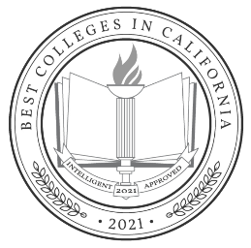 | Moorpark College  7075 Campus Road  Moorpark, CA 93021  805.378.1400  moorparkcollege.edu

For Immediate Release

Moorpark College Work-Based Learning Program
Championed by Congresswoman Julia Brownley

Moorpark, Calif. (August 12, 2021)–Moorpark College’s Work-Based Learning Program, a paid internship that connects students with local employers, is one of nine programs potentially to benefit from more than $20.6 million requested by Congresswoman Julia Brownley (D-CA 26th District) for Ventura County. Before the pandemic, the program, launched in 2018, annually served 250 students. The $225,000 in funds would provide an additional 150 students with $1,500 in paid internships while they earn college credit.

“I’m proud that so many of our community’s priorities were included in this first round of the appropriations process,” said Congresswoman Brownley. “Our work is only now beginning, and as these projects make it through the legislative process I will continue to fight for Ventura County’s priorities.”

Moorpark College’s work-based intern program came to the attention of Congresswoman Brownley’s Office after they reached out to the City of Moorpark to identify programs that encouraged outreach to local industries for internships. City officials contacted the college and requested information on projects and/or needs that federal funds could support.

Moorpark College leadership selected the Work-Based Learning program for its impact on the local economy and its benefit to students. In the program, eligible students work for at least 75 hours, earn $14.50 per hour and are enrolled for college credit. The $1,500 internship total also includes administration and payroll fees and statutory benefits. The internships enable students to apply classroom concepts in the workplace, gain practical experience toward a future career and supplement their income.

“We are excited about our partnership with the City of Moorpark and Congresswoman Brownley in recognizing our career education programs that support work-based learning,” said Robert Cabral, interim dean of student learning at Moorpark College. “This project improves the quality of post-secondary education by providing paid learning opportunities for our students and giving them insights into potential careers.”

The program uses existing processes at the college’s Career Transfer Center and actively engages with the local business community to locate internship opportunities. Each internship team consists of a student, workplace supervisor and faculty advisor. Together they set learning objectives for the student and meet three times to ensure that students achieve their objectives. Academic studies show that students in work-based learning programs are more likely to complete their studies and achieve their academic goals.

“It’s a privilege connecting employers with Moorpark College’s robust internship program,” said Dr. Celine Park, job developer in the college’s Career Center. “These connections allow us to better serve our students with workforce training and support business retention throughout Ventura County.”

The college partners with many local public and private employers to provide students with real-world experiences in a variety of career fields. The City of Moorpark was instrumental in securing the funding for Moorpark College and hosts interns from this program.

“The partnership between Moorpark College and the City of Moorpark provides students with first-hand experience in public administration and working directly with the community,” said Interim Community Development Director Doug Spondello, who hosted Hanna Dever, a planning intern and Moorpark College student, this summer. “This exposure broadens their understanding and helps inform their career decisions. We are very grateful for our relationship with Moorpark College and the dedicated advocacy of Congresswoman Brownley that provides for this.”

“The internship with the Moorpark Community Development Department has been an incredible experience. I have learned so much about how government works. It has been an amazing opportunity,” said Dever.

Once the Committee approves the draft fiscal year 2022 federal agency funding bills, they will advance to the floor for a vote by the full U.S. House of Representatives.

Information on the more than 150 Associate Degrees for Transfer, Career Education Certificates and Proficiency Awards offered at Moorpark College can be found at MoorparkCollege.edu/Academics.

About Moorpark College

Moorpark College Mission

Grounded in equity, social justice, and a student’s first philosophy, Moorpark College values diverse communities. We empower learners from local, national, and global backgrounds to complete their degree, certificate, transfer, and career education goals. Through innovation and customized student support, our programs are designed to achieve equitable outcomes.

Moorpark College is one of three colleges in the Ventura County Community College District and annually serves more than 14,000 students. Founded in 1967, Moorpark College is fully accredited and has the highest six-year completion rate within the California Community College System. The Campaign for College Opportunity named Moorpark College a 2020 Champion of Higher Education for the Associate Degree for Transfer Pathway. It is also a designated Hispanic-Serving Institution. The college’s signature career/technical programs include nursing, radiologic technology, biotechnology and journalism. The college’s America’s Teaching Zoo is the only associate degree exotic animal training program in the country. To learn more, visit MoorparkCollege.edu or follow @MoorparkCollege on social media.

###
Media Contact:
John Loprieno
Interim Director of IA
Community Relations & Marketing
(805) 378-1469
JLoprieno@vcccd.edu

