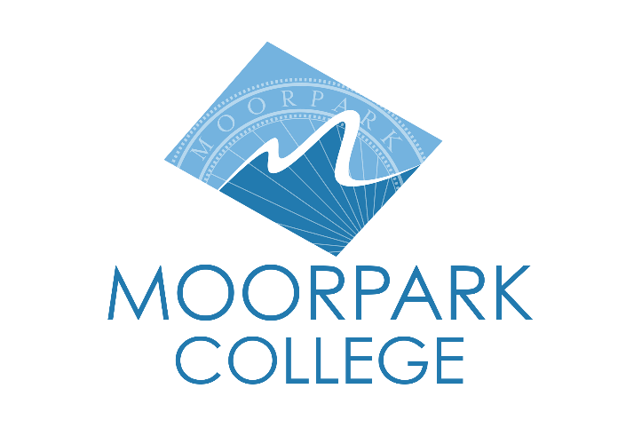 | Moorpark College  7075 Campus Road  Moorpark, CA 93021  Telephone: 805.378.1400  www.moorparkcollege.edu

For Immediate Release
Moorpark College Theatre Arts Brings “Nell Gwynn”
From Over the Pond to a Parking Garage

Moorpark, Calif. (September 29, 2021) - The Moorpark College Theatre Arts Department is proud to present live theatre with “Nell Gwynn,” a comedy that chronicles the true story of the play’s namesake, a prostitute turned orange-seller who becomes the mistress of King Charles II in 17th century London. The play runs Oct. 7 – 17, with matinee, evening and live streaming performances.

After much discussion and adhering to COVID-19 safety guidelines, the department received approval to perform the play in a parking garage on the Moorpark College campus, creating an indoor-outdoor theatre.

“This decision to perform in a parking garage was not easy, and it has presented many challenges. But with those challenges have come unexpected triumphs,” said Suzanne Fagan, who teaches in Moorpark College’s Theatre Arts Department and directs the show. “Though we are not performing it in a traditional theatre, the play, cast and crew solidified for me that theatre can be anywhere and is everywhere.”
Set Designer Brian Koehler echoed Fagan’s sentiments: “In facing the challenges of putting a traditional production in a very untraditional setting like a parking garage, we really wanted to re-examine how we looked at it. It doesn't work just ignoring this space and doing a show—it's obvious where we are. Hence, we've come up with what we are referring to as ‘The Nell Gwynn Experience.’”

“We are attempting to create something that is as much an art/scenic installation as it is a theatrical production set,” Koehler added. “It is exciting and a tad terrifying, and we hope you enjoy what we've created.”

British playwright Jessica Swale wrote the award-winning play, which premiered at Shakespeare’s Globe in 2015 and in the U.S. in 2018. It features music by Nigel Hess.

Moorpark College students Jade Morrisey and Erin Baxter share the role of the saucy, bawdy title character. Of the part, Morrisey said, “This show is a great reminder of what live theatre is about. ‘That one moment…and then, it’s someone else’s’ is such a beautiful line written by an incredible female playwright.”

“I love Nell because she represents someone that I think most people can relate to and get attached to,” Baxter added. “She feels very real to me, and I'm honored to be able to bring this amazing woman to life.”

Performances are Oct. 7, 8, 14 and 15 at 8 p.m.; Oct. 13 at 10 a.m.; and Oct. 9, 10, 16 and 17 at 2 p.m. in the parking garage on the southeast side of Moorpark College, 7075 Campus Road, Moorpark. Tickets are $5 for students and $10 for non-students.

Because seating is limited due to COVID-19 safety protocols, the department will also live stream the performance on Oct. 14 and Oct. 15 at 8 p.m. at no cost to viewers.

For more information about the live or streaming performances or to purchase tickets, visit the Moorpark College Performing Arts Center Box Office at moorparkcollege.edu/pac. For questions, email mcboxoffice@vcccd.edu or call (805) 378-1485.

Contact Fagan at sfagan@vcccd.edu for details or information on how to get involved with the Theatre Arts Department at Moorpark College.

About Moorpark College

Moorpark College Mission

Grounded in equity, social justice, and a students first philosophy, Moorpark College values diverse communities. We empower learners from local, national, and global backgrounds to complete their degree, certificate, transfer, and career education goals. Through innovation and customized student support, our programs are designed to achieve equitable outcomes.

Moorpark College is one of three colleges in the Ventura County Community College District and annually serves more than 14,000 students. Founded in 1967, Moorpark College is fully accredited and has the highest six-year completion rate within the California Community College System. The Campaign for College Opportunity named Moorpark College a 2020 Champion of Higher Education for the Associate Degree for Transfer Pathway. It is also a designated Hispanic-Serving Institution. The college’s signature career/technical programs include nursing, radiologic technology, biotechnology and journalism. The college’s America’s Teaching Zoo is the only associate degree exotic animal training program in the country. To learn more, visit MoorparkCollege.edu or follow @MoorparkCollege on social media.

Media Contact:
Suzanne Fagan
Moorpark College
(805) 553-4847
sfagan@vcccd.edu

