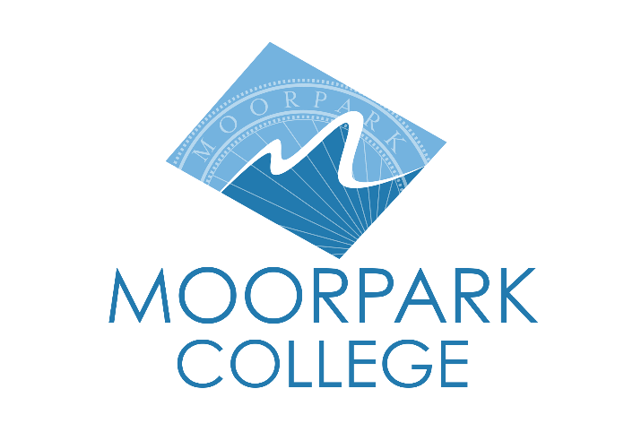 | Moorpark College  7075 Campus Road  Moorpark, CA 93021  805.378.1400  moorparkcollege.edu

For Immediate Release
“Boo at the Zoo” Offers No Tricks, Just Treats
America’s Teaching Zoo at Moorpark College Hosts Annual Family-Friendly Halloween Event

Moorpark, Calif. (October 8, 2021) –America’s Teaching Zoo at Moorpark College turns wildly spooktacular on Oct. 30 and 31 for “Boo at the Zoo,” the annual Halloween-themed event that features animal shows, costume parades, prizes and treats for kids.

For the family-fun event, the Zoo will be draped in decorations, and people of all ages can closely view the more than 100 animals cared for at the Zoo. Each child wearing a costume will receive a zoo-themed bingo card upon entry. Each square of the card represents a trick-or-treat station where the child can receive candy or a treat.

“Our guests look forward to our family-friendly Halloween event each year, and we have the best one around!” said Zoo Operations Assistant Kris Romero. “We have more and more local families discovering this gem of a Zoo in their own backyard, and we have new animals and new animal habitats for the community to discover.”

New this year, families will be introduced to Kylo the skunk and Chloe and Bubba the baboons.

Animal shows start at noon and 2:30 p.m., and animal demonstrations will be throughout the day at the Zoo, located on the Moorpark College campus, 7075 Campus Road, Moorpark.

All tickets must be pre-purchased; no tickets will be sold at the gate. Tickets are available at https://zoo.moorparkcollege.edu/. Entry fee is $9 for adults and $7 for children ages 3-12. Kids ages 2 and under are admitted free.

“Boo at the Zoo” attendees must follow COVID-19 safety protocols, and social distancing guidelines will be enforced.

America’s Teaching Zoo is the only zoo in Ventura County and is the home of the Exotic Animal Training and Management Program, which started in 1971. The program offers preparation for those interested in entering the expanding animal care industry. The students study zoo keeping, basic medical care, wildlife education and training using positive reinforcement methods.

For additional information, call Mara Rodriguez at (805) 378-1441. Follow the Zoo on Instagram at @americasteachingzoo.

About Moorpark College

Moorpark College Mission

Grounded in equity, social justice, and a students first philosophy, Moorpark College values diverse communities. We empower learners from local, national, and global backgrounds to complete their degree, certificate, transfer, and career education goals. Through innovation and customized student support, our programs are designed to achieve equitable outcomes.

Moorpark College is one of three colleges in the Ventura County Community College District and annually serves more than 14,000 students. Founded in 1967, Moorpark College is fully accredited and has the highest six-year completion rate within the California Community College System. The Campaign for College Opportunity named Moorpark College a 2020 Champion of Higher Education for the Associate Degree for Transfer Pathway. It is also a designated Hispanic-Serving Institution. The college’s signature career/technical programs include nursing, radiologic technology, biotechnology and journalism. The college’s America’s Teaching Zoo is the only associate degree exotic animal training program in the country. To learn more, visit MoorparkCollege.edu or follow @MoorparkCollege on social media.

Media Contact:
Mara Rodriguez
America’s Teaching Zoo at Moorpark College
(805) 378-1441
mararodriguez@vcccd.edu

