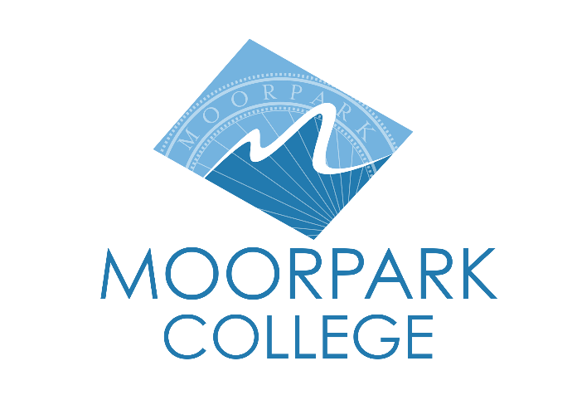 | Moorpark College  7075 Campus Road  Moorpark, CA 93021  805.378.1400  moorparkcollege.edu

For Immediate Release

Moorpark College Fall Dance Concert Showcases “Speaking Movement”
Dance Artists and Choreographers Perform Two Evenings of Meaningful Movement

Moorpark, Calif. (October 27, 2021)–After more than a year of remote learning, faculty and student choreographers and student dancers from the Moorpark College Dance Department joyfully return to live performances on Nov. 12 and 13 for “Speaking Movement.”

The fall concert features 12 pieces that reflect the choreographers’ interpretations of ever-evolving social dynamics and relationships while intimately reflecting on our human experience.

Works range from funky to fun and from poignant to provocative. They include ballet, contemporary dance and tap and are performed by 19 Moorpark College student dancers, many of whom are in three or four pieces. The dancers worked with each choreographer to deliver a vision that is unique and discrete to the work.

“Dance is most enjoyable live, where you can see the efforts of the dancers, hear the noise of their feet on the floor, hear them breathing and feel the energy permeating the shared space,”
said Beth Megill, Moorpark College dance faculty and the show’s artistic director. “Dance reminds us of our human fragility in a way like no other. In a world where we are navigating victimhood, oppression and trauma, performance goes way beyond entertainment.”

The concert also includes more than 100 costumes and technical support from the college’s theater students under the direction of the performing arts center’s Technical Director Ariana Burrell and Performing Arts Technician Melissa Lay.

This performance gives voice to a company of dance artists navigating meeting together in shared spaces after living in isolation for more than a year. According to Megill, the event’s title reflects the freedom of expression we support through these works.

“Movement speaks beyond the verbal. It can speak to the heart and spirit as well as the head. There is nothing more revealing of the human condition than bodies in motion,” she added.

Students and faculty were invited to produce work that was meaningful to them. Some works follow a specific “story,” while others celebrate human movement and the designs of time and space.

A sampling of the dance performances includes:

The Other Side
Veteran faculty choreographer Vivian Goldes offers a beautiful balletic work that highlights grace and flow as it evokes images of connection and ensemble after a time of separation and isolation.

For the Culture
Student choreographer Tatyana Peña pays homage to her heritage in a celebration of Black culture in America that grooves through a blend of social and concert dance styles rooted in Africanist aesthetics.

Back in Place
Morpheus Kostromin returns as a student choreographer with a piece about the human desire to endure amidst a world of numbness and sorrow.

“Live dance theater is the unpredictability of humanness and art,” said Kostromin. “Dancing on stage is an experience like no other—it's like time has stopped, and it's just you and the theater, and the dance is your conversation.”

Performances for “Speaking Movement” begin at 7:30 p.m. on the main stage of the Moorpark College Performing Arts Center, located at 7075 Campus Road, Moorpark. Tickets are $15.

For more information or to purchase tickets, visit the Moorpark College Performing Arts Center Box Office at www.moorparkcollege.edu/pac or contact Krista Lederer at (805) 378-1485. Important COVID-related safety information is also available on the box office website.

For additional information or programming questions, contact Megill at bmegill@vcccd.edu.

About Moorpark College

Moorpark College Mission

Grounded in equity, social justice, and a students first philosophy, Moorpark College values diverse communities. We empower learners from local, national, and global backgrounds to complete their degree, certificate, transfer, and career education goals. Through innovation and customized student support, our programs are designed to achieve equitable outcomes.

Moorpark College is one of three colleges in the Ventura County Community College District and annually serves more than 14,000 students. Founded in 1967, Moorpark College is fully accredited and has the highest six-year completion rate within the California Community College System. The Campaign for College Opportunity named Moorpark College a 2020 Champion of Higher Education for the Associate Degree for Transfer Pathway. It is also a designated Hispanic-Serving Institution. The college’s signature career/technical programs include nursing, radiologic technology, biotechnology and journalism. The college’s America’s Teaching Zoo is the only associate degree exotic animal training program in the country. To learn more, visit MoorparkCollege.edu or follow @MoorparkCollege on social media.

Media Contact:
Beth Megill
Artistic Director and Moorpark College Dance Program Lead
(805) 433-4649
bmegill@vcccd.edu

