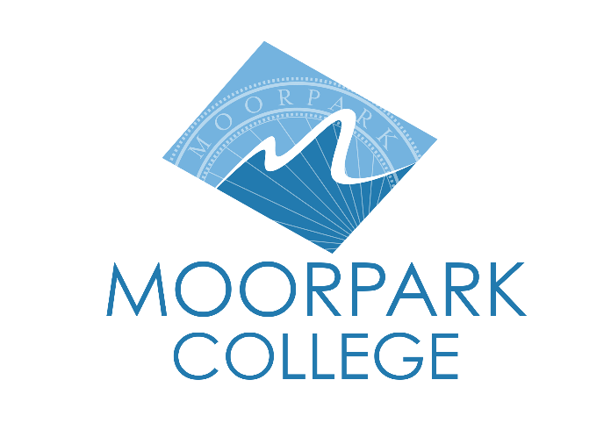 | Moorpark College  7075 Campus Road  Moorpark, CA 93021  805.378.1400  moorparkcollege.edu

For Immediate Release

Bengal Tigers to Get a New $3.5 Million Habitat at
America’s Teaching Zoo at Moorpark College
Groundbreaking ceremony kicks off construction for Rajah’s Retreat and Habitat

Moorpark, Calif. (November 19, 2021)—Following a groundbreaking ceremony at America’s Teaching Zoo at Moorpark College on Nov. 16, the Zoo’s big cats, Neil and Karma, are one step closer to living in an approximately 4,000-square-foot habitat complete with a tiger tunnel connecting two large enclosures. The project will also feature a water installation where they can splash and play in front of Zoo guests and glass viewing areas for visitors.

The event commemorated the start of formal construction for Rajah’s Retreat Tiger Exhibit and Habitat, the $3.5 million sanctuary for the Bengal tigers. Planning began in 2017 when Neil and Karma arrived at the Zoo. Each weighed around 50 pounds; today, Neil and Karma are 375 and 275 pounds, respectively.

“When completed, Rajah’s Retreat will be the embodiment of the dreams of our students, faculty and staff brought to life through the support of our community members and business partners,” said Moorpark College President Julius Sokenu.

Guests included Ventura County Community College District Board Vice Chair Dianne B. McKay, Trustee Stan Mantooth and Chancellor Greg Gillespie. Other special guests included Grammy-nominated performing artist John Ondrasik (Five for Fighting) and his family and Moorpark College leadership and donors.

“I have been to the Zoo countless times over the years and always have been impressed with the caliber of the students and staff. This new exhibit is to be celebrated for how it prioritizes the majestic cats’ quality of life and provides the community with an opportunity to learn about the tigers,” said McKay.

“Growing America’s Teaching Zoo to provide our animals with more naturalistic enclosures is high on our priority list,” added Mara Rodriguez, zoo development coordinator. “Completing the lion exhibit earlier this year and launching the construction of the tiger habitat within months of each other is an indicator that our goals are attainable and that the animals will continue to thrive under our care.”

Following remarks, the group held a “Golden Shovel” ceremony to acknowledge major gifts from Moorpark College and other donors, as well as the hundreds of contributions from the community who helped fulfill the long-awaited dream of building a retreat for the tigers.

Ondrasik and his wife, Carla, are regular Zoo patrons, and their son attends Moorpark College. In September, the couple hosted “Concert for the Cats” at the college. The live, outdoor concert raised more than $50,000 for the project, which is expected to be completed in June 2022.

Amador Whittle Architects in Agoura Hills designed the 8,700-square-foot development that will be constructed by the Bedrock Group Inc., La Canada Flintridge.

“The Exotic Animal Training Management program and America’s Teaching Zoo provide wildlife education and model animal conservation practices for children and adults. Learning in the new tiger habitat will prepare our students for careers in high-wage, high-skill employment in zoos, wildlife rehabilitation centers and aquariums,” said Sokenu.

For more information about supporting the tigers, America’s Teaching Zoo or questions about visiting the Zoo, go to zoo.moorparkcollege.edu or call (805) 378-1441.

About Moorpark College

Moorpark College Mission

Grounded in equity, social justice, and a students first philosophy, Moorpark College values diverse communities. We empower learners from local, national, and global backgrounds to complete their degree, certificate, transfer, and career education goals. Through innovation and customized student support, our programs are designed to achieve equitable outcomes.

Moorpark College is one of three colleges in the Ventura County Community College District and annually serves more than 14,000 students. Founded in 1967, Moorpark College is fully accredited and has the highest six-year completion rate within the California Community College System. The Campaign for College Opportunity named Moorpark College a 2020 Champion of Higher Education for the Associate Degree for Transfer Pathway. It is also a designated Hispanic-Serving Institution. The college’s signature career/technical programs include nursing, radiologic technology, biotechnology and journalism. The college’s America’s Teaching Zoo is the only associate degree exotic animal training program in the country. To learn more, visit MoorparkCollege.edu or follow @MoorparkCollege on social media.

Media Contact:
Mara Rodriguez
mararodriguez@vcccd.edu
805.378.1441

