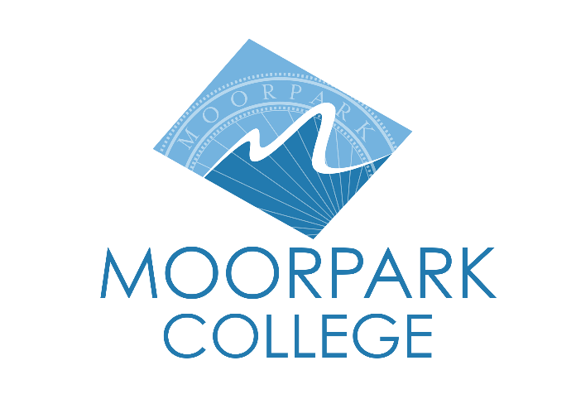 | Moorpark College  7075 Campus Road  Moorpark, CA 93021  Telephone: 805.378.1400  www.moorparkcollege.edu

For Immediate Release

Tony Award-Winning Musical “Kinky Boots” Auditions
Held at Moorpark College
College among initial amateur theatres in the U.S. to stage production

Moorpark, Calif. (November 23, 2021)–The Moorpark College Theatre Arts Department will hold auditions for its spring 2022 production of the six-time Tony Award® Winning Best Musical “Kinky Boots.” Auditions for actors and musicians will be held Dec. 10-15 on campus. The play will run in March with evening and matinee performances.

“We are overjoyed to be returning to the Moorpark College main stage with a theatre arts performance for the first time in two years with ‘Kinky Boots,’” said director and theatre arts faculty member John Loprieno.

“It’s especially exciting because the rights for ‘Kinky Boots’ were just released, and we are honored to be one of the first non-professional theatres to be producing this hilarious and vibrant musical.”

Based on the eponymous 2005 film, “Kinky Boots” features the joyous, Tony Award-winning score with music and lyrics by singer-songwriter Cyndi Lauper and an uplifting book from playwright Harvey Fierstein. It is mostly inspired by true events and centers around Charlie Price, who reluctantly inherited his father’s shoe factory that is on the verge of bankruptcy.

Trying to live up to his father’s legacy and save the family business, Charlie finds inspiration in a fabulous entertainer named Lola in need of some sturdy stilettos. Lola turns out to be the one person who can help Charlie discover his potential. In the process, the duo find that they have more in common than they thought, and they learn that when you change your mind about someone, you can change your whole world.

“This is a perfect show with a perfect message for these challenging times,” said Loprieno.

Audition and callback dates, times and locations are as follows:

- Dance Auditions – Dec. 10, 12:30-2 p.m., in the Performing Arts Center Dance Studio, PA-107
- Orchestra Pit Auditions – Dec. 11, 1:30-4:30 p.m., in the Music Building, M114
- Acting Auditions – Dec. 13, 6-10 p.m., and Dec. 14, 3:30-6 p.m., on the main stage of the Performing Arts Center
- Callbacks – Dec. 15, 6-10 p.m., on the main stage of the Performing Arts Center

All will take place on the Moorpark College campus, 7075 Campus Road, Moorpark. An accompanist will be present for the auditions. Anyone auditioning should bring 32 bars, or one minute of sheet music, preferably from musical theatre.

“Kinky Boots” will run March 10 through March 27 with evening performances from Thursday to Saturday at 8 p.m. and Sunday matinees at 2 p.m. in the Studio Theatre at Moorpark College. Tickets go on sale Jan. 15 and can be purchased through the Moorpark College Performing Arts Center Box Office at (805) 378-1485 or online at www.moorparkcollege.edu/pac.

For additional information about the show or the Moorpark College Theatre Arts Department, contact Loprieno at (805) 378-1469 or jloprieno@vcccd.edu.

About Moorpark College

Moorpark College Mission

Grounded in equity, social justice, and a students first philosophy, Moorpark College values diverse communities. We empower learners from local, national, and global backgrounds to complete their degree, certificate, transfer, and career education goals. Through innovation and customized student support, our programs are designed to achieve equitable outcomes.

Moorpark College is one of three colleges in the Ventura County Community College District and annually serves more than 14,000 students. Founded in 1967, Moorpark College is fully accredited and has the highest six-year completion rate within the California Community College System. The Campaign for College Opportunity named Moorpark College a 2020 Champion of Higher Education for the Associate Degree for Transfer Pathway. It is also a designated Hispanic-Serving Institution. The college’s signature career/technical programs include nursing, radiologic technology, biotechnology and journalism. The college’s America’s Teaching Zoo is the only associate degree exotic animal training program in the country. To learn more, visit MoorparkCollege.edu or follow @MoorparkCollege on social media.

Media Contact:
John Loprieno
jloprieno@vcccd.edu
(805) 378-1469

