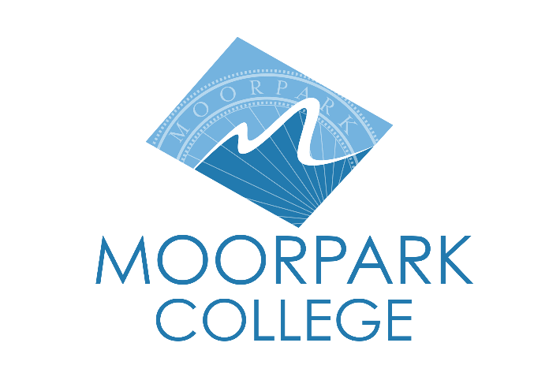 | Moorpark College  7075 Campus Road  Moorpark, CA 93021  Telephone: 805.378.1400  www.moorparkcollege.edu

For Immediate Release
Video Link
Media Guide Link
America’s Teaching Zoo at Moorpark College
Sparks Seasonal Cheer with “Wild Lights & Disco Nights”
Evenings under the stars feature a twinkling disco ball forest
and an interactive light wall

Moorpark, Calif. (November 23, 2021)—America’s Teaching Zoo at Moorpark College lights up the holiday season with its first-ever “Wild Lights & Disco Nights.” The Zoo will be decked out for the holidays with a canopy of lights on Ira the Lion’s den, a sparkling disco ball forest and thematic evenings where guests can wear “groovy” garb from the 1970s or other themed attire. This festive evening event for the whole family runs Nov. 24-28 (closed Thanksgiving Day) and select dates through December.

For the first time in its 50-year history, the Zoo will be open to the public at night. “This will be visitors’ first opportunity to see animals in the dark, and for them to see you,” said Mara Rodriguez, zoo development coordinator. “It’s a festive event that is also educational. Will you look into the green eyes of a tiger? Does Ira the Lion sleep at night or play?” Attendees can bop to ‘80s dance music and holiday tunes in the Zoo’s “Artic Vibes” area that features an interactive light wall that responds to the music’s beat and dancers’ moves.

“Creating a safe outdoor holiday experience for guests of all ages was actually a fun task for our staff after such an unpredictable couple of years,” said Zoo Operations Supervisor Alisa Behar. “There will not be a brighter hilltop in all of the area--I can assure you of that!”

“Wild Lights & Disco Nights” festivities also include:

- A 30-foot “snowfall” tree lit in white and dripping with light icicles
- Four theme nights, where guests receive giveaway items that glow and can sport ‘70s-style clothing, ugly holiday sweaters and matching holiday pajamas
- Take a family photo beside a 12-foot Christmas tree

During the wild wonderland events, attendees can also take a self-guided walk through the Zoo’s main area, where they can participate in photo opportunities near colorful vistas.

Events take place Nov. 24, 26, 27 and Dec. 3, 4, 10, 11, 17-19, 21-23 from 6 p.m. to 8:30 p.m. at the Zoo, located on the Moorpark College campus, 7075 Campus Road, Moorpark. The Zoo will offer value nights, with reduced ticket prices on Nov. 28 and Dec. 5, 16 and 20. Last entry time for all evenings is 7:45 p.m.

Advanced ticket purchases are recommended. Tickets are $8 to $11 and are available at https://zoo.moorparkcollege.edu/holiday-lights. Value night tickets are $7 and $9; children ages 2 and under are admitted free.

“Wild Lights & Disco Nights” attendees must follow COVID-19 safety protocols, and social distancing guidelines will be enforced. Events will occur rain or shine.

America’s Teaching Zoo is the only Zoo in Ventura County and is the home of the Exotic Animal Training and Management Program, which started in 1971. The program offers preparation for those interested in entering the expanding animal care industry. The students study zoo keeping, basic medical care, wildlife education and training using positive reinforcement methods.

For additional information, call Mara Rodriguez at (805) 378-1441. Follow the Zoo on Instagram at @americasteachingzoo.

About Moorpark College

Moorpark College Mission

Grounded in equity, social justice, and a students first philosophy, Moorpark College values diverse communities. We empower learners from local, national, and global backgrounds to complete their degree, certificate, transfer, and career education goals. Through innovation and customized student support, our programs are designed to achieve equitable outcomes.

Moorpark College is one of three colleges in the Ventura County Community College District and annually serves more than 14,000 students. Founded in 1967, Moorpark College is fully accredited and has the highest six-year completion rate within the California Community College System. The Campaign for College Opportunity named Moorpark College a 2020 Champion of Higher Education for the Associate Degree for Transfer Pathway. It is also a designated Hispanic-Serving Institution. The college’s signature career/technical programs include nursing, radiologic technology, biotechnology and journalism. The college’s America’s Teaching Zoo is the only associate degree exotic animal training program in the country. To learn more, visit MoorparkCollege.edu or follow @MoorparkCollege on social media.

Media Contact:
Mara Rodriguez
Zoo Development Coordinator
mararodriguez@vcccd.edu
(805) 378-1441

