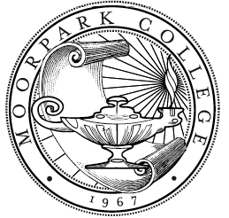
Moorpark College
Scholarship Application

Student I.D. #: _________________________________________________________
Name of Scholarship: Classified Senate Scholarship
Student Name: __________________________________________________________________________
Address: _______________________________________________________________________________
City: _______________________________ State: ______________________ Zip: ____________________
Email: ________________________________________________________________________________________
Home Phone: (_________) _________ - _________ Cell Phone: (_________) _________ - __________
Self (MC Classified Employee) working towards a degree: _________
Self (MC Classified Employee) Professional Development: _________
Spouse or Child/Dependent – working towards a degree: __________
If you checked Spouse or Child/Dependent, list the name of the MC Classified Employee: ______________________
Eligibility Criteria:
- Classified Employee seeking to enroll (or currently enrolled in) a professional development course at a higher learning accredited institution or working towards a degree.

- Spouse or Dependent (s) of a MC Classified Employee currently enrolled at a higher learning accredited institution working towards a degree.

- Applicant must be an undergraduate or graduate student in a degree-seeking program
- Full-time or Part-time (6 or more units) – transcripts must be submitted to verify enrollment.
- GPA of 2.5 or higher

Essay Prompt:
For Classified Employee:
Please describe in detail, how this scholarship award would impact your work? Explain how you will apply/incorporate what you have learned and integrate it with your work.

For Spouse or Dependent (s) of Classified Employee:
Please describe in detail, how this award will help achieve your educational goals and include specific examples if possible.
I authorize the college to release requested information from my student records to validate scholarship eligibility, and use my name for publicity purposes if I am awarded a scholarship. I also authorize my email to be shared with the Moorpark College Foundation.

________________________________________________ _____________/_____________/_____________
Applicant’s Signature Date

