Let’s get together…

Join us for Develop Your Personal Brand To Meet All Your Goals
with Katy Goshtasbi
on August 12, 2021, at 12:30 PM.

Take part in this online event via Zoom or join the watch party in room T-216.

We hope you can make it!!

About this event
Our personal brands make us unique as humans. They also create an environment where conflict reigns and diversity is lacking if the personal brand distinctions are not clarified and harnessed well. When done well, the results are a thriving and happy work environment, easy self-promotion, collaborative work environment, maximum efficiency and better relationships.

Until August 12, spend a few minutes during your typical day considering the following:
- How do others view you and your brand right now?
- How would you like to be viewed and remembered by your colleagues?
- What is one challenge you face at work?
- What is one opportunity you have/may have coming up for you at work?

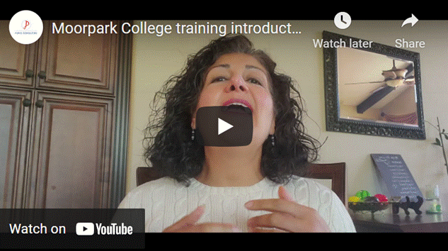

Speaker Bio:
Katy Goshtasbi is a branding, diversity and growth expert and founder of Puris Consulting. She works with organizations on growing with diversity, in size and profits, by mastering change and developing brands that get their message out effectively and ethically. The results include happier, more productive employees, reduced stress, attracting better clients and more revenues. Katy practiced securities law for over 14 years at the US Securities & Exchange Commission, on Capitol Hill, in a major law firm and in-house. She has written two books on the subject matter, one for the ABA. She was the 2018-2019 Chair of the ABA Law Practice Division and 2020-2021 Chair of the Division's Diversity & Inclusion Committee.

She can be reached by email at katy@purisconsulting.com.

