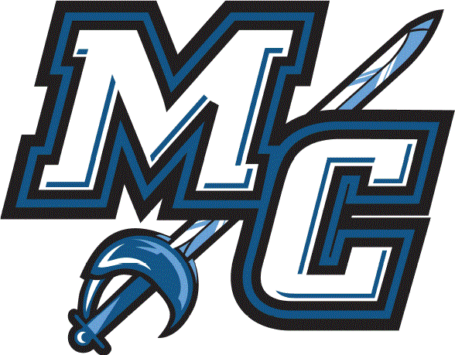
Moorpark College Athletics Mentor Program
The Moorpark College Athletic Mentor program is an opportunity to foster a relationship between intercollegiate athletics and the rigors of the undergraduate academic expectations at Moorpark College.
The program allows academics and athletics to effectively integrate and work together to bolster the mission of Moorpark College and support the CCCAA Student-athlete experience. The partnership with athletics and academics helps student-athletes understand the importance of academics as part of the team culture within Moorpark College Athletics. In addition, the Mentor Program provides an academic mentoring point of contact for student-athletes and coaches.
Mentors are Employees from the campus and vetted by the Athletic Director, Coaches, and TMWOCA's. Each team has one or two volunteers who understand and appreciate athletics as a meaningful and valuable part of the student-athletes college experience.
Specific expectations of the mentor program are determined by the mutual agreement between the volunteers and the head coach and based on program needs.
Mentors are Volunteers who are willing to develop relationships and have a positive impact on our student's lives

Possible duties include:
- Attend at least two practices per season; level and type of involvement is entirely at the head coach's discretion and mutually agreed upon
- Attend at least two home contests per season
- Attend one away game if practical
- Serve as a role model and resource as an additional advisor/mentor to the student-athletes you are serving.
- Serve as an academic link or point of contact if there is an academic conflict or problem for a member on that team. Work collaboratively with the Athletic Director and Counseling on these types of issues.
- Help to foster harmonious connections between the academic, athletic, and social cultures of our campus.
- Serve as an enthusiastic supporter of your specific sport and sports in general at Moorpark.
- When possible, attend get-together meetings with other Faculty Athletic Mentors to share experiences and provide mutual support, encouragement, and best practices.
  - Included but not limited to meeting before or after games.
  - Athletics Meetings
- Meet with prospective student-athletes for that sport
- Host or take student-athletes to dinner or lunch when possible
- Share life experiences and personal perspectives with student-athletes, especially first year students navigating their new environment
- Instruct and model for students how to interact/communicate with professors in the event they need to handle academic conflicts or requests
- Help with coordinating and participating in community service events when possible
- Be highly accessible by student-athletes and coaches (i.e., permit cell phone contact)

