Introduction to Drupal 8

Ventura County Community College District
Office of Public Affairs and Marketing
Revised 06.08.2021

Table of Contents
Introduction to Drupal 8 3
Overview 3
Objectives 3
Accessibility 4
Getting Started 5
Logging In 5
Drupal 8 Menu 6
Managing Content 7
Add Content: 7
Editing and Adding a Page 7
Content 7
Basic Page Title 9
Hero Slideshow or Image 9
Hero Banner of Slideshow- Adding Media 9
Images and PDFs 12
Accordion 12
Expanding Existing Menus 12
Paragraphs 13
Events and Articles 15
Accessibility and Adding Files and Media 17
Images and Graphic Design Accessibility 17
Adobe Acrobat and PDF Accessibility 17
Checking PDF Accessibility 18

Introduction to Drupal 8

Overview
Welcome to Drupal 8, a powerful content management system. This guide will facilitate your learning and familiarize you with Drupal and the layout of the site, regardless of your skill level.

Objectives
In this VCCCD Introduction to Drupal 8, users will learn:

- How to log in.
- Site layout: menus, employee directory, newsroom, maps, and events.
- How to create a:
  - Basic page
  - Event
  - News article
- File Organization/How to add:
  - Content
  - Media
  - Documents
- Employee Directory
- News Articles and Calendar Events
- Accessibility Requirements

Other trainings offered include:

- Graphics for Web
- Photos for Web

If you have any questions, email websiteupdates@vcccd.edu

Accessibility
A few words about accessibility before we get started. VCCCD is building a culture of accessibility. This is our commitment. What does that mean?

A 2017 Accessibility White Paper discusses the importance of accessibility in all communications. Access to instructional materials and information and communication technology (ICT) is integral to fulfilling the missions of the California Community Colleges, higher education institutions designed to serve all members of our communities. Accessibility standards and institutional policies and procedures work in conjunction to promote a campus culture supporting access for individuals with disabilities. Many students, faculty, staff, and community members have a disability.
According to data collected by the California Community Colleges Chancellor’s Office, in the 2015- 2016 academic year over 121,000 students with disabilities were identified through the Disabled Students Programs & Services (DSPS), and many more are likely unidentified. Examples of different disabilities include blind and low-vision, mobility impairment, chronic health conditions, and cognitive or psychological disorders. Students with disabilities face a variety of accessibility challenges making it difficult to interact with the college and complete their work, which places them at a higher risk for matriculation and completion failure.
Accessibility standards ensure students, faculty, staff, and community members from all backgrounds can access college services.
More information on accessibility is available at: California Community Colleges Accessibility Center proactively assesses the California community college system’s web and information technology accessibility needs and offers services, guidance and technical assistance to help colleges in realizing an accessible technology environment.
Diversity and inclusion are core values embraces by the California Community Colleges. Accessible websites and information technology positively impacts individuals with disabilities, offering greater opportunity for engagement and participation in pursuit of lifelong learning throughout California’s community colleges.
World Wide Web Consortium (W3C). An international community that develops open standards to ensure the long-term growth of the Web.
As a Drupal 8 user, you have a responsibility to make sure your webpages, graphics, photos, and videos meet accessibility standards. Get your webpage published – be accessible.

Getting Started

Logging In
- sign in by going to my.vcccd.edu
- sign in with your MyVCCCD credentials
- Click on the "Work Life" tab
- Scroll down and locate the "Public Websites" channel, then locate the “Content Editor Access” section
- Inside the channel, look for the link for your site (Moorpark College = "Drupal Moorpark")

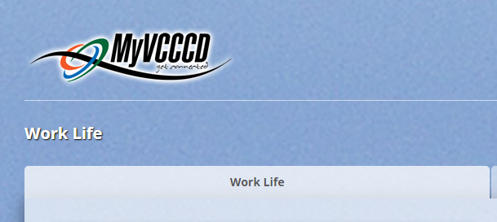

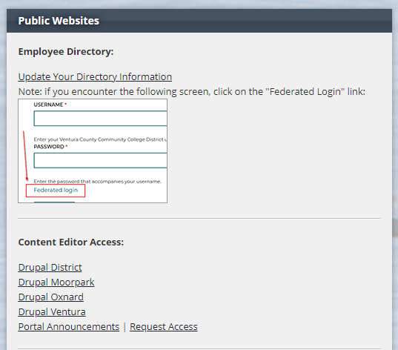

Drupal 8 Menu
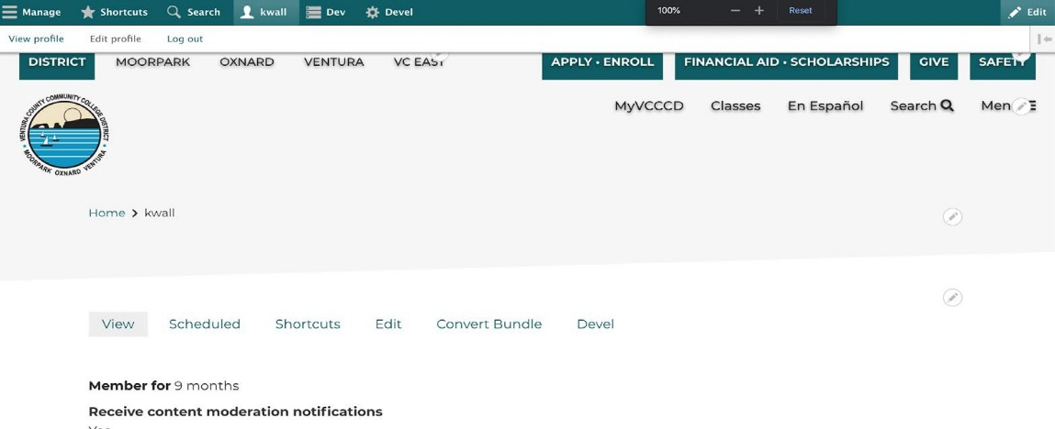
Now that you have logged into the site, you will want to familiarize yourself with the site structure. In the top left corner, click “Manage.”
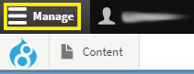

Managing Content

Depending on your access, the menu will expand to include the following menu: Content

Add Content:
  - Files- files that have been uploaded. (Site Editors and Administrators Only)
  - Media – media that has been uploaded.
  - My Groups – access to groups (departments/sections) that are assigned to you.

Editing and Adding a Page
First, click “Content.”
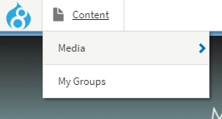

Content
Hover over Content to see:
  - Media
  - My Groups
This is the place to create or edit information. If you compare the site to a newspaper this is the site’s articles. All of the site’s information is stored here. Click Content. From this menu you can Click “Add Content” or search by title, content type, workbench, or published status then click Filter.
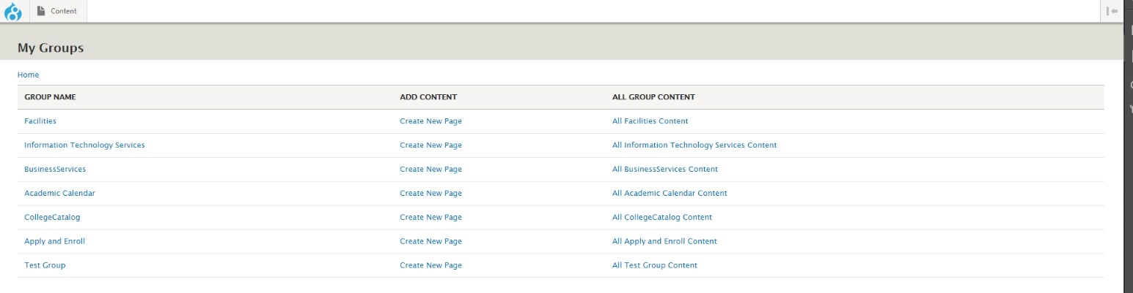
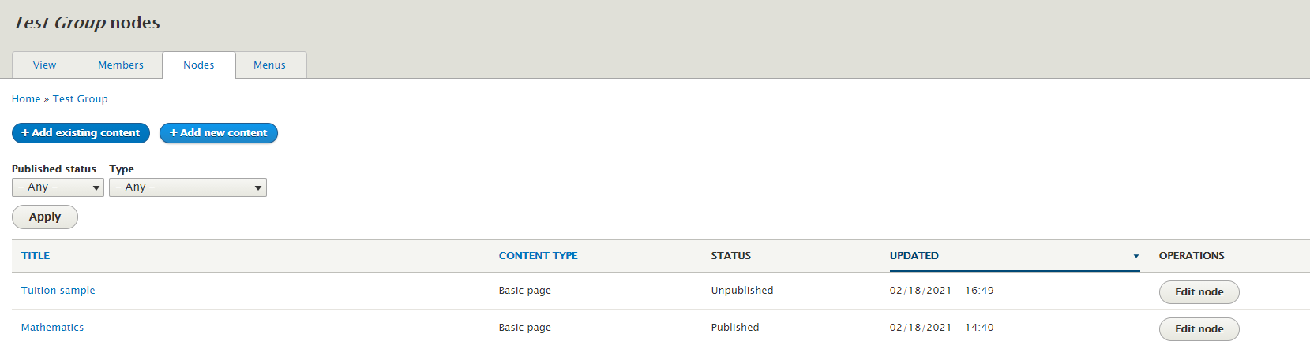
Don’t see your group? Submit a Website Request

Now let’s create a basic page. This test page will be deleted after training. You should be at the “Create Basic page” screen.
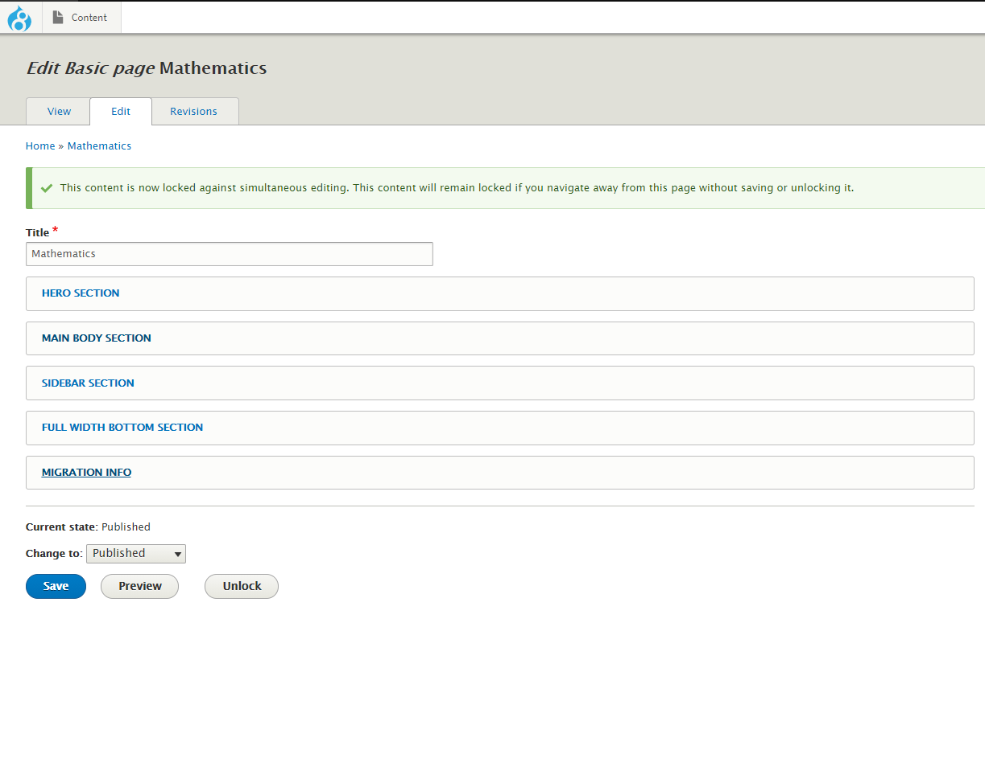

This is where you will add content to your page.

Basic Page Title
Add the following title to your page: Drupal 8 Test Page – YOUR NAME Pages content sections. Each section contents paragraphs.

Hero Slideshow or Image
This header hero section is the first section where you can add paragraphs. Paragraphs are small pieces of reusable content, which are meant to be added to specific pages.

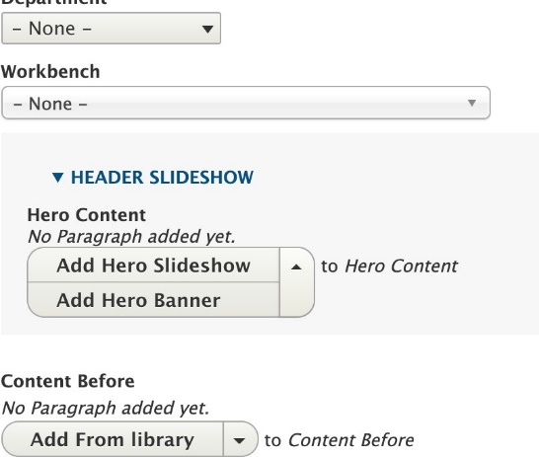

Hero Banner of Slideshow- Adding Media
Paragraphs are designed to allow content creators to be flexible and choose what works best for the page you create.
Click the Hero Banner. You can add a photo or video. Click add media.
Here you can upload your own hero image, or use one which has been used on another page. I’m going to select a previously used hero image for this example. Click insert selected when you are done.

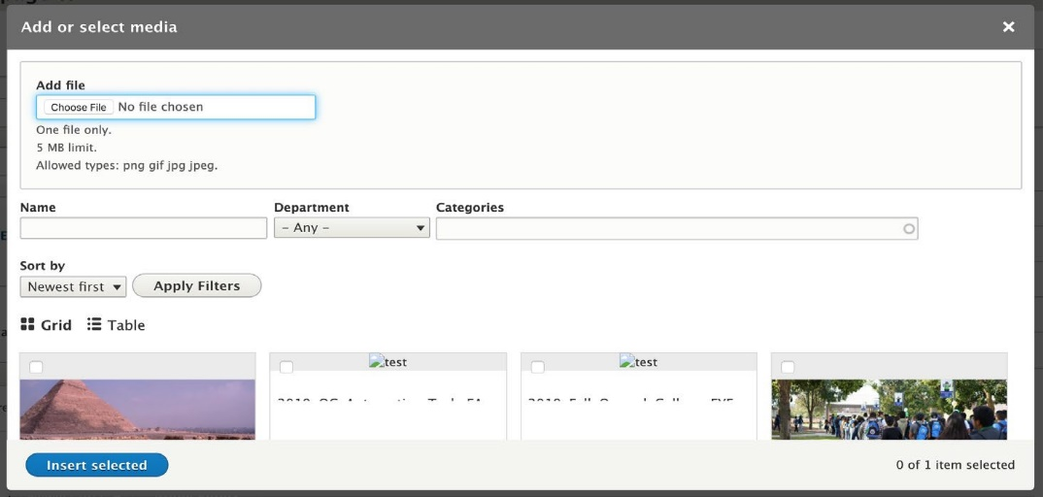

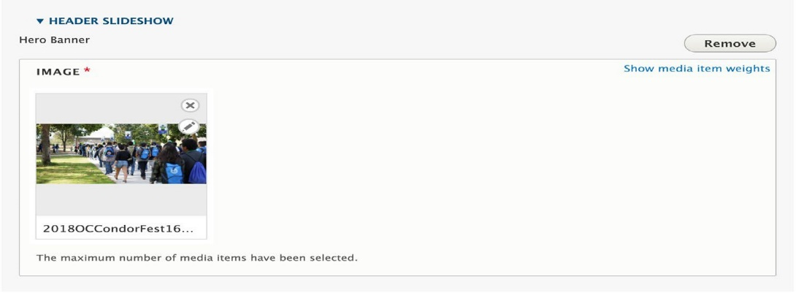
Now the image can be seen in the paragraph section where we added it.

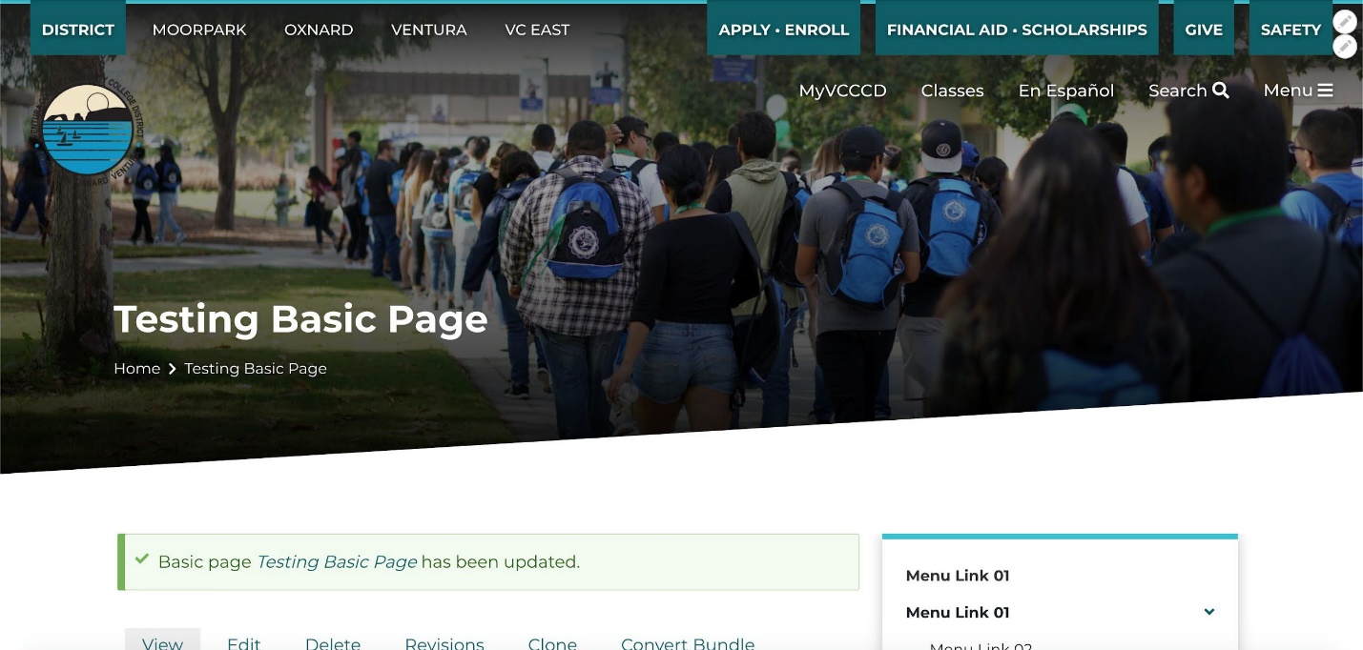
If we save the page we can now see the hero image we added.

If you are adding multiple paragraphs to a page in the same section, you can rearrange them using by dragging the “+” symbol:
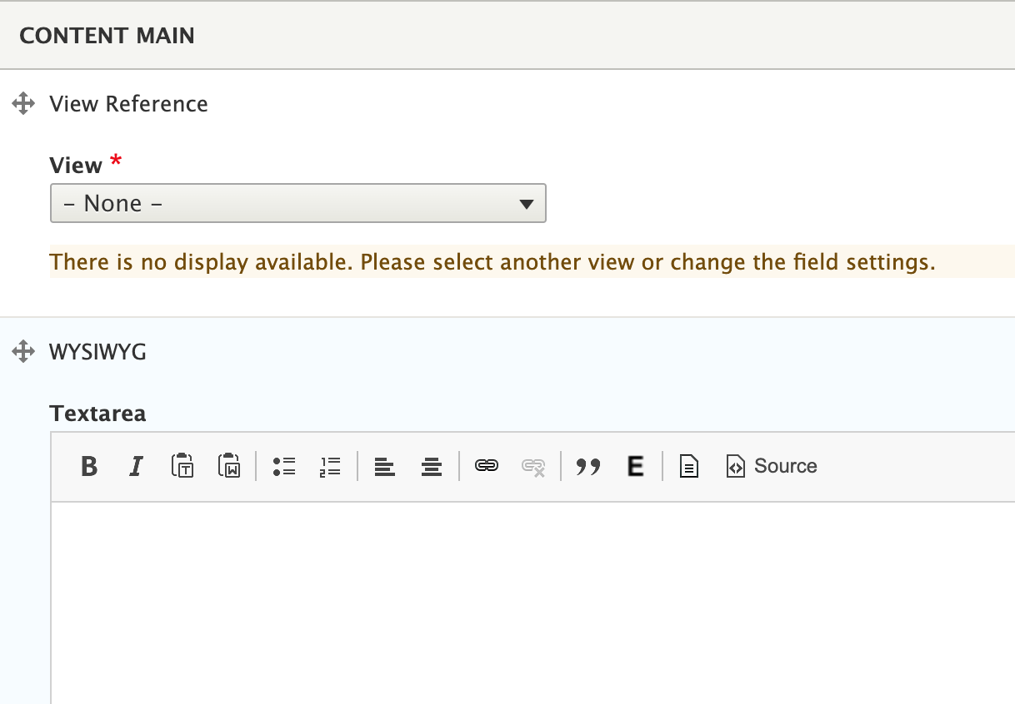

You can add content to the main content of the page. The buttons here help for formatting the text you create, embedding html, creating links and editing the html source code. This editor is commonly referred to as the WYSIWYG, or ‘What you see is what you get’ editor, since the editor will preview what you add and what it looks like, (to an extent) while you work.
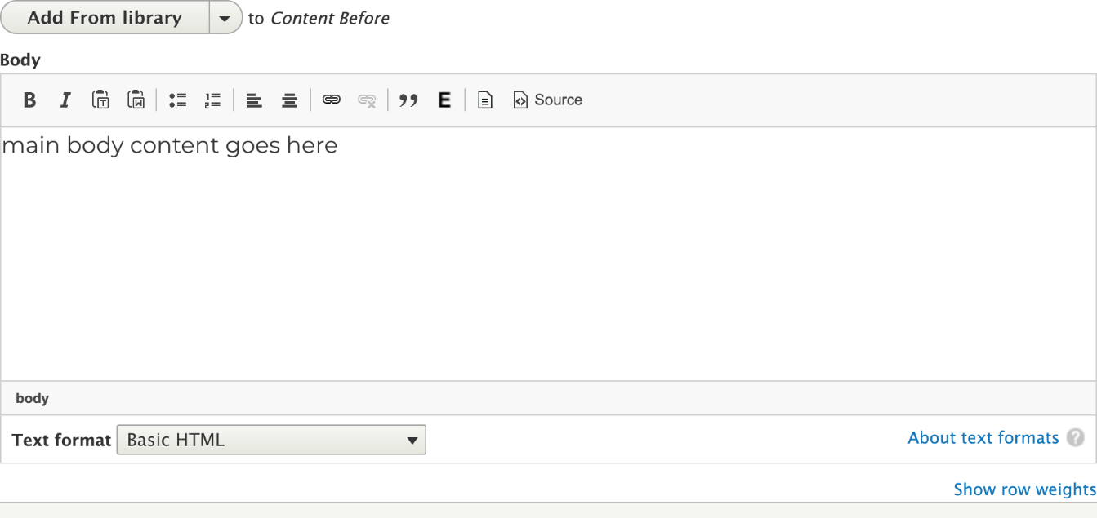
Below the body content you can add more paragraphs. You can add paragraphs to the main content of the page, to the sidebar, or after the main section and sidebar.

Images and PDFs
You can also embed an image or PDF into the body of a paragraph. Before you add a PDF, make sure it is accessible. Click
:

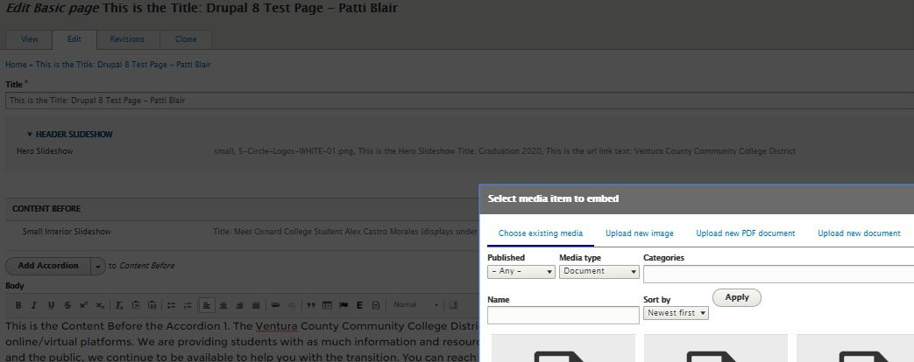
Accordion
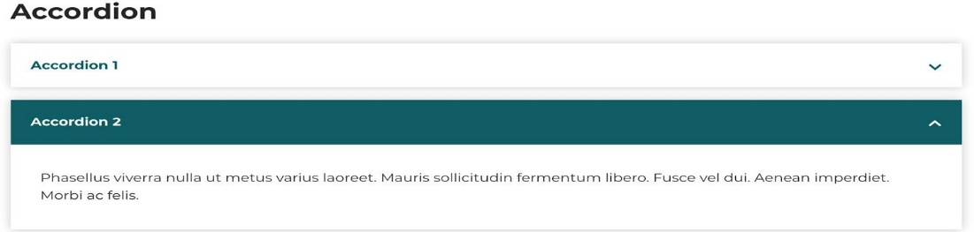
With an accordion, you can organize content into sections, which expand into a drop-down:

Expanding Existing Menus
The menu settings tab lets you automatically add this content to an existing menu. Url redirects lets editors make url redirects to or from this page. Url alias allows editors to give the page a practical url such as:
  - ‘/math’
  - ‘/department_staff’

Paragraphs
There are many useful sections for you to experiment with. Click on the link below to explore a few and see how they are displayed on a page. Some sections include:

CTA Blocks (Call to Actions)
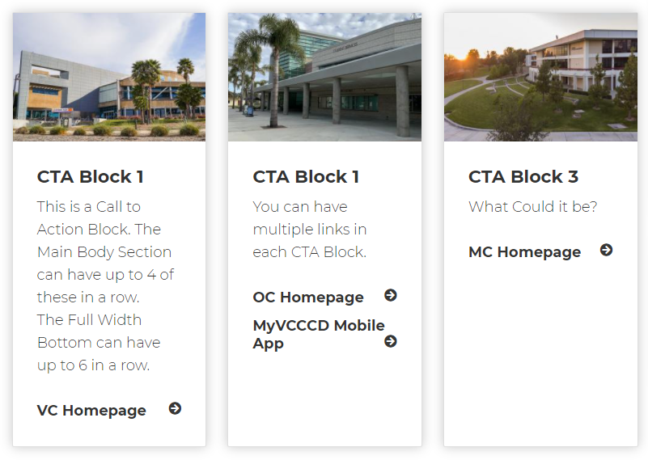
Interior Slideshow
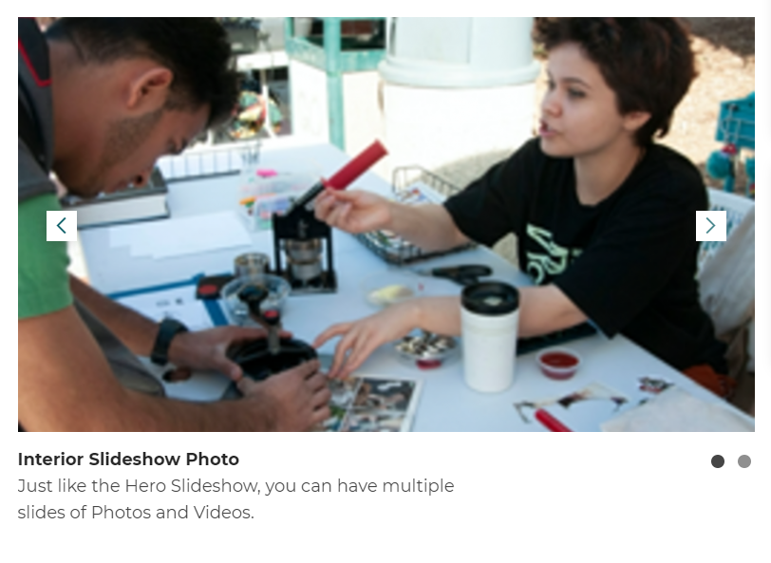
Adjustable Media and Content Bar
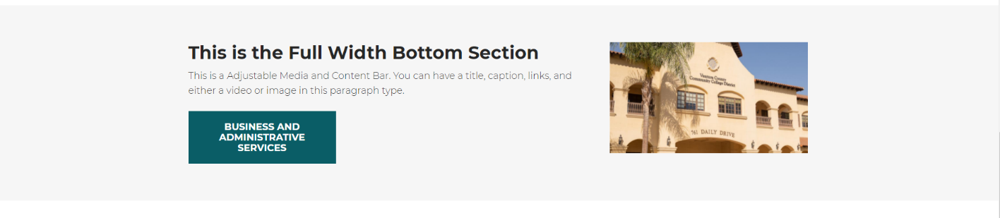
Full-Width Image Section Bar
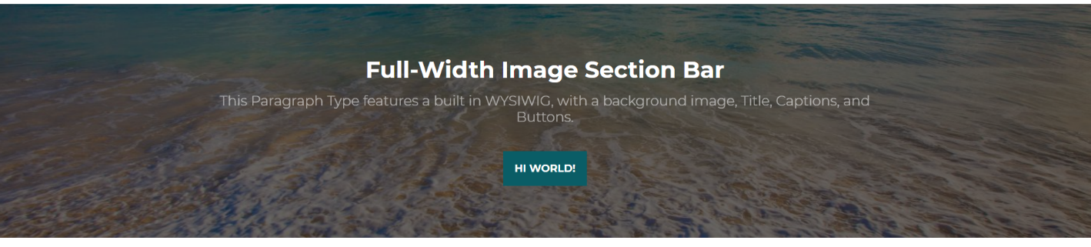
Sidebar Contact Card
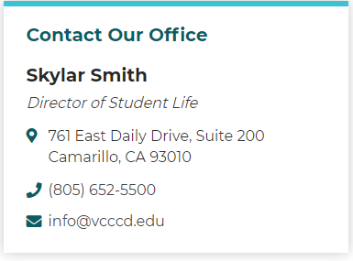
Related Links
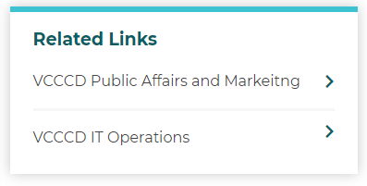
Buttons
Photo and Video Sidebar Blocks
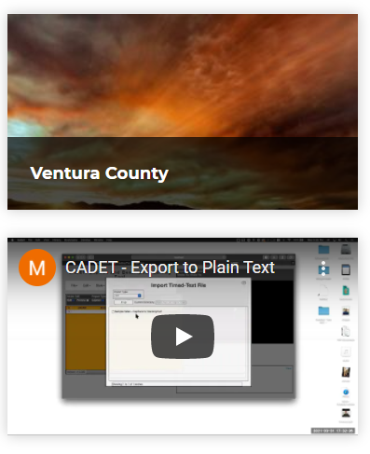

Events and Articles
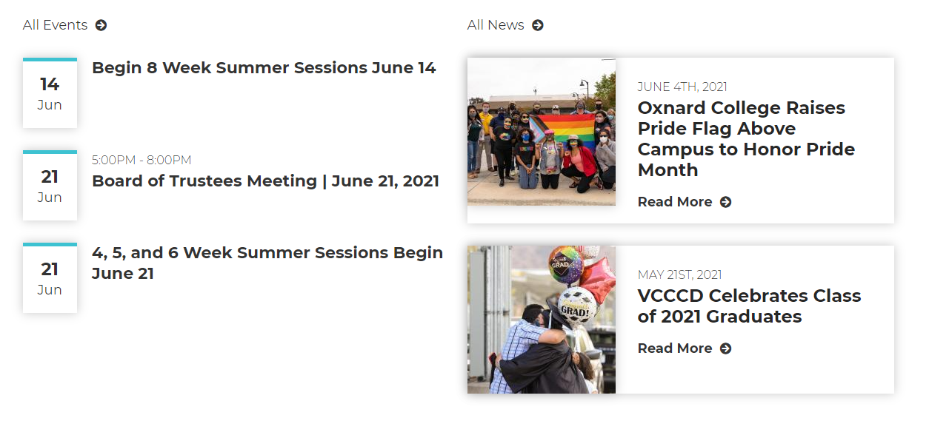

Following is an example of a Basic Page using the different paragraph types.

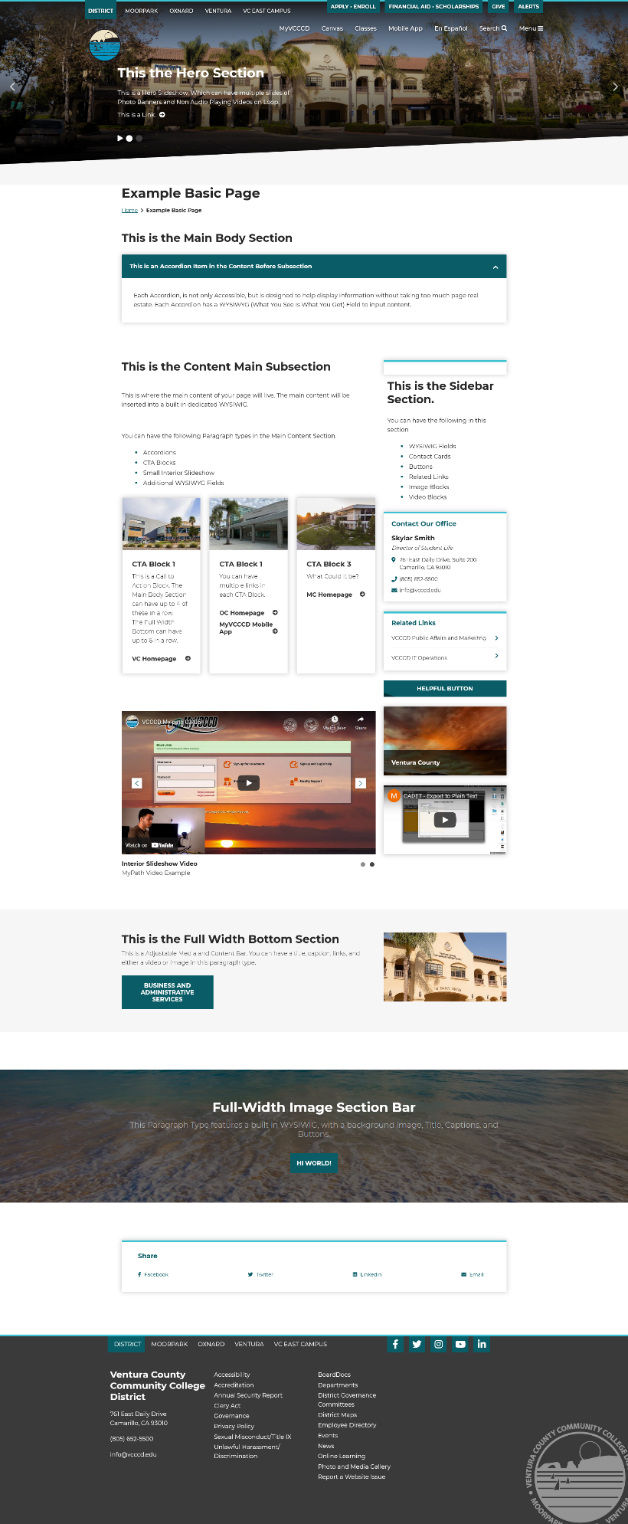

Accessibility and Adding Files and Media

Images and Graphic Design Accessibility
When designing a graphic, accessibility should be kept in mind, from the start, however, accessibility considerations may not be implemented until the final product of the graphic and the time of distribution. Alt text should be added before completing. The main idea of alt text is focus on “what is the image about?” If the graphic contains text, the exact text should be reflected in the Alt Text. If the graphic contains text and visual images, first type the focus of the graphic, then provide a 3 to 5 word description about the visual elements. Omit phrases such as; “Image of,” “Portrait of,” “Flyer of” It is implied that the graphic is an image because the assistive technology announces the type of element after the Alt Text is spoken.
Alt Text Example

Text reads, Moorpark College presents, Romeo and Juliet, March 12th, 13th, and 14th at 7:30 PM. March 19th, 20th and 21st at 7:30 PM and March 15th and 22nd at 1:30 PM. Moorpark Performing Arts 7075 Campus rd. Juliet leaning back with hair flowing.

Adobe Acrobat and PDF Accessibility
Be Accessible. Open Adobe Acrobat Pro. Click “Edit” then click “Preferences.”
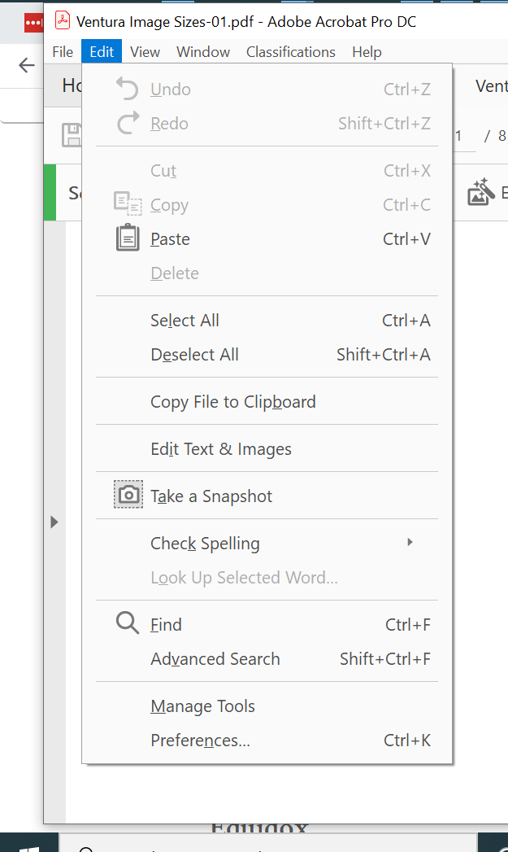
Click “Accessibility.” Look under “Other Accessibility Options” and make sure there is a check in the “Enable assistive technology support.” Click “OK” at bottom of page.

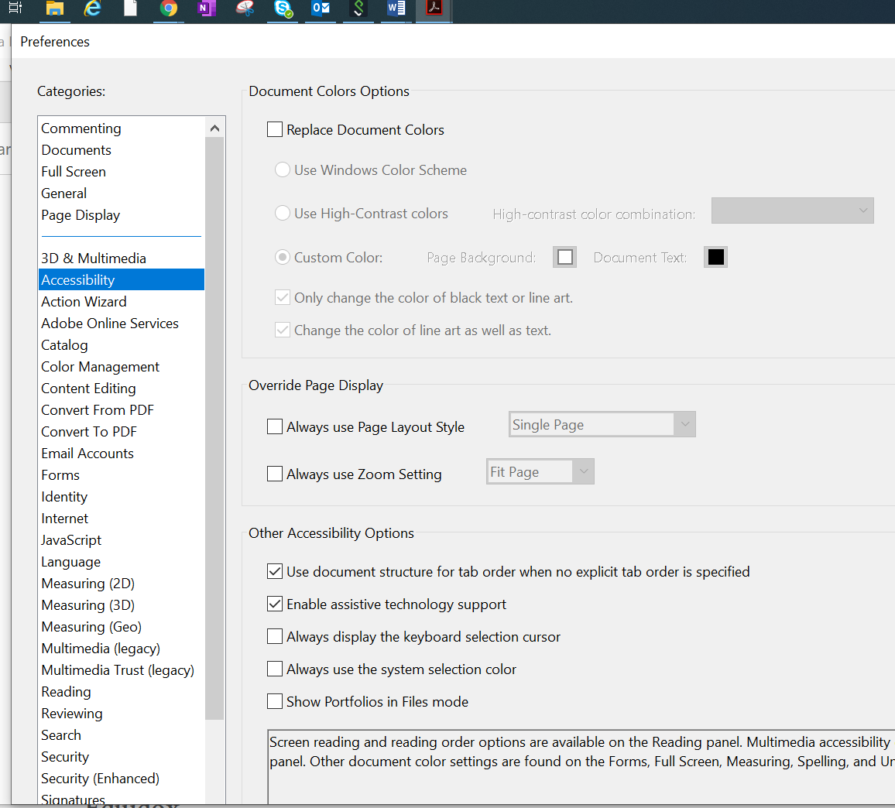

Checking PDF Accessibility
Open Adobe Acrobat Pro DC. Open your PDF. Click the “Tools” tab. Click “Accessibility” in the toolbar at the right. Click “Full Check.” If you have not gone through the setup, click “Setup Assistant.” After you check your document, you will get a report of any accessibility issues you need to correct before distributing or uploading the pdf to your webpage.
