

Draft VCCCD Strategic goals, Measures of Achievement and strategies

VCCCD Strategic Plan to follow the vetting of this document



July 29, 2021

Dr. Cynthia Herrera, Vice Chancellor

Institutional Effectiveness

|  |  |  |  |
| --- | --- | --- | --- |
| VCCCD Strategic Goals | Measures of Achievement | Strategies | Nexus to College’ Strategic Goals |
| 1. Instill a culture that values diversity, students, our communities, collaboration, and the success of each employee   Nexus with CCCCO’s Vision for Success Strategic Goals  CCCCO Goal #5  Reduce equity gaps across all of the above measures (Goals #1-5 Equitable Access to Completion and Job Placement) through faster improvements among traditionally underrepresented student groups.  CCCCO Goal #6  Over five years, reduce regional achievement gaps across all of the above measures (Goals #1-5 Equitable Access to Completion and Job Placement) through faster improvements among colleges located in regions with the lowest educational attainment of adults. | 1.1 Develop a process to administer, analyze and act-upon gaps identified from regularly administered surveys to students and Staff.  1.2 Distribute the Community College Survey of Student Engagement (CCSSE) on a bi-annual basis, provide results and incorporate into districtwide planning & Improvement efforts/activities, as appropriate.  1.3 Provide satisfaction survey results specific to the change in medical benefits for active benefits eligible retirees.  1.4 Distribute bi-annual employee satisfaction surveys, provide results and incorporate into districtwide planning and improvement efforts/activities, as appropriate. (Modern-Think)  1.5 Provide an annual summary of professional development activities and trainings across the District. | 1. Implement the VCCCD Leadership Academy and establish coordinated district/college new employee orientation. 2. Support professional development activities, engagement in participatory governance committees, and employee training on safety, discrimination, harassment, Title IX, and ethics as examples. 3. Promote implementation of safety mechanisms and communication networks and protocols to quickly and effectively respond to emergency situations and protect the safety and health of employees and students. 4. Support the maintenance and/or installation of facilities to provide effective, relevant, and safe educational, work, and community spaces 5. Support implementation of the college-level sustainability plans and promote efforts to positively impact the environment and climate. 6. Review organizational structure and processes to establish equitable workloads and support structures for the success of employees and all operations by prioritizing and establishing new positions and revisions of current positions and structures. 7. Provide timely and open communication on district plans, initiatives, actions, emergency situations, and news items of interest including student and employee success stories. | Moorpark College  MC Strategic Goal #2  Improve campus organizational infrastructure with a focus on inclusive decision-making  MC Strategic Goal #4  Reinforce culture of continuous improvement through professional development |
| Oxnard College  OC Initiative # III Goals  III.A. Enhance recruitment and professional development.  III.B. Focus on institutional effectiveness.  III.C. Continually refine the college’s planning and resource allocation processes.  III.D. Optimize organizational support structures  OC Initiative # IV Goals  IV.A. Enhance awareness and positive perception of the college.  IV.B. Foster collaborative community relations.  IV.C. Promote shared resources with educational partners |
| Ventura College  VC Strategic Goal #3  Strengthen local/regional partnerships and community engagement.  VC Strategic Goal #4  Enhance institutional effectiveness and accountability to improve innovation  and student outcomes  VC Strategic Goal #5  Effectively manage campus resources to meet student and community needs |
| VCCCD Strategic Goals | **Measures of Achievement** | **Strategies** | **Nexus to College’ Strategic Goals** |
| 1. Increase equitable access and success for all students   Nexus with CCCCO’s Vision for Success Strategic Goals  CCCCO Goal #5  Reduce equity gaps across all of the above measures (Goals #1-5 Equitable Access to Completion and Job Placement) Through faster improvements among traditionally underrepresented student groups.  CCCCO GOAL #6  Over five years, reduce regional achievement gaps across all of the above measures (Goals #1-5 Equitable Access to Completion and Job Placement) through faster improvements among colleges located in regions with the lowest educational attainment of adults. | 2.1 Increase the unduplicated count of students that achieve a Chancellor’s Office approved degree and / or certificate by 20% from 5,199 to 6,239 by 2027. (Baseline Year 2019-20)  2.2 Increase the percentage of degree, certificate or transfer seeking students completing college level English and math within their first year from 25% to 45% by 2027. (Baseline Year 2019-20  2.3 Increase overall course success rate from 76% to 81% by 2027. (Baseline Year 2018-2019)  2.4 Increase the proportion of degree, certificate or transfer seeking students taking at least 24 degree applicable units annually from 22% to 30% by 2027. (Baseline Year 2019-20)  2.5 Increase dual enrollment Headcount by 50%, through both College and Career Access Pathways (CCAP) and non-CCAP offerings from 2,047 to 3,069 FTES by 2027. (Baseline Year 2019-20 Semesters) | 1. Implement Strategic Plans, Equity Plans and Guided Pathway Plans which promote degree and certificate completion to students. 2. Student-centered implementation of AB705 and support to students for success and timely completion of all college level courses. 3. Support communication and student awareness of programs, course offerings, deadlines, services, resources, and events. 4. Expand dual enrollment agreements with county school districts and establish CCAP and non-CCAP classes with county high schools. 5. Evaluate and implement the use of technology and training to increase the number of online classes, certificates, and degrees along with online services to support access and completion.   **Draft**   1. Adjust the local funding allocation model to align with the Student Centered Funding Formula and prioritized needs. 2. Provide resources and training to enhance student learning outcomes, development, and assessment and improvement in curriculum, teaching, and learning. 3. Establish annual FTES enrollment targets and document actual enrollments in order to maximize access with annual state funding. | Moorpark college  MC Strategic Goal #1  Improve campus physical infrastructure, with a focus on sustainability  MC Strategic Goal #2  Improve campus organizational infrastructure with a focus on inclusive decision-making  MC Strategic Goal #4  Reinforce culture of continuous improvement through professional development |
| Oxnard College  OC Initiative # I Goals  I.A. Actively identify current and future students’ educational needs.  I.B. Improve enrollment management practices.  I.C. Accelerate student progression towards completion.  OC Initiative # II Goals  II.A. Strengthen the college’s responsiveness to student needs.  II.B. Focus on quality instruction.  II.C. Provide comprehensive student support |
| Ventura College  VC Strategic Goal #1  Increase the success of our students while closing equity gaps  VC Strategic Goal #2  Increase our community’s access to transfer, workforce preparation, and basic skills education.  VC Strategic Goal #4  Enhance institutional effectiveness and accountability to improve innovation and student outcomes |
| VCCCD Strategic Goals | **Measures of Achievement** | **Strategies** | **Nexus to College’ Strategic Goals** |
| 1. Support the closing of academic achievement and support services equity gaps across all racial, ethnic, socioeconomic, and gender groups.   Nexus with CCCCO’s Vision for Success Strategic Goals  CCCCO Goal #5  Reduce equity gaps across all of the above measures (Goals #1-5 Equitable Access to Completion and Job Placement) Through faster improvements among traditionally underrepresented student groups.  CCCCO GOAL #6  Over five years, reduce regional achievement gaps across all of the above measures (Goals #1-5 Equitable Access to Completion and Job Placement) through faster improvements among colleges located in regions with the lowest educational attainment of adults. | * 1. Achieve a 5% course success rate increase across all disaggregated student groups. (Baseline Year 2018-2019)   2. For degree, certificate or transfer seeking students, achieve a 10% increase across all disaggregated student groups transferring to a Four-Year Institution by 2027. With the focus on closing equity gaps. (Base Year 2018-2019) due to data availability   3. Decrease the percentage of D, F, and NP grades for all disaggregated student groups to 8% by 2027 with the focus on closing equity gaps. (Base Year 2018-2019)*   4. Increase enrollments among LGBTQ, Veterans and Foster Youth by 5% by 2027. (Base Year 2019-2020)   5. For students seeking a degree, certificate or transfer, reach a 20% degree or certificate completion rate for each disaggregated student group by 2027. | 1. Implement Strategic Plans, Equity Plans and Guided Pathway Plans which promote degree and certificate completion to students 2. Promote diversity, equity, and inclusion and support elimination of equity gaps by reviewing and revising District policies and procedures and college instruction and support services to address institutional barriers and systems of oppression. 3. Develop and use culturally relevant curriculum and instruction across all subject areas. 4. Provide professional development programs that support employees in promoting inclusivity and social justice. 5. Implement recruitments to establish diverse applicant pools and train employees to be aware of and able use strategies to mitigate bias. 6. Establish a district diversity, equity, and inclusion work group and a Director of Diversity, Equity, and Inclusion position. 7. Develop and implement an EEO plan with clear goals, timelines, and metrics for accountability. | Moorpark College  MC Strategic Goal #1  Improve campus physical infrastructure, with a focus on sustainability  MC Strategic Goal #2  Improve campus organizational infrastructure with a focus on inclusive decision-making  MC Strategic Goal #4  Reinforce culture of continuous improvement through professional development |
| Oxnard College  OC Initiative # I Goals  I.A. Actively identify current and future students’ educational needs.  I.B. Improve enrollment management practices.  I.C. Accelerate student progression towards completion.  OC Initiative # II Goals  II.A. Strengthen the college’s responsiveness to student needs.  II.B. Focus on quality instruction.  II.C. Provide comprehensive student support |
| Ventura College  VC Strategic Goal #1  Increase the success of our students while closing equity gaps  VC Strategic Goal #2  Increase our community’s access to transfer, workforce preparation, and basic skills education.  VC Strategic Goal #4  Enhance institutional effectiveness and accountability to improve innovation and student outcomes |
| VCCCD Strategic Goals | **Measures of Achievement** | **Strategies** | **Nexus to College’ Strategic Goals** |
| 1. Actively support equitable workforce and economic development in Ventura County through partnerships and relevant programs and pathways leading from education to careers   Nexus with CCCCO’s Vision for Success Strategic Goals  CCCCO Goal #4  Over five years, increase the percent of exiting CTE students who report being employed in their field of study  CCCCO GOAL #6  Over five years, reduce regional achievement gaps across all of the above measures (Goals #1-5 Equitable Access to Completion and Job Placement) through faster improvements among colleges located in regions with the lowest educational attainment of adults. | * 1. Increase the number of CTE completers and skill builders attaining living wage employment by 10% over 2019-20 baseline by 2027.   2. Increase the number of CTE certificate and degree completers from 9% to 15% by 2027.   3. Continue CTE program revisions, addition of new certificate & degree programs and specialized trainings as needed, based on regional labor market data. Provide the Board of Trustees an annual report and update.   4. By 2027, develop a system of contract education at the VCCCD that includes the use of ETP funding to minimize costs to businesses. | 1. Market/outreach CTE programs to students, employers, and community partners. 2. Maintain existing and establish new relationships with employers and private, governmental, and educational institutions to actively engage in and support workforce and economic development. 3. Expand work-based learning opportunities and support CTE job placement services. 4. Support the ongoing review of current programs and; establishment of new career education certificates, degrees and specialized training to meet local workforce needs. 5. Establish aligned career pathways with K-12 and higher education partners. 6. Joint Trustee/College/District presentations to K-12 School Boards, higher education partners, business and community groups (e.g. P-20 Council, Workforce Development Board, Economic Development Collaborative, Ventura County Economic Development Alliance, City Councils, Ventura County Board of Supervisors, and Chambers of Commerce) 7. Participate in Regional and Local Strong Workforce Collaborations, Projects and Programs. Engage in innovative career education opportunities using Strong Workforce Funding sources. | Moorpark College  MC Strategic Goal #2  Improve campus organizational infrastructure with a focus on inclusive decision-making  MC Strategic Goal #4  Reinforce culture of continuous improvement through professional development |
| Oxnard College  OC Initiative # I Goals  I.A. Actively identify current and future students’ educational needs.  I.B. Improve enrollment management practices.  I.C. Accelerate student progression towards completion.  OC Initiative # II Goals  II.A. Strengthen the college’s responsiveness to student needs.  II.B. Focus on quality instruction.  II.C. Provide comprehensive student support |
| Ventura College  VC Strategic Goal #2  Increase our community’s access to transfer, workforce preparation, and basic skills education  VC Strategic Goal #3  Strengthen local/regional partnerships and community engagement  VC Strategic Goal #5  Effectively manage campus resources to meet student and community needs |

**Alignment with the**

**California Community College Chancellor’s Office Vision Goals**

Below are the Vision for Success Goals for California Community Colleges (<https://www.cccco.edu/About-Us/Vision-for-Success/vision-goals>) of which the VCCCD Strategic Goals and Measurements of Achievement are aligned.

**1. Over five years, increase by at least 20 percent the number of California Community College students annually who acquire associate degrees, credentials, certificates, or specific skill sets that prepare them for an in-demand job.**

This increase is needed to meet future workforce demand in California, as analyzed by the Centers of Excellence for Labor Market Research. This goal is consistent with the recommendations of the California Strategic Workforce Development Plan. Equally important to the number of students served will be the type of education they receive: programs, awards, and course sequences need to match the needs of regional economies and employers.

**2. Over five years, increase by 35 percent the number of California Community College students transferring annually to a UC or CSU.**

This is the increase needed to meet California’s future workforce demand for bachelor’s degrees, as projected by the Public Policy Institute of California. (In California, occupations requiring bachelor’s degrees are growing even faster than jobs requiring associate degrees or less college.) Meeting this aggressive goal will require the full engagement and partnership of CSU and UC. While ambitious, the pace of improvement envisioned in this goal is not unprecedented: between 2012-13 and 2015-16 (a three-year period), California Community College to CSU transfers increased by 32 percent and between Fall 1999 and Fall 2005 (a six-year period), California Community College to UC transfers increased by 40 percent.

**3. Over five years, decrease the average number of units accumulated by California Community College students earning associate degrees.**

Decrease from approximately 87 total units (the most recent system-wide average) to 79 total units—the average among the quintile of colleges showing the strongest performance on this measure. (Associate degrees typically require 60 units.) Reducing the average number of units-to-degree will help more students reach their educational goals sooner, and at less cost to them. It will also free up taxpayer dollars that can be put toward serving more students.

**4. Over five years, increase the percent of exiting CTE students who report being employed in their field of study.**

Increase from the most recent statewide average of 60 percent to an improved rate of 76 percent—the average among the quintile of colleges showing the strongest performance on this measure and ensure the median earning gains of the exiting students are at least twice the statewide consumer price index. Improvements on this measure would indicate that colleges are providing career education programs that prepare students for available jobs and offering supports that help students find jobs.

**5. Reduce equity gaps across all of the above measures through faster improvements among traditionally underrepresented student groups.**

Reduce equity gaps with the goal of cutting achievement gaps by 40 percent within 5 years and fully closing those achievement gaps within 10 years.

**6. Over five years, reduce regional achievement gaps across all of the above measures through faster improvements among colleges located in regions with the lowest educational attainment of adults.**

Reduce regional achievement gaps with the ultimate goal of fully closing regional achievement gaps within 10 years.

**Rationale and Data Trends**

**For the VCCCD Strategic Goals’ Measurements of Achievement**

**VCCCD GOAL # 1:** Instill a culture that values diversity, students, our communities, collaboration, and the success of each employee

**Measures of Achievement**

**1.1** Develop a process to administer, analyze and act-upon gaps identified from regularly administered surveys to students and Staff which is integrated into participatory governance structures and committees

1. The measurement is aligned with the CCCCO’s Vision for Success Goals
2. This measure affords the VCCCD the opportunity to develop and/or enhance an ongoing evaluation cycle that is incorporated into the Participatory Governance committees throughout the District.
3. The analysis and integration of survey outcomes/results into Participatory Committees promotes continuous quality improvement
4. Data collected will be used to support Goal #1 which in-turn supports the attainment of all of the VCCCD Strategic Goals

**1.2 – 1.4** Survey Distributions

1. The measurement is aligned with the CCCCO’s Vision for Success Goals
2. The incorporation of the various surveys identified in these measures allows for the identification of gaps, strengths, opportunities for improvement and the development of innovative programs and projects to support all of the VCCCD Strategic Goals 1-4.

**1.5** Provide an annual summary of professional development activities and trainings across the District

1. Through the Participatory Governance process, the summarization and identification of findings relative to the impact of professional development can be utilized as a tool to support the success of all of the VCCCD Goals. High impact practices and trainings can be replicated and expanded to assure continuous quality improvement within each college, among the colleges and across the district.

**VCCCD Goal # 2:** Increase equitable access and success for all students

**Measurements of Achievement**

* 1. Increase the unduplicated count of students that achieve a Chancellor’s Office approved degree and / or certificate by 20% from 5,199 to 6,239 by 2027. (Baseline Year 2019-20)
     + 1. The measurement is aligned with CCCCO’s Vision for Success Goals.
       2. The baseline year of 2019-20 was selected due to the global pandemic in 2020-21 and potential pandemic’ variables influencing outcomes during the ‘20-21 timeframe.
       3. The VCCCD had achieved the CCCCO Vision for Success metric goal #1 by increasing from 4,304 (2016-2017) awards to 5,199 (2019-2020). This represented a 21% increase.
       4. Given this past year with the COVID 19 global pandemic, it is anticipated that student’ outcomes (based on COVID factors affecting this measure) are still forthcoming, therefore recommending the alignment with the CCCOs Vision for Success Goal of a 20% increase by 2027.

Source: CCCCO Student Success Launch Board

* 1. Increase the percentage of degree, certificate or transfer seeking students completing college level English and math within their first year from 25% to 45% by 2027. (Baseline Year 2019-20)
  2. The measurement is aligned with CCCCO’s Vision for Success Goal #1.
  3. The baseline year of 2019-20 was selected due to the global pandemic in 2020-21 and potential pandemic’ variables influencing outcomes during the ‘20-21 timeframe
  4. VCCCD is currently experiencing a decline in unduplicated overall headcount. Thus, in order to meet the previous Measure of Achievement (2.1) to increase the unduplicated count of students that achieve a Chancellor’s Office approved degree and / or certificate by 20%, VCCCD must increase the rate for which current students are succeeding.
  5. Among students in selected student journey, the proportion who completed transfer-level math and/or English in their first academic year of credit enrollment from their first term within the district allowing for students who enrolled in credit ESL to complete transfer-level math and English within three complete years from first term in the baseline year of 2019-20 is 25% or 2,527 of 10,305 students.
  6. This measure supports CCCCO Vision goals 1, 2 and 3. Increases graduation and transfer rates while decreasing overall units to obtain goal.

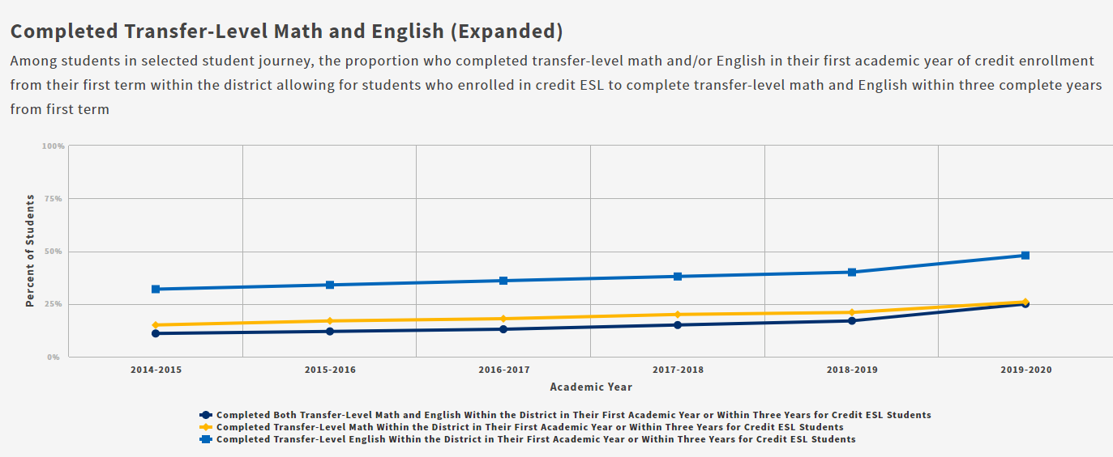



Source: CCCCO Student Success Launch Board

* 1. Increase overall course success rate from 76% to 81% by 2027 utilizing the baseline year 2018-2019*.
  2. Rationale for using Base Year 2018-2019* - CCCCO Note: Due to more students received “EW” or Excused Withdrawal grades in Spring 2020 as a result of the COVID-19 pandemic. Those grades are excluded from the denominator of success rates to maintain alignment with Datamart. As a result, course success rates are higher in 2019-2020 than in prior years. Included and excluded EWs should be carefully examined locally to more completely understand course performance in Spring 2020 or in 2019-2020 which includes that term.
  3. VCCCD is currently experiencing a decline in unduplicated overall headcount. Thus, in order to meet the VCCCD Measurement of Achievement 2.1 of increasing the unduplicated count of students that achieve a Chancellor’s Office approved degree and / or certificate by 20% by 2027, the VCCCD must increase the rate for which current students are succeeding.
  4. Prior five-year increase 2% (using base year 2018-2019)
  5. Supports CCCCO Vision for Success goals (Increase graduation and transfer rates)

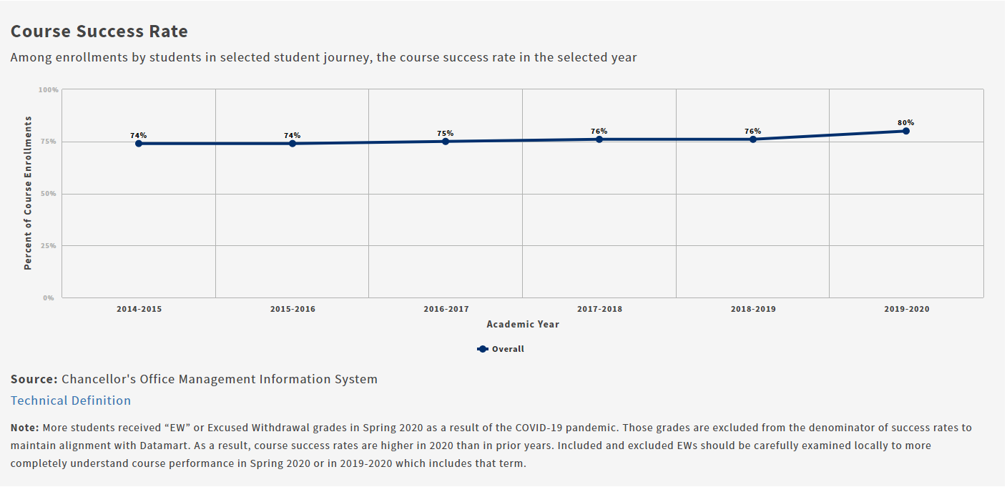

Source: CCCCO Student Success Launch Board

* 1. Increase the proportion of degree, certificate or transfer seeking students taking at least 24 degree applicable units annually from 22% to 30% by 2027 utilizing the baseline year 2019-20.

1. VCCCD is currently experiencing a decline in unduplicated overall headcount. Thus, in order to meet the Measurement of Achievement 2.1 of increasing the unduplicated count of students that achieve a Chancellor’s Office approved degree and / or certificate by 20% by 2027, VCCCD must increase the rate for which current students are succeeding
2. The prior five-year increase was 4% and in order to meet and support CCCCO Vision goal 1, 2 and 3, the VCCCD must focus in this area.
3. Guided Pathways is anticipated to impact and increase graduation and transfer rates while decreasing overall units to obtain goal.

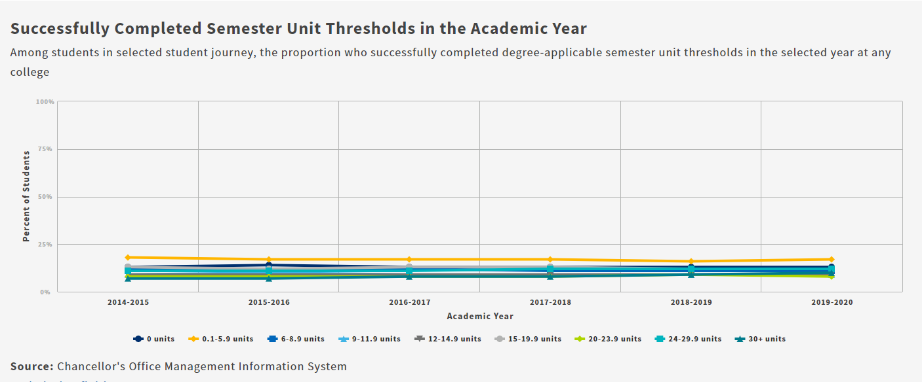

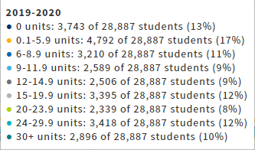

* 1. Increase dual enrollment Headcount by 50%, through both College and Career Access Pathways (CCAP) and non-CCAP offerings, annually, from 5,435 to 8,152 FTES by 2027. (Baseline Year 2019-20 All Semesters) Source: CCCCO Data Mart
  2. Supports CCCCO Vision goals, enhances college-preparedness and increases graduation and transfer rates while decreasing overall units to obtain goal.
  3. Utilizing baseline year of 2019-20 given anomalies associated with COVID year 20/21.



**VCCCD Goal # 3:** Support the closing of academic achievement and support services equity gaps across all racial, ethnic, socioeconomic, and gender groups.

**Measurements of Achievement**

* 1. Achieve a 5% course success rate increase across all disaggregated student groups. (Baseline Year 2018-2019)

1. Measurement of Achievement 2.3 identifies the 5% overall increase for this metric (Increase overall success rate from 76% to 81%). The displayed increases represent the ideal equitable outcome for a 5% increase without decreasing any of the identified groups. Disaggregated % “from and to” are as follows:

* Asian 82% to 83% (+1%)
* Black 68% to 79% (+11%)
* Hispanic 73% to 80% (+7%)
* Combined 78% to 81% (+3%) combined due to low disaggregate counts
* White 80% to 81% (+1%)
* Female 77% to 81% (+4%)
* Male 74% to 81% (+7%)

1. Prior five-year overall average increase 2% (using base year 2018-2019)

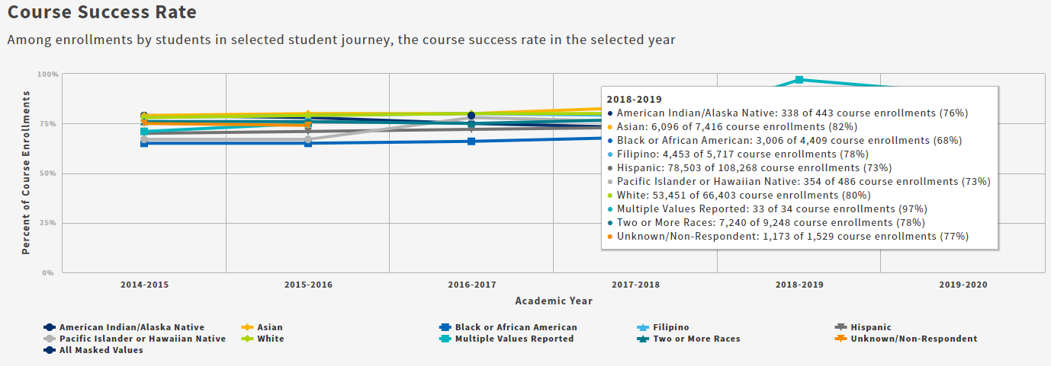

(Source: CCCCO SS Launch Board)

* 1. For degree, certificate or transfer seeking students, achieve a 10% increase across all disaggregated student groups transferring to a four-year Institution by 2027. With the focus on closing equity gaps. (Base Year 2018-2019) most recent available data

1. The baseline year of 2018-19 is the most recent data available on the CCCCO Student Success Launch Board
2. CCCCO Vision for Success goal #2 calls for a 35% system wide increase in students that transfer to a UC or CSU by 2022. VCCCD shows a 3% prior five-year increase. This is well below the 35% system wide increase called for by Vision for Success goal. Disaggregated % “from and to” are as follows:

* Asian 54% to 55% (+1%)
* Black 28% to 47% (+19%)
* Hispanic 32% to 47% (+15%)
* Combined 38% to 47% (+9%) combined due to low disaggregate counts
* White 43% to 47% (+4%)
* Female 37% to 47% (+10%)
* Male 37% to 47% (+10%)

1. Prior five year average increase 3% (base year 2018-2019)

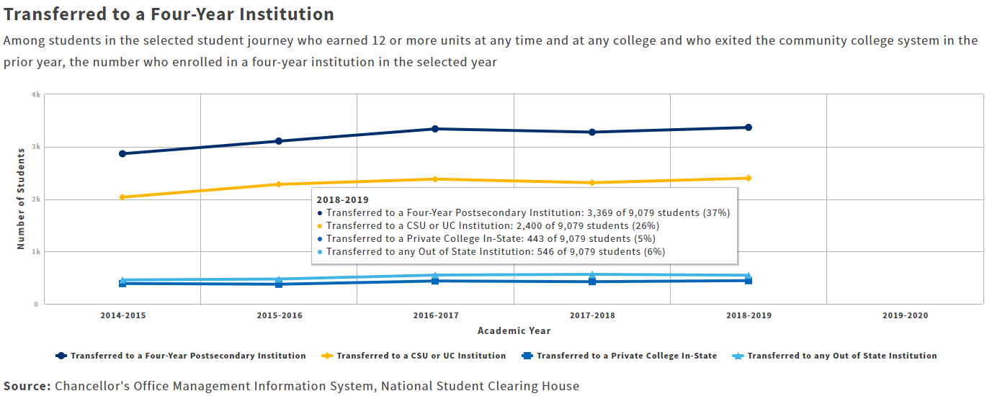

Source: CCCCO Student Success Launch Board

* 1. Decrease the percentage of D, F, and NP grades for all disaggregated student groups to 8% by 2027 with the focus on closing equity gaps. (Base Year 2018-2019)*

1. (Base Year 2018-2019)* CCCCO Note: Due to more students received “EW” or Excused Withdrawal grades in Spring 2020 as a result of the COVID-19 pandemic. Those grades are excluded from the denominator of success rates to maintain alignment with Datamart. As a result, course success rates are higher in 2020 than in prior years. Included and excluded EWs should be carefully examined locally to more completely understand course performance in Spring 2020 or in 2019-2020 which includes that term.
2. 8% represents the lowest “D, F, NP” proportion of all the ethnicities during the base year. Closing equity gap for this metric would be to bring all identified groups to the lowest represented group

* Asian 9% to 8% (-1%)
* Black 15% to 8% (-7%)
* Hispanic 14% to 8% (-6%)
* Combined 9% to 8% (-1%) combined due to low disaggregate counts
* White 8% to 8% (-0%)
* Female 11% to 8% (-3%)
* Male 12% to 8% (-4%)

1. Prior five year average decrease 1% (base year 2018-2019)

Source: VCCCD SIS

* 1. Increase enrollments among LGBTQ, Veterans, and Foster Youth by 5% by 2027. (Base Year 2019-2020)
  2. The baseline year of 2019-20 was selected due to the global pandemic in 2020-21 and potential pandemic’ variables influencing outcomes during the ‘20-21 timeframe
  3. LGBTQ - This is a relatively new collected metric, thus has seen a skewed increase over the past five years of 1000+%. Going from 61 enrollments to 829. Although, the overall percentage of LGBTQ enrollments vs. the whole remain low at 2%. Thus, VCCCD’s goal is to increase the proportion of LGBTQ enrollments to 5% by 2027.
  4. Veterans - The Veteran population has remained constant at VCCCD over the past five years at 2% of total enrollments. Thus, VCCCD’s goal is to increase the proportion of Veteran enrollments to 5% by 2027.
  5. Foster Youth - The Foster Youth population has remained constant at VCCCD over the past five years, increasing from 1% to 2% of the total population. Thus, VCCCD’s goal is to increase the proportion of Foster Youth enrollments to 5% by 2027.
  6. For students seeking a degree, certificate or transfer, reach a 20% degree or certificate completion rate for each disaggregated student group by 2027.

a) The baseline year of 2019-20 was selected due to the global pandemic in 2020-21 and potential pandemic’ variables influencing outcomes during the ‘20-21 timeframe

* Asian from 15% to 20% (+5%)
* Black from 11% to 20% (+9%)
* Hispanic from 13% to 20% (+7%)
* Combined from 10% to 20% (+10%) combined due to low disaggregate counts
* White from 15% to 20% (+5%)
* Female from 15% to 20% (+5%)
* Male from 12% to 20% (+8%)

1. Prior five-year average increase is 5%, therefore by establishing the overall 20% completion rate would equate to a 7% average increase from base year 2019-2020, overall.

**VCCCD Goal # 4** Actively support equitable workforce and economic development in Ventura County through partnerships and relevant programs and pathways leading from education to careers.

**Measurements of Achievement**

* 1. Increase the number of CTE completers and skill builders attaining living wage employment by 10% over 2019-20 baseline by 2027.

1. The baseline year of 2019-20 was selected due to the global pandemic in 2020-21 and potential pandemic’ variables influencing outcomes during the ‘20-21 timeframe
2. The 10% increase is ambitious but with the integration of Regional and Local Strong Workforce funding, it should be attainable.
3. Major focus of the Career Education programs is the expansion of internships and apprenticeships while the student is pursuing their career educational pathway. This exposes employers to the VCCCD students and visa-versa to promote job placement upon completion.
4. Prior five-year increase 3% (base year 2018-2019)

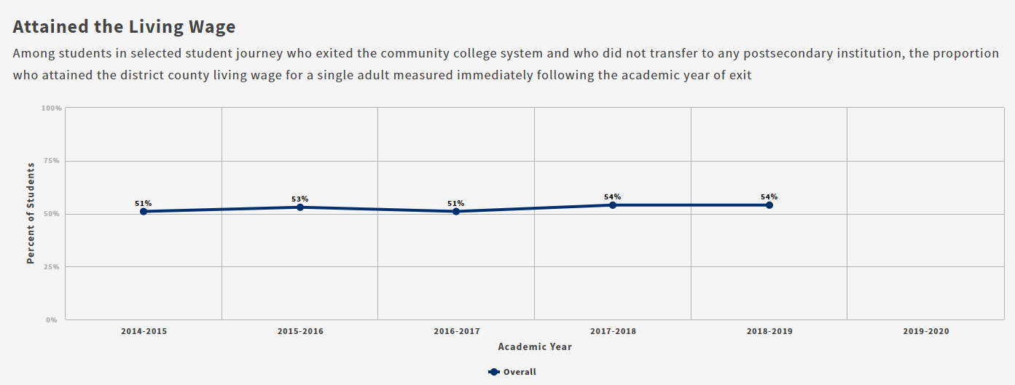

*Source: CCCCO Student Success Launch Board*

* 1. Increase the number of CTE certificate and degree completers from 9% to 15% by 2027.

1. The prior five-year increase was 3%. The Strong Workforce funding focus and the implementation of the following 4.3 and 4.4 measures of achievement will support this goal achievement.

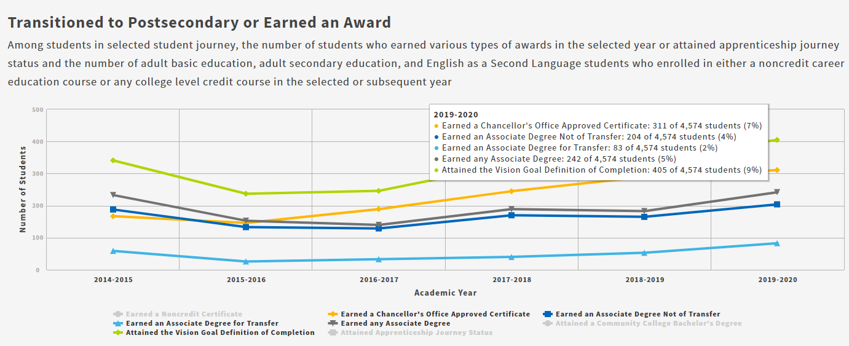

* 1. Continue CTE program revisions, addition of new certificate & degree programs and specialized trainings as needed, based on regional labor market data. Provide the Board of Trustees an annual report and update.

1. No data metric needed
   1. By 2027, develop a system of contract education at the VCCCD that includes the use of ETP funding to minimize costs to businesses.
2. No data metric needed