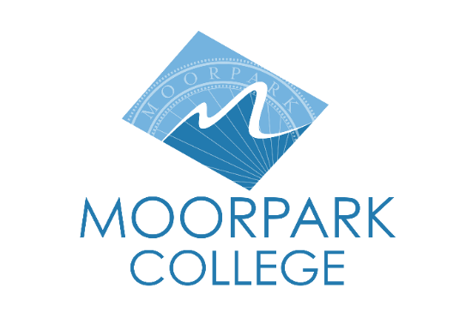 |  | Moorpark College  7075 Campus Road  Moorpark, CA 93021  805.378.1400  moorparkcollege.edu

For Immediate Release

State-of-the-Art Biotech Lab on Display at Open House
Event is open to students and the community interested in STEM careers

Moorpark, Calif. (February 15, 2022)–Moorpark College’s biotechnology program offers a comprehensive curriculum in bio-manufacturing that includes hands-on learning in a state-of-the-art biotech lab. Students and the community who are interested in this rapidly growing industry are invited to attend the Biotech Open House, 5 - 7 p.m., March 9.

Visitors can watch lab demonstrations, explore the lab and examine how recombinant cells are grown in bioreactors and see how chromatography columns are used to purify life-saving biotech products.

The program’s faculty will share information about opportunities for research, internships, apprenticeships and current job openings. They will also offer insights into biotech industry positions and high-paying biotech careers with an associate degree or certificate, including manufacturing associate and quality control analyst, among others.

The program is supported by an active advisory board comprised of leading companies, such as Amgen, Takeda, Thermo Fisher Scientific, Atara Biotherapeutics, Capsida Biotherapeutics, PBS Biotech, Kinamed Incorporated, Arcutis Biotherapeutics, Neogene Therapeutics, Amethyst Life Sciences, Stryker and Curia.

“Moorpark College created the biotechnology program in the 1990s to meet the growing needs of the biotech industry. The advisory board’s continued participation ensures that the program provides students with the specialized skills to meet businesses’ ever-evolving needs,” said Moorpark College President Julius Sokenu.

The biotech lab is inside the Health Science Center on Moorpark College’s campus, 7075 Campus Road, Moorpark. Seating is limited. Register for the free Biotech Open House at https://www.eventbrite.com/e/bio-technology-open-house-tour-tickets-264425693367.

For more information about the Open House, contact Dr. Celine Park at 805-553-4732 or cpark@vcccd.edu. For information about Moorpark College’s biotechnology program, visit https://www.moorparkcollege.edu/departments/academic/biotechnology.

About Moorpark College

Moorpark College Mission

Grounded in equity, social justice, and a students first philosophy, Moorpark College values diverse communities. We empower learners from local, national, and global backgrounds to complete their degree, certificate, transfer, and career education goals. Through innovation and customized student support, our programs are designed to achieve equitable outcomes.

Moorpark College is one of three colleges in the Ventura County Community College District and annually serves more than 14,000 students. Founded in 1967, Moorpark College is fully accredited and has the highest six-year completion rate within the California Community College System. The Campaign for College Opportunity named Moorpark College a 2020 Champion of Higher Education for the Associate Degree for Transfer Pathway. It is also a designated Hispanic-Serving Institution. The college’s signature career/technical programs include nursing, radiologic technology, biotechnology and journalism. The college’s America’s Teaching Zoo is the only associate degree exotic animal training program in the country. To learn more, visit MoorparkCollege.edu or follow @MoorparkCollege on social media.

Media Contact:
Debi Klein
Director of Institutional Advancement and Community Outreach
dklein@vcccd.edu
805.553.4760

