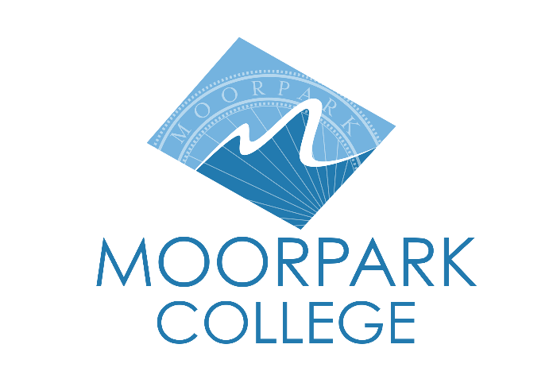 | Moorpark College  7075 Campus Road  Moorpark, CA 93021  805.378.1400  moorparkcollege.edu

For Immediate Release

Tony Award-Winning Musical “Kinky Boots”
Opens at Moorpark College
College among initial amateur theatres in the U.S. to stage production

Moorpark, Calif. (February 24, 2022)–The Moorpark College Theatre Arts and Dance departments are proud to announce the opening of “Kinky Boots,” a high-energy and timely story of all the wonderful things that happen when people from different worlds embrace diversity and inclusion. This Spring 2022 production of the six-time Tony Award® Winning Best Musical runs March 10 – 27, Thursday through Saturday nights at 8 p.m., with Sunday matinees at 2 p.m.

‘‘‘Kinky Boots’ has been an amazing journey for Moorpark College, our faculty and students on all fronts,” said director and Theatre Arts faculty member John Loprieno. “What started with fully masked outdoor rehearsals in our parking garage on cold January night has miraculously transformed into a fully realized and triumphant return to our mainstage.”

Based on the eponymous 2005 film, “Kinky Boots” features the joyous, Tony Award-winning score with music and lyrics by singer-songwriter Cyndi Lauper and an uplifting book from playwright Harvey Fierstein. It is mostly inspired by true events and centers around Charlie Price, who reluctantly inherits his father’s shoe factory that is on the verge of bankruptcy.

Trying to live up to his father’s legacy and save the family business, Charlie finds inspiration in a fabulous entertainer named Lola in need of some sturdy stilettos. Lola turns out to be the one person who can help Charlie discover his potential. In the process, the duo finds that they have more in common than they thought, and they learn that when you change your mind about someone, you can change your whole world.

“With all that is happening in our country and community, we can’t think of a better time to return to the theatre for a night of musical comedy that embraces the power of what we can achieve together through compassion and acceptance,” said Loprieno.

“Kinky Boots” will be performed on the main stage of the Performing Arts Center on the Moorpark College campus, 7075 Campus Road, Moorpark. Tickets can be purchased through the Moorpark College Performing Arts Center Box Office at (805) 378-1485 or online at www.moorparkcollege.edu/pac.

About Moorpark College

Moorpark College Mission

Grounded in equity, social justice, and a students first philosophy, Moorpark College values diverse communities. We empower learners from local, national, and global backgrounds to complete their degree, certificate, transfer, and career education goals. Through innovation and customized student support, our programs are designed to achieve equitable outcomes.

Moorpark College is one of three colleges in the Ventura County Community College District and annually serves more than 14,000 students. Founded in 1967, Moorpark College is fully accredited and has the highest six-year completion rate within the California Community College System. The Campaign for College Opportunity named Moorpark College a 2020 Champion of Higher Education for the Associate Degree for Transfer Pathway. It is also a designated Hispanic-Serving Institution. The college’s signature career/technical programs include nursing, radiologic technology, biotechnology and journalism. The college’s America’s Teaching Zoo is the only associate degree exotic animal training program in the country. To learn more, visit MoorparkCollege.edu or follow @MoorparkCollege on social media.

Media Contact:
John Loprieno
jloprieno@vcccd.edu
(805) 378-1469

