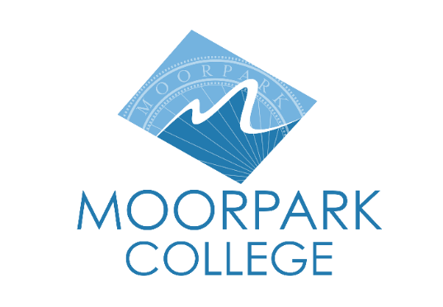 | 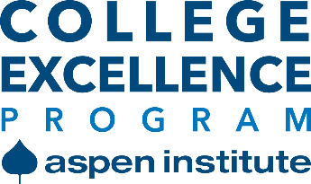 | Moorpark College  7075 Campus Road  Moorpark, CA 93021  805.378.1400 moorparkcollege.edu

For Immediate Release

Moorpark College Named Aspen Institute Semifinalist

for Prestigious 2023 Aspen Prize
College is one of 25 eligible for a $1 million prize

Moorpark, Calif. (April 27, 2022)—Today the Aspen Institute announced that Moorpark College is one of 25 semifinalists for the Aspen Prize for Community College Excellence, adding a milestone in the award selection process. Previously, only 10 finalists were named, and this change is designed to highlight the increased number of colleges nationwide doing excellent work.

The $1 million Aspen Prize is the nation’s signature recognition of community colleges achieving high, improving and equitable outcomes for students.

Of the 25 semifinalists, only Moorpark College and Imperial Valley College are located in California. For the 2021 Aspen Prize, Moorpark College was named a Top 150 U.S. Community College.

"We are honored to make it to this next milestone for the 2023 Aspen Prize! The excellent work taking place at Moorpark College demonstrates the efforts of our students, faculty and staff. It exemplifies our commitment to empowering learners and facilitating the academic and career achievements of our students. When we provide equitable educational opportunities, our students and community benefit, " said Julius Sokenu, president of Moorpark College.

“We thank the Aspen Institute for this prestigious recognition. It is a testament to the forward-thinking leadership at Moorpark College and the hard work and dedication of the students,” said Chancellor Greg Gillespie. “Each of our colleges—Moorpark, Oxnard and Ventura—were named among the Top 150 U.S. Community Colleges Eligible for the 2023 Aspen Prize, which reflects on the excellence of Ventura County’s community colleges.”

Awarded every two years, the Aspen Prize honors colleges with outstanding performance in five critical areas: teaching and learning, certificate and degree completion, transfer and bachelor’s attainment, workforce success and equitable outcomes for students of color and students from low-income backgrounds. The winner will be announced spring 2023.

“We are thrilled to see America's community colleges making meaningful and measurable progress, educating people from all backgrounds and preparing them for good jobs,” said Josh Wyner, executive director of the Aspen Institute College Excellence Program. He cited graduation rates that have risen more than 6% for all students since 2015 and 5% for students of color. “These 25 colleges represent our dreams for a better country and a reinvigorated democracy.”

The Prize selection process began this past October, when the Aspen Institute invited 150 community colleges to apply, based on data showing strong and improving student outcomes in key areas such as retention, completion, transfer and equity. Applications went to a diverse selection committee of 16 higher education experts who reviewed extensive data and application narratives. For the list of 25 semifinalists, visit https://highered.aspeninstitute.org/aspen-prize-semifinalists.

The committee will review interviews with leadership teams and narrow down the 25 semifinalists to 10 finalists, to be announced in early June 2022.

About the Aspen Institute
The Aspen Institute College Excellence Program aims to advance higher education practices, policies, and leadership that significantly improve student outcomes, especially for the growing population of low-income students and students of color on American campuses. For more information, visit https://highered.aspeninstitute.org and www.linkedin.com/showcase/aspenhighered.

The Aspen Institute is a community-serving organization with global reach whose vision is a free, just, and equitable society. For 70 years, the Institute has driven change through dialogue, leadership, and action to help solve the world’s greatest challenges. Headquartered in Washington, DC, the Institute has offices in Aspen, Colo., and New York City, and an international network of partners. For more information, visit www.aspeninstitute.org.

About Moorpark College

Moorpark College Mission

Grounded in equity, social justice, and a students first philosophy, Moorpark College values diverse communities. We empower learners from local, national, and global backgrounds to complete their degree, certificate, transfer, and career education goals. Through innovation and customized student support, our programs are designed to achieve equitable outcomes.

Moorpark College is one of three colleges in the Ventura County Community College District and annually serves more than 14,000 students. Founded in 1967, Moorpark College is fully accredited and has the highest six-year completion rate within the California Community College System. The Campaign for College Opportunity named Moorpark College a 2020 Champion of Higher Education for the Associate Degree for Transfer Pathway. It is also a designated Hispanic-Serving Institution. The college’s signature career/technical programs include nursing, radiologic technology, biotechnology and journalism. The college’s America’s Teaching Zoo is the only associate degree exotic animal training program in the country. To learn more, visit MoorparkCollege.edu or follow @MoorparkCollege on social media.

Media Contact:
Debi Klein
Public Information Officer
805.553.4760
dklein@vcccd.edu

