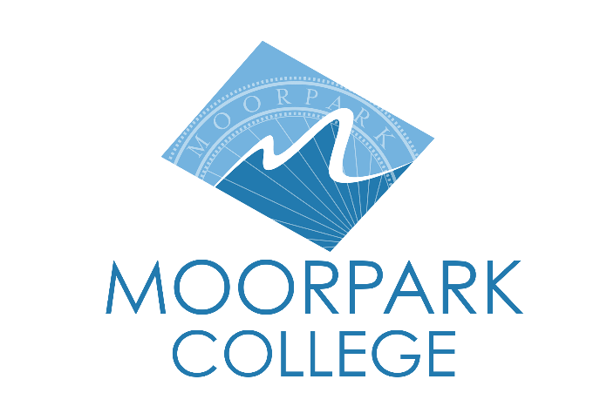 | Moorpark College  7075 Campus Road  Moorpark, CA 93021  805.378.1400  moorparkcollege.edu

For Immediate Release

Moorpark College Holds Auditions
for Summer Productions of “Blithe Spirit” and “Disenchanted!”
Theatre Arts department showcases Noël Coward’s spirited family comedy
and popular musical based on Disney princesses

Moorpark, Calif. (May 9, 2022)–The Moorpark College Theatre Arts department will host auditions for its upcoming summer 2022 productions of “Blithe Spirit” and “Disenchanted!” Auditions for actors for both productions will be held May 16-18 on campus. Both productions will run in July.

“We are thrilled to have the Performing Arts Center fully open and bring to our summer stage a classic family farce and the inaugural presentation of the hit fairy tale parody ‘Disenchanted!’” said John Loprieno, director and theatre arts faculty member.

Playwright Noël Coward’s “Blithe Spirit” tells the story of a cantankerous novelist named Charles Condomine, who has re-married but is literally haunted by the ghost of his first wife, the clever and insistent Elvira, who is summoned by a visiting “happy medium,” Madame Arcati. As the worldly and other-worldly personalities clash, laughs ensue.

Some theatre arts alumni will return to the Performing Arts Center at Moorpark College to work with current students on “Disenchanted!” the musical comedy from Dennis T. Giacino that explores the illusions surrounding Disney princesses. The original storybook characters are unhappy with their depictions in modern pop culture, so they come to life to correct their reputations. Note: These fairy tales contain adult language and content.

“Our summer program has always been about welcoming graduating high school students to Moorpark College and theatre arts. This year, we’ll have our incoming students sharing the stage with our department’s alumni, who are either enrolled in four-year institutions or working in the entertainment industry in Los Angeles,” said Loprieno.

Audition and callback dates, times and locations are as follows:

- Acting auditions: May 16, 3:30-6 p.m., and May 17, 6-10 p.m.
- Callbacks: May 18, 6-10 p.m.

All will take place in the Performing Arts Center on the Moorpark College campus, 7075 Campus Road, Moorpark. An accompanist will be present for the auditions, and anyone auditioning should prepare 30 bars (1 minute) of an upbeat song from any musical and be prepared to read from a script and improvise.
“Blithe Spirit” will run July 21-31, Thursday through Saturday at 8 p.m., and Sundays at 2 p.m.
“Disenchanted!” will run July 24-27 with performances at 8 p.m.
Reservations for both productions can be made after July 1 through the Moorpark College Performing Arts Center Box Office at (805) 378-1485 or online at www.moorparkcollege.edu/pac.
About Moorpark College

Moorpark College Mission

Grounded in equity, social justice, and a students first philosophy, Moorpark College values diverse communities. We empower learners from local, national, and global backgrounds to complete their degree, certificate, transfer, and career education goals. Through innovation and customized student support, our programs are designed to achieve equitable outcomes.

Moorpark College is one of three colleges in the Ventura County Community College District and annually serves more than 14,000 students. Founded in 1967, Moorpark College is fully accredited and has the highest six-year completion rate within the California Community College System. The Campaign for College Opportunity named Moorpark College a 2020 Champion of Higher Education for the Associate Degree for Transfer Pathway. It is also a designated Hispanic-Serving Institution. The college’s signature career/technical programs include nursing, radiologic technology, biotechnology and journalism. The college’s America’s Teaching Zoo is the only associate degree exotic animal training program in the country. To learn more, visit MoorparkCollege.edu or follow @MoorparkCollege on social media.

Media Contact:
John Loprieno
jloprieno@vcccd.edu
(805) 378-1469

