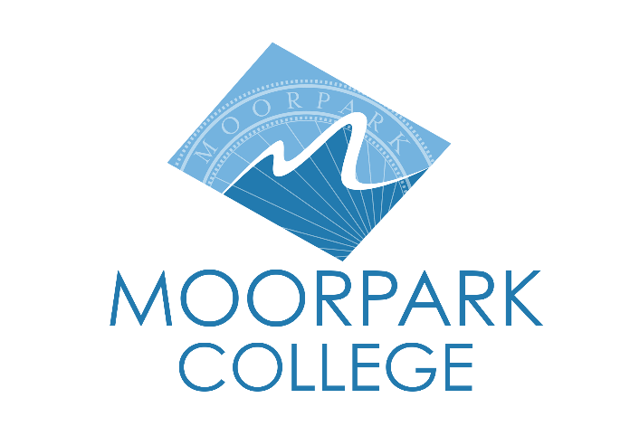 | Moorpark College  7075 Campus Road  Moorpark, CA 93021  805.378.1400  moorparkcollege.edu

For Immediate Release
Jorge Corralejo Photography Featured In Moorpark College Art Gallery
Exhibition is open to students and the community during Latinx Heritage Month
Moorpark, Calif. (October 3, 2022) — Moorpark College is proud to announce the exhibition of “Huelga! Photographs from the Frontlines by Jorge Corralejo.” Corralejo is a civil rights activist, photographer, philanthropist and author. The free exhibition is open to students and the community in the Moorpark College Art Gallery. This event is part of the campuswide Latinx Heritage Month Celebration.
Corralejo fought tirelessly alongside labor leaders and political activists César Chávez and Dolores Huerta to establish suitable working conditions and fair treatment for farmworkers. Corralejo assisted with the recruitment and construction of Agbayani Village, a retirement community for elderly Filipino farmworkers in Delano, Calif.
For over 50 years, he has advocated for laborers everywhere by serving on community and business boards and working with state and federal legislators. “Huelga! Photographs from the Frontlines by Jorge Corralejo” was originally organized by the Museum of Ventura County and curated by Anna Bermudez with promotional support generously provided by Lazer Broadcasting.
“This exhibition provides an in-depth view into the life’s work of the dedicated activist Jorge Corralejo. Through his photos and personal materials, we are transported back in time to witness the struggles of farmworkers throughout Ventura County, particularly the rise of the United Farm Workers in the 1970s, the strike at the Mel Finerman Farms in Oxnard and the Egg City strike in Moorpark,” said Erika Lizée, art department chair and gallery director at Moorpark College.
“This exhibit demonstrates how Jorge Corralejo and others have been actively fighting for social justice and equitable treatment in Ventura County and beyond.”
The “Huelga! Photographs from the Frontlines by Jorge Corralejo” exhibition is on display in the Administration Building at Moorpark College, 7075 Campus Road, Moorpark. The Art Gallery is located in the Administration Building and is open Monday through Thursday, 8 a.m. to 6 p.m., and Friday, 8 a.m. to noon.
The exhibition and all Latinx Heritage Month activities on the campus run through Oct. 15. For a full list of Latinx Heritage Month activities, visit MoorparkCollege.edu/Latinx.
For additional information about “Huelga! Photographs from the Frontlines by Jorge Corralejo” or the Moorpark College Art Gallery, contact Lizée at (805) 553-4170 or elizee@vcccd.edu.

About Moorpark College

Moorpark College Mission

Grounded in equity, social justice, and a students first philosophy, Moorpark College values diverse communities. We empower learners from local, national, and global backgrounds to complete their degree, certificate, transfer, and career education goals. Through innovation and customized student support, our programs are designed to achieve equitable outcomes.

Moorpark College is one of three colleges in the Ventura County Community College District and annually serves more than 14,000 students. Founded in 1967, Moorpark College is fully accredited and has the highest six-year completion rate within the California Community College System. An Aspen Institute Top 10 Finalist for 2023, Moorpark College has also been named a 2020 Champion of Higher Education by The Campaign for College Opportunity for the Associate Degree for Transfer Pathway. It is also a designated Hispanic-Serving Institution. The college’s signature career/technical programs include nursing, radiologic technology, biotechnology and journalism. The college’s America’s Teaching Zoo is the only associate degree exotic animal training program in the country. To learn more, visit MoorparkCollege.edu or follow @MoorparkCollege on social media.

Media Contact:
John Loprieno
jloprieno@vcccd.edu
805.378-1469

