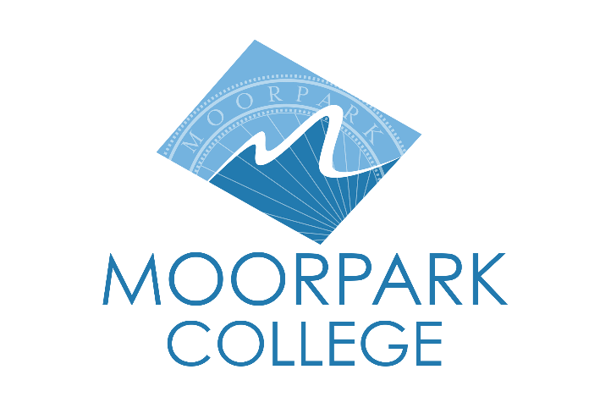 | Moorpark College  7075 Campus Road  Moorpark, CA 93021  805.378.1400  moorparkcollege.edu

For Immediate Release
Javier Zamora to be Keynote Speaker at Moorpark College
for Undocumented Student Action Week
Memoir author will share his experiences in Zoom Webinar

Moorpark, Calif. (October 7, 2022) — Award-winning author Javier Zamora will discuss his new memoir, “Solito,” on Oct. 19 at noon as part of Moorpark College’s Undocumented Student Action Week, Oct. 17-21. The hour-long Zoom event is free to students and the community.
“We are excited to have Javier Zamora as the keynote speaker for Undocumented Student Action Week this year,” said Alex Yepez, Moorpark College counseling services specialist and Dreamers support lead. “Javier’s story and experiences reflect those of many of our undocumented student population at Moorpark College. It is critical to host a speaker such as Javier to validate and lift up the experiences of our students, especially in this current political climate.”
Zamora was born in La Herradura, El Salvador in 1990. When he was a year old, his father fled El Salvador due to the U.S.-funded Salvadoran Civil War (1980-1992). His mother followed in 1995, when Javier was about to turn five. Zamora was left in the care of his grandparents, who helped raise him until he immigrated to the U.S. when he was nine. His first poetry collection, “Unaccompanied” (Copper Canyon Press, 2017), explores themes revolving around these experiences.
In “Solito” (Hogarth, 2022), Zamora retells his nine-week odyssey across Guatemala, Mexico, and eventually through the Sonoran Desert. He traveled unaccompanied by boat, bus and foot. After a coyote abandoned his group in Oaxaca, Zamora managed to make it to Arizona with the aid of other migrants.
Zamora was a 2018-2019 Radcliffe Fellow at Harvard University and holds fellowships from CantoMundo, Colgate University (Olive B. O'Connor), MacDowell, Macondo, the National Endowment for the Arts, Poetry Foundation (Ruth Lilly), Stanford University (Stegner) and Yaddo. He is the recipient of a 2017 Lannan Literary Fellowship, the 2017 Narrative Prize and the 2016 Barnes & Noble Writer for Writers Award for his work in the Undocupoets Campaign.
To attend the Zoom webinar, register at bit.ly/Javier-Zamora.
For a complete list of Undocumented Student Action Week activities, visit moorparkcollege.edu/Dreamers
For additional information about “Solito” and Zamora, contact Yepez at (805) 553-4165 or mcdreamers@vcccd.edu.

About Moorpark College

Moorpark College Mission

Grounded in equity, social justice, and a students first philosophy, Moorpark College values diverse communities. We empower learners from local, national, and global backgrounds to complete their degree, certificate, transfer, and career education goals. Through innovation and customized student support, our programs are designed to achieve equitable outcomes.

Moorpark College is one of three colleges in the Ventura County Community College District and annually serves more than 14,000 students. Founded in 1967, Moorpark College is fully accredited and has the highest six-year completion rate within the California Community College System. An Aspen Institute Top 10 Finalist for 2023, Moorpark College has also been named a 2020 Champion of Higher Education by The Campaign for College Opportunity for the Associate Degree for Transfer Pathway. It is also a designated Hispanic-Serving Institution. The college’s signature career/technical programs include nursing, radiologic technology, biotechnology and journalism. The college’s America’s Teaching Zoo is the only associate degree exotic animal training program in the country. To learn more, visit MoorparkCollege.edu or follow @MoorparkCollege on social media.

Media Contact:
John Loprieno
jloprieno@vcccd.edu
(805) 378-1469

