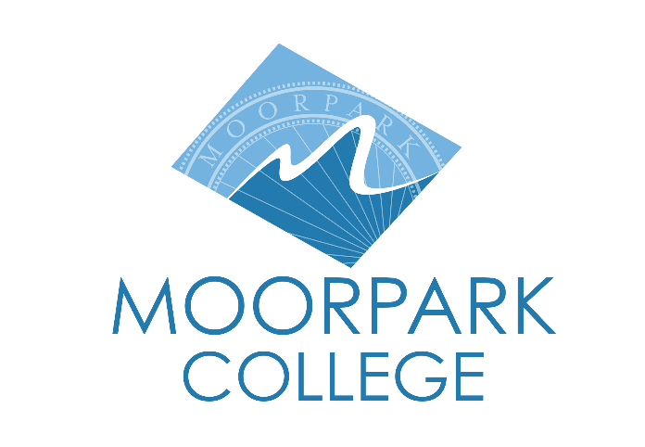 | Moorpark College  7075 Campus Road  Moorpark, CA 93021  805.378.1400  moorparkcollege.edu

For Immediate Release

MOORPARK COLLEGE THEATRE ARTS
BRAVES THE TEMPEST
Theatre Arts department holds auditions for Shakespearean classic

Moorpark, Calif. (Nov. 28, 2022)—Moorpark College Theatre Arts will hold auditions for the main stage presentation of the classic Shakespearean comedy “The Tempest.” Auditions will run Dec. 12-14 on campus. The production will run March 16-26.

“The highlight of our two-season rotation of plays is the main stage Shakespeare production,” said John Loprieno, director and Theatre Arts faculty member. “The fact that ‘Romeo & Juliet’ was canceled mid-run by the pandemic only elevated the excitement surrounding the return of Shakespeare to our main stage. The magical love story of ‘The Tempest’ has roles available for all types—comedians, romantic leads, protective fathers, fanciful monsters and beautiful sprites.”

In this classic fantasy, Prospero uses his magic to conjure a storm and torment the survivors of a shipwreck, including the King of Naples and Prospero’s treacherous brother, Antonio. Ferdinand, the King’s son thought dead in the shipwreck, falls in love with Prospero’s daughter, Miranda, through an awkwardly sweet courtship. Meanwhile, the half-man-half beast Caliban plots to rid himself of Prospero’s servitude but is thwarted by Prospero’s magical spirit-ally Ariel. After several comedic and mystical misadventures, as happens in all Shakespearean comedies, the families are reunited and all conflict is resolved for a happy ending.

Auditions will be held Dec. 12 from 3:30-6 p.m. and Dec. 13 from 6-10 p.m. with callbacks on Dec. 14 from 6-10 p.m. There will be a pre-audition workshop to review the play and audition material on Dec. 5 at 3:30 p.m. All will take place in the Moorpark College Performing Arts Center room PA-100 at 7075 Campus Road, Moorpark.

“The Tempest” will run March 16-26 with performances Thursdays through Saturdays at 8 p.m. and Sundays at 2 p.m. Cast members will be required to enroll in the three-unit Theatre Production: Performance class in the Spring semester. Tickets will be available early 2023 and can be purchased through the Moorpark College Performing Arts Center Box Office at (805) 378-1485 or online at www.moorparkcollege.edu/pac.

About Moorpark College

Moorpark College Mission

Grounded in equity, social justice, and a students first philosophy, Moorpark College values diverse communities. We empower learners from local, national, and global backgrounds to complete their degree, certificate, transfer, and career education goals. Through innovation and customized student support, our programs are designed to achieve equitable outcomes.

Moorpark College is one of three colleges in the Ventura County Community College District and annually serves more than 14,000 students. Founded in 1967, Moorpark College is fully accredited and has the highest six-year completion rate within the California Community College System. The Campaign for College Opportunity named Moorpark College a 2020 Champion of Higher Education for the Associate Degree for Transfer Pathway. It is also a designated Hispanic-Serving Institution. The college’s signature career/technical programs include nursing, radiologic technology, biotechnology and journalism. The college’s America’s Teaching Zoo is the only associate degree exotic animal training program in the country. To learn more, visit MoorparkCollege.edu or follow @MoorparkCollege on social media.

Media Contact:
John Loprieno
jloprieno@vcccd.edu
(805) 378-1469

