Microsoft Word Read Aloud
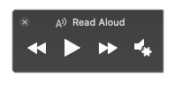

Microsoft Word provides a Read Aloud feature. Listen to text in the document spoken aloud.

Install Microsoft Word

- Visit the VCCCD Office 365 Student Licensing
- Go to the “Where to Sign Up” section and choose the link provided
- Enter the school email
  - Example: first_lastname#@my.vcccd.edu
- Choose “Get Started”
- Follow instruction provided by Microsoft for installing Office 365, which includes Microsoft Word, PowerPoint and Excel.

Activate Read Aloud:
- Open a Microsoft Word document
- Choose the “Review” ribbon
- Choose “Read Aloud”
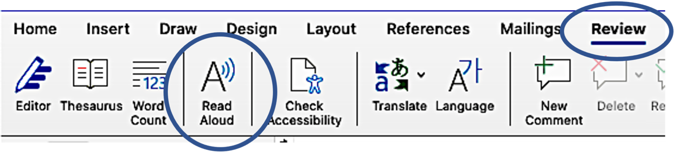

How Read Aloud Works
Two methods for using the Read Aloud feature:
- Select/Highlight a specific phrase, sentence, word, etc of the document
  - Press “Play”
  - Only the words selected will read aloud
- With nothing selected
  - Press “Play”
  - Reading will begin from where the typing cursor is placed.

Other Features:
- While reading, the words will be highlighted to offer tracking while the voice reads.
- There are options to slow down or speed up the speaking rate.
- The voice can be changed.
