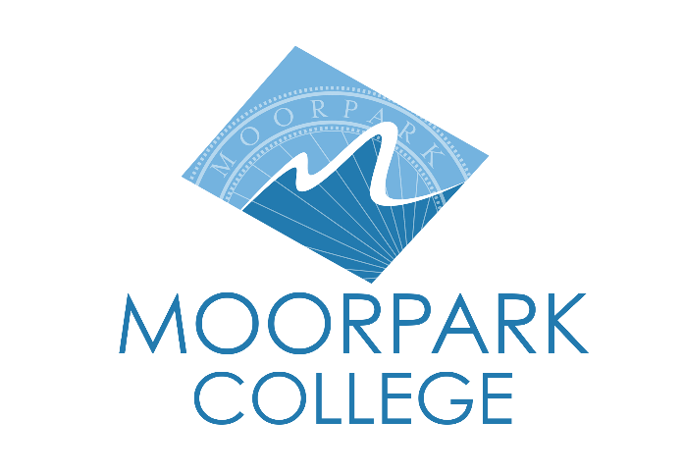 | Moorpark College  7075 Campus Road  Moorpark, CA 93021  805.378.1400  moorparkcollege.edu
FOR IMMEDIATE RELEASE
Moorpark College President Selected for Aspen Institute’s Presidents Fellowship
Dr. Julius Sokenu to Join Prestigious Cohort of Community College Leaders
Moorpark, Calif. (Sept. 19, 2023) — The Aspen Institute College Excellence Program announced today that Dr. Julius Sokenu, President of Moorpark College, was selected for the inaugural class of the Aspen Presidents Fellowship. This intensive leadership program focuses on developing a sustainable and comprehensive reform agenda that advances excellence and equity in student outcomes.
“It is an honor to have been selected to join the admirable efforts of this collective,” said President Sokenu. “This is an opportunity for community college leaders from across the nation to share ideas, offer new perspectives, and ultimately, collaborate on our shared goal of serving our nation’s students.”
Selected through a competitive process, the fellows will work closely with their cohort of community college presidents and senior staff from the Aspen Institute over 12 months. The fellows will share insights and practices from their field-leading colleges and receive guidance on advancing reforms aimed at delivering excellent and equitable student outcomes.
“Scaled improvements in student outcomes at our nation’s community colleges requires excellent leadership,” said Josh Wyner, executive director of the Aspen Institute College Excellence Program. “I am continually inspired and motivated by the dedication and expertise that our fellows bring to the work of advancing excellence and equity on their campuses, and I look forward to supporting them as they improve outcomes for their students.”
In April of this year, Moorpark College was awarded 4th place out of thousands of community colleges for the 2023 Aspen Prize for Community College Excellence, an award recognizing the top colleges in the nation excelling in areas of student achievement and success. All three Ventura County community colleges placed in the top 150.
“The Aspen Institute supports community colleges in our mission to provide high quality education and career opportunities for students in search of a better future for themselves and their communities. We are immensely proud that President Sokenu has been selected to join these efforts,” said Rick MacLennan, Chancellor of the Ventura County Community College District.
For more information about the Aspen Institute, the Presidents Fellowship, and this year’s cohort of community colleges leaders, visit the Aspen Institute's Presidents Fellowship webpage.
About Moorpark College
Grounded in equity, social justice, and a student’s first philosophy, Moorpark College values diverse communities. We empower learners from local, national, and global backgrounds to complete their degree, certificate, transfer, and career education goals. Through innovation and customized student support, our programs are designed to achieve equitable outcomes.
Moorpark College is one of three colleges in the Ventura County Community College District and annually serves more than 14,000 students. Founded in 1967, Moorpark College is fully accredited and has the highest six-year completion rate within the California Community College System. An Aspen Institute Top 10 Finalist for 2023, Moorpark College has also been named a 2020 Champion of Higher Education by The Campaign for College Opportunity for the Associate Degree for Transfer Pathway. It is also a designated Hispanic-Serving Institution. The college’s signature career/technical programs include nursing, radiologic technology, biotechnology and journalism. The college’s America’s Teaching Zoo is the only associate degree exotic animal training program in the country. To learn more, visit MoorparkCollege.edu or follow @MoorparkCollege on social media.
About The Aspen Institute
The Aspen Institute is a global nonprofit organization committed to realizing a free, just, and equitable society. Founded in 1949, the Institute drives change through dialogue, leadership, and action to help solve the most important challenges facing the United States and the world. Headquartered in Washington, DC, the Institute has a campus in Aspen, Colorado, and an international network of partners.
The Aspen Institute College Excellence Program supports colleges and universities in their quest to achieve a higher standard of excellence, delivering credentials that unlock life-changing careers and strengthen our economy, society, and democracy. We know it takes visionary college leaders to achieve this higher standard and we make it our mission to equip them with the knowledge, skills, and research-backed tools to inspire change, shift practice, and advance the capacity of colleges to deliver excellent and equitable student outcomes. For more information, visit our website and follow us on LinkedIn and Twitter.
Media Contact:
Jamie Whittington Studer
Public Information Officer
jamie_whittingtonst1@vcccd.edu
805.338.3610

