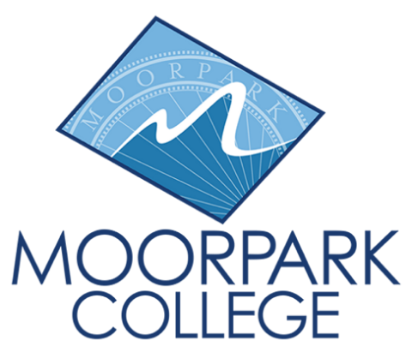
Moorpark College
7075 Campus Road
Moorpark, CA 93021
805.378.1400
moorparkcollege.edu

FOR IMMEDIATE RELEASE

Moorpark College to Launch Bachelor’s Degree in Applied Biomanufacturing
Four-year degree is the first for Ventura County Community College District

Moorpark, Calif. (January 27, 2023) —The biotech field is expected to grow faster than average through 2031, according to the Bureau of Labor Statistics. Area biotech companies report struggling to fill positions for well-trained staff on their production teams. To meet this need, Moorpark College will offer a bachelor’s degree in applied biomanufacturing, expanding on the college’s proven track record of its associate degree in biotechnology.
The California Community Colleges Board of Governors granted Moorpark College official approval of the degree on Jan. 23. Students can begin the program with the fall 2024 semester.

“Students who earn this degree will be well-equipped to pursue careers in the growing biotech industry,” said Dr. Julius Sokenu, president of Moorpark College. “Moorpark College aims to provide our community with educational opportunities that lead to careers that help them build wealth — not just a living wage — and salaries that lift students out of poverty into solid middle-class professional jobs.”

Annual regional job growth in the biotech industry is estimated at 8.1%. The median annual salary comparison in Ventura/L.A. County for students with an associate degree in biotech can be as high as $52,000 and up to $84,000 with a bachelor’s degree in biomanufacturing.

The new bachelor’s degree, developed with input from key industry advisors, will help diversify the local workforce by removing barriers and offering employment opportunities for low-income and minority individuals, women and recent immigrants.

Another benefit is that students can stay within the community to earn a baccalaureate, which better prepares them for employment in the biotechnology/biomanufacturing industry in our region.

Moorpark College’s associate degree biotechnology program has already closed the equity gap between white and Latinx students and narrowed the gap for black students in comparison with other disciplines.

“The Ventura County Community College District prides itself on the work we do with our industry partners to enhance students’ futures and address workforce needs,” said Chancellor Rick McLennan. “Ventura College and Oxnard College are in the process of exploring baccalaureate programs for in-demand fields.”

The newly approved program is part of Gov. Gavin Newsom’s 2021 authorization for the California Community Colleges Board of Governors to expand and extend the four-year degree pilot program indefinitely. The goal is to launch up to 30 baccalaureate degree programs annually. As of January 2023, 17 of the 116 community colleges in the state offer their students the opportunity to earn a bachelor’s degree.

The college plans to hold an informational event this summer to introduce the program to students and the community.

For more information about Moorpark College’s biotechnology program, visit the program’s webpage.

About Moorpark College
Grounded in equity, social justice, and a student’s first philosophy, Moorpark College values diverse communities. We empower learners from local, national, and global backgrounds to complete their degree, certificate, transfer, and career education goals. Through innovation and customized student support, our programs are designed to achieve equitable outcomes.
Moorpark College is one of three colleges in the Ventura County Community College District and annually serves more than 14,000 students. Founded in 1967, Moorpark College is fully accredited and has the highest six-year completion rate within the California Community College System. An Aspen Institute Top 10 Finalist for 2023, Moorpark College has also been named a 2020 Champion of Higher Education by The Campaign for College Opportunity for the Associate Degree for Transfer Pathway. It is also a designated Hispanic-Serving Institution. The college’s signature career/technical programs include nursing, radiologic technology, biotechnology, and journalism. The college’s America’s Teaching Zoo is the only associate degree exotic animal training program in the country. To learn more, visit MoorparkCollege.edu or follow @MoorparkCollege on social media.
Media Contact:
Jamie Whittington Studer
Public Information Officer
jamie_whittingtonst1@vcccd.edu
805.378.1400

