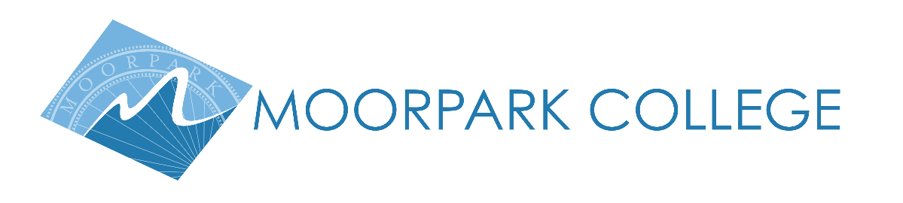

For Immediate Release

Summer Stars Shine in Bring It On the Musical
Young performers showcase their training in summer theatre intensive

Moorpark, Calif. (Aug. 2, 2023) — In collaboration with the alumni-operated Born to Perform Studio, Moorpark College is proud to present Bring It On the Musical, the culminating performance of the youth summer musical theatre intensive.

After a hiatus during the pandemic, the Moorpark College Theatre Arts Department has revived its youth summer theatre program where aspiring artists earn college credit while rehearsing a full theatrical production and receiving expert training from our Theatre Arts faculty and instructors.

“We have been eager to bring back this opportunity for young performers, and it is exciting to work with Moorpark College alumni Brent Ramirez and Ryan Lefton to make it happen,” said Suzanne Fagan, Moorpark College Theatre Arts professor.

“This partnership with Moorpark College is very meaningful for me, as I would not be where I am today without the resources and connections I gained inside the Moorpark College Performing Art Centers’ walls,” said Ramirez, Born to Perform Director.

Bring It On the Musical, with music written by Tom Kitt and Hamilton’s Lin-Manuel Miranda, is a lively adaptation of the cult-classic cheerleading film that deals with themes of acceptance, teamwork and perseverance.

“This show has such an inspiring message,” said cast-member Drake Mulligan. “It deals with really important issues like bullying and body image.” Lefton also noted, “seeing this show performed by high schoolers, who are experiencing some of these issues in their daily lives, is a really powerful thing to watch.”

This feel-good musical runs Friday through Sunday with performances Aug. 4 at 7 p.m., Aug. 5 at 1 p.m. and 7 p.m. and Aug. 6 at 1 p.m. on the Moorpark College Performing Arts Center Mainstage. To purchase tickets, visit www.borntoperformstudio.com/bringiton.

For more details about the youth summer theatre program or the Moorpark College Theatre Arts Department, contact Professor Suzanne Fagan at sfagan@vcccd.edu.

About Moorpark College
Founded in 1967, Moorpark College is fully accredited and has the highest six-year completion rate within the California Community College System. The Campaign for College Opportunity named Moorpark College a 2020 Champion of Higher Education for the Associate Degree for Transfer Pathway. It is also a designated Hispanic-Serving Institution. The college’s signature career/technical programs include nursing, radiologic technology, biotechnology and journalism. The college’s America’s Teaching Zoo is the only associate degree exotic animal training program in the country. To learn more, visit MoorparkCollege.edu or follow @MoorparkCollege on social media.

Media Contact:
Jamie Whittington-Studer
Moorpark College PIO
jamie_whittingtonst1@vcccd.edu

