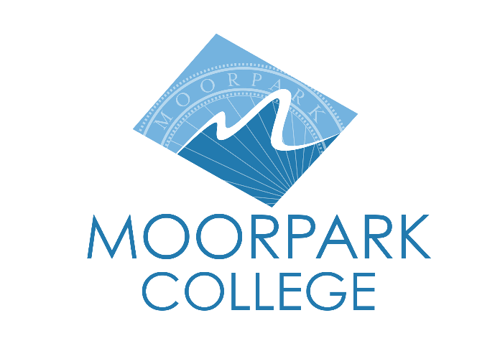 | Moorpark College  7075 Campus Road  Moorpark, CA 93021  805.378.1400  moorparkcollege.edu
FOR IMMEDIATE RELEASE
Moorpark College Piques Audience Curiosity with The Curious Savage
Experience a Unique Blend of Humor and Heart in John Patrick's Classic Comedy
Moorpark, Calif. (Aug. 15, 2023) — The Curious Savage is coming to The Moorpark College Performing Arts Center Mainstage October 12-22. This uproarious 1950s comedy set in The Cloisters Sanitorium in Massachusetts follows the story of a flamboyant widow who is forcibly admitted to the sanatorium by her greedy stepchildren when she refuses to hand over her sizable inheritance.
“This play was very ahead of its time in terms of its message and structure,” said director and Theatre Arts faculty Suzanne Fagan. “It’s hysterical, and yet, by the end of the play, you’re blown away by the social commentary surrounding mental health, stigma, and family that’s been woven in throughout the story.”
Junior and Sophomore Theatre Arts students Annabelle Sanders and Kourtney Westphal share the lead role of Mrs. Savage, embodying the widow with comedic prowess and maturity far beyond their years.
“I’m normally behind the scenes as a costumer, but I wanted this opportunity to push myself as a performer to portray this over-the-top character,” said Sanders.
Pulitzer Prize winning playwright John Patrick expertly crafts a wacky yet charming world of acceptance and creativity inside the walls of the Sanitorium, leaving Mrs. Savage (and the audience) to question their perceptions of reality and normativity.
“This show sends such a powerful and universal message,” said Westphal. “It’s an honor to be able to perform an important piece like this alongside such a talented cast and crew.”
Performances of this thought-provoking comedy are Thursdays, Fridays, and Saturdays at 8 p.m. and Sundays at 2 p.m. October 12-21 on the Moorpark College Performing Arts Center mainstage.
Tickets are $20 ($15 for students and seniors) and can be purchased through the Moorpark College Performing Arts Center Box Office. For questions about the show or information about our Performing Arts programs, contact Moorpark College Theatre Arts Faculty Suzanne Fagan at sfagan@vcccd.edu.
About Moorpark College
Grounded in equity, social justice, and a student’s first philosophy, Moorpark College values diverse communities. We empower learners from local, national, and global backgrounds to complete their degree, certificate, transfer, and career education goals. Through innovation and customized student support, our programs are designed to achieve equitable outcomes.
Moorpark College is one of three colleges in the Ventura County Community College District and annually serves more than 14,000 students. Founded in 1967, Moorpark College is fully accredited and has the highest six-year completion rate within the California Community College System. An Aspen Institute Top 10 Finalist for 2023, Moorpark College has also been named a 2020 Champion of Higher Education by The Campaign for College Opportunity for the Associate Degree for Transfer Pathway. It is also a designated Hispanic-Serving Institution. The college’s signature career/technical programs include nursing, radiologic technology, biotechnology and journalism. The college’s America’s Teaching Zoo is the only associate degree exotic animal training program in the country. To learn more, visit MoorparkCollege.edu or follow @MoorparkCollege on social media.
Media Contact:
Jamie Whittington Studer
Public Information Officer
jamie_whittingtonst1@vcccd.edu
805.378.1400

