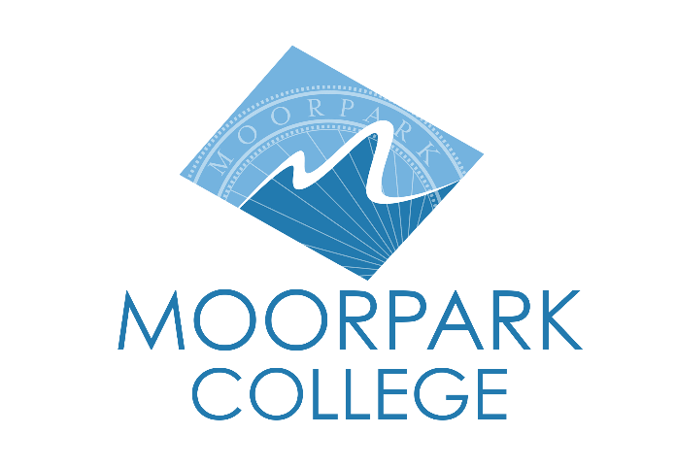
FOR IMMEDIATE RELEASE
Motion Flux Brings Movement, Story, and Innovation to the Stage
Moorpark College Dance Program presents three community performances of original choreography, May 9-10
Moorpark, Calif. (May 7, 2025) — The community is invited to experience the energy, creativity, and range of Motion Flux, the spring dance concert presented by the Moorpark College Dance Program. This year’s program features original choreography by faculty, students, and a local dance artist, with performances in ballet, jazz, modern, contemporary, and hip hop.
The program has something for everyone. Faculty member Vivian Goldes tickles the imagination with Carnaval de Nuit, Wendi Baity moves us to connect with our human stories in Life, Robert Salas pays homage to his teacher in Duetto’s Ghost, and Nancy Paradis gets jazzy in Pulse. Student works include pieces by Jadyn Bonewitz, Malaya Clark, Felix Galavis, and Chelsea Turitz. With co-direction by Nancy Paradis and Vivian Goldes, the show fosters collaboration across the program and departments.
“Sometimes the flow of the creative process feels more like a fierce cyclone than a peaceful and refreshing brook,” said Beth Megill, artistic director. “Waves of uncertainty, challenge, upset, and change crashed over us this semester. But I believe in perseverance, and I believe this show is evidence of that. I regard the art-making process as a great teacher for how we can and want to be in the world as co-creators and collaborators.”
The closing piece in the concert is an ensemble performance entitled Wings and Strings. Based on Leonardo da Vinci’s dreams of flight and set to the choral music of Eric Whitacre, this piece is a reminder that we, as artists, are visionaries of wildly new possibilities that can seem unfathomable from our current vantage points. Artists have the gift of dreaming outside of conventions and limiting beliefs. Wings and Strings is a piece about new possibilities, new futures, and new dreams.
Performances will be held May 9 at 7:30 p.m. and May 10 at 2 p.m. and 7:30 p.m. To purchase tickets or learn more information, visit moorparkcollege.edu/PAC. One piece includes mature content and may not be appropriate for all audiences. If you have questions about the show, please email the box office at mcboxoffice@vcccd.edu.
About Moorpark College
Moorpark College is one of three colleges in the Ventura County Community College District and annually serves more than 14,000 students. Founded in 1967, Moorpark College is fully accredited and has the highest six-year completion rate within the California Community College System. An Aspen Institute Top 10 Finalist for 2023, Moorpark College has also been named a 2020 Champion of Higher Education by The Campaign for College Opportunity for the Associate Degree for Transfer Pathway. It is also a designated Hispanic-Serving Institution. The college’s signature career/technical programs include nursing, radiologic technology, biotechnology and journalism. The college’s America’s Teaching Zoo is the only associate degree exotic animal training program in the country. To learn more, visit MoorparkCollege.edu or follow @MoorparkCollege on social media.
Media Contact:
Beth Megill
bmegill@vcccd.edu

